Name: Date:

**Student Exploration: Dilations**

**Vocabulary:** dilation, image, matrix, preimage, scalar, scale factor, transformation

**Prior Knowledge Questions** (Do these BEFORE using the Gizmo.)

Marie has a small photograph of a rose. She goes to a photo store and asks them to enlarge the photo to three times its original size.

1. How will the enlarged image of the flower be different from the original?

1. How will the enlarged image be the same as the original?

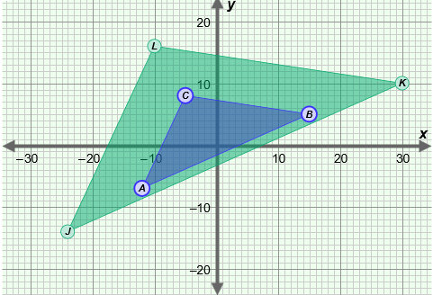

**Gizmo Warm-up**

When you enlarge or reduce the size of a picture, you perform a geometric **transformation** called a **dilation**. In the *Dilations* Gizmo, you can experiment with these transformations by dilating different figures.

Be sure **Point** is selected from the **Figure type** dropdown menu. Drag point *A* to (8, 6). Look at the **matrix** (rectangular array of numbers) under **Preimage matrix**.

1. How is the preimage matrix related to the coordinates of point *A*?

1. Where will point *A* be if the preimage matrix is ? ( , )

Check your answer in the Gizmo by entering the numbers under **Preimage matrix**. (Click on a number in the text field, type in a new value, and hit **Enter**.)

|  |  |  |
| --- | --- | --- |
| **Activity A:**  **Dilating geometric figures** | Get the Gizmo ready:   * Select **Segment** from the **Figure type** menu. * Drag point *A* to (–7, 5) and point *B* to (10, 9). | 182SE2 |

1. With *A* at (–7, 5) and *B* at (10, 9), look at the **Preimage matrix**. How is it related to ?

1. Drag the **Scale factor** slider.  is the dilated **image** of  (the **preimage**). The ratio of the length of  to the length of  is the **scale factor**.
2. What happens to  when the scale factor is greater than 1?
3. What happens to  when the scale factor is less than 1?

Experiment with a variety of segments to see if this is always true.

1. Drag point *A* to (–4, 5) and point *B* to (9, –8). Set **Scale factor** to 2.0. Mouseover points *J* and *K* to see their coordinates.
2. How can you use the scale factor of 2 and the endpoints of  to find the endpoints of ?
3. Experiment with a variety of scale factors and watch how the endpoints of  change. If the coordinates of the preimage are (*x*, *y*), write a rule for finding the coordinates of the image of a dilation by a scale factor of *r*.

(*x*, *y*) → ( , )

1. Set **Scale factor** to 2.0.
2. How do you think *JK* compares to *AB*?

Use the Gizmo rulers to check your answer. (Select **Show ruler**. Attach one set of “donuts” to points *A* and *B*, and the other set to points *J* and *K*.)

1. Repeat with several other segments and different scale factors. In general, how can you use the scale factor to find the length of the image?

**(Activity A continued on next page)**

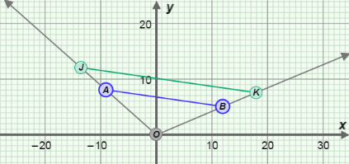**Activity A (continued from previous page)**

1. Turn off the Gizmo rulers. Turn on **Show rays**. Drag the endpoints of  until the graph looks like the one to the right.
2. Where is the endpoint of both rays?

1. What other points do the rays include?
2. Vary the scale factor. Describe the motion of points *J* and *K*.

1. Turn off **Show rays**.
2. What do you think the **Preimage matrix** will look like for a triangle?

Set **Figure type** to **Triangle** to check.

1. Drag the **Scale factor** slider. Describe how the scale factor changes the relationship between the image, Δ*JKL*, and the preimage, Δ*ABC*. (Hint: Look at both the sizes of the triangles and the coordinates of their vertices.)

1. Set **Scale factor** to 1.5. Use the Gizmo rulers to measure corresponding sides of  and . How does *JK* relate to *AB*?
2. Measure the other pairs of corresponding sides. What do you notice?

Experiment with other triangles and scale factors to check that this is always true.

1. Use the protractors to measure each pair of corresponding angles. (Select **Show angle measure tool** and attach the “donuts” of each protractor.) What do you find?

Create more triangles to see if this is always true.

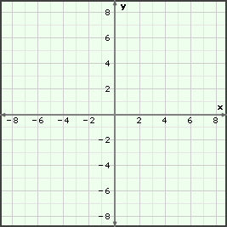



|  |  |  |
| --- | --- | --- |
| **Activity B:**  **Dilations and matrices** | Get the Gizmo ready:   * Under **Figure type**, select **Segment**. * Turn off the rulers and protractors. | 182SE4 |

1. Set the **Preimage matrix** to . Drag the **Scale factor** slider. Look at the matrix equation displayed above the graph as you do.
2. How is the first number related to the scale factor?

This number is called a **scalar**.

1. What is the first matrix in the equation the same as?
2. How do the elements in the last matrix relate to the coordinates of *J* and *K*?

The last matrix is the *image matrix*.

1. How can you use the scalar and the preimage matrix to get the image matrix?

1. Experiment with other points and translations in the Gizmo. How is the image matrix always related to the preimage matrix?
2. What do you think the matrix equation will look like for the dilation of a triangle?

Select **Triangle** from the **Figure type** menu to check.

1. The matrix  describes the location of the vertices of Δ*ABC*. In the space below, write a matrix equation to show the result of dilating Δ*ABC* by a scale factor of 0.5. Check your answer in the Gizmo.

|  |  |  |
| --- | --- | --- |
| **Activity C:**  **Using dilations** | Get the Gizmo ready:   * Under **Figure type**, select **Triangle**. | 182SE5 |

1. A triangle has vertices at *A*(6, 3), *B*(8, –4), and *C*(–2, 5). The triangle is dilated and the image of point *B* lies at (12, –6).
2. Is the image, Δ*JKL*, larger or smaller than the preimage, Δ*ABC*?

Explain how you know.

1. 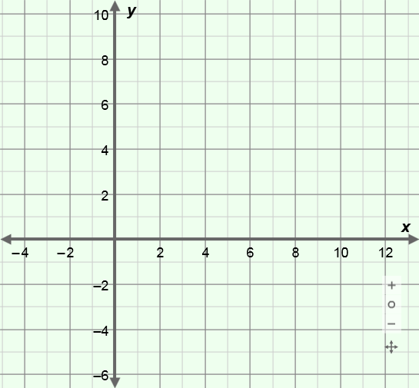Find the scale factor for this dilation. Show your work in the space below.

scale factor =

Write a matrix equation to find the coordinates of the vertices of Δ*JKL*. Show your work in the space below. Then sketch the preimage and image on the grid to the right. Check your answer in the Gizmo.

1. Andrea is making a copy of a picture that is 8 inches wide and 10 inches tall. The copy is 75% the size of the original picture. Find the dimensions of the copy. Show your work in the space below.

Dimensions of copy: wide and tall