Name: Date:

**Student Exploration:** **Dividing Exponential Expressions**

**Vocabulary:** base, exponent, expression

**Prior Knowledge Questions** (Do these BEFORE using the Gizmo.)

1. Factor the numerator and denominator into prime numbers. Then simplify the fraction.

 = =

1. What did you do to simplify the fraction?

**Gizmo Overview**

In the *Dividing Exponential Expressions* Gizmo, you divide **expressions** with exponents, step-by-step. An **exponent** is a number, written to the right of and just above a number or expression (called the **base**), that indicates how many times the base is multiplied by itself.

Here’s how the Gizmo looks at first:

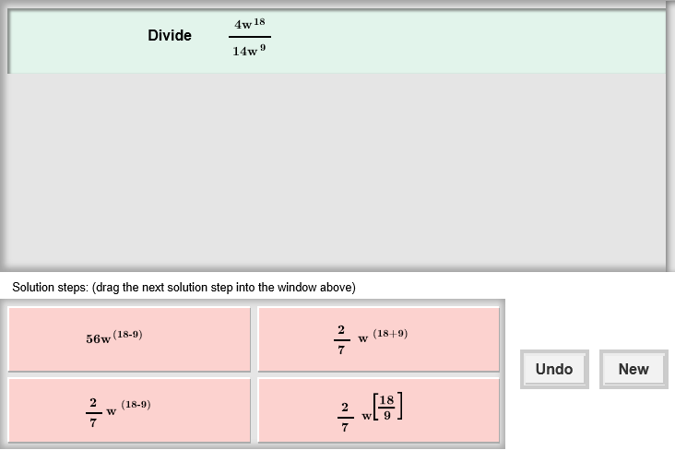The expressions for you to divide are here.

The tiles give you four choices for the next step. Choose the one you think is correct and drag it into the white area above.

Click **Undo** to undo your last choice.

Click **New** to go to a different problem.

Read your feedback in the Gizmo. (No feedback is given for correct answers.)

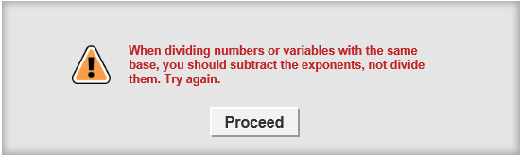

Click **Proceed** to go to the next step.

Continue until the expression is simplified. Then click **New** for a new problem to work on.

|  |  |  |
| --- | --- | --- |
| **Activity:**  **Simplifying the expression** | Get the Gizmo ready:   * You should see the expression . If not, click **Refresh** in your browser. | 342SE5 |

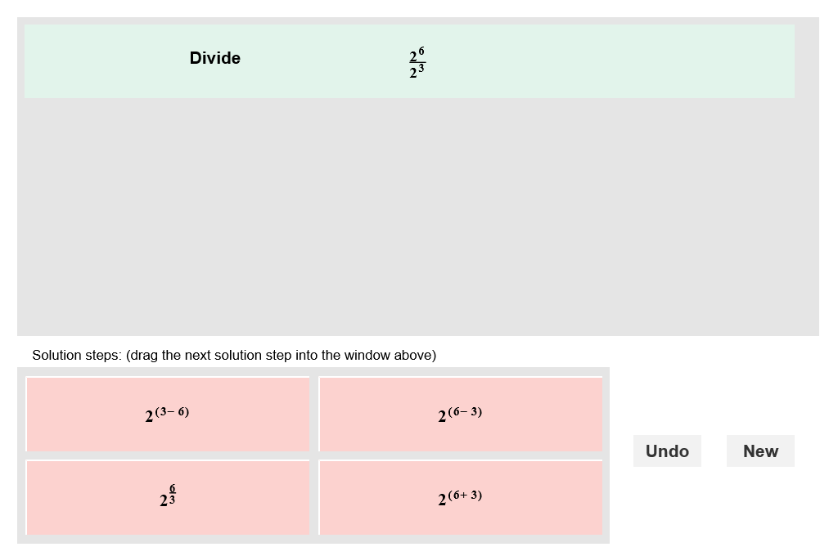

1. When you begin, you should see the expression shown to the right at the top of the Gizmo.
2. Write the numerator and the denominator as the product of factors. Then divide out the common factors.

= ___________

 =

1. What can you do to the exponents 6 and 3 to get the number of 2’s left in the numerator?
2. Choose the correct steps in the Gizmo to simplify the expression. If your choice is incorrect, read the given feedback and try again. What is the answer?
3. Write a rule that explains how to divide exponential expressions with like bases.

 =

1. Use the rule you described above to simplify this exponential expression.

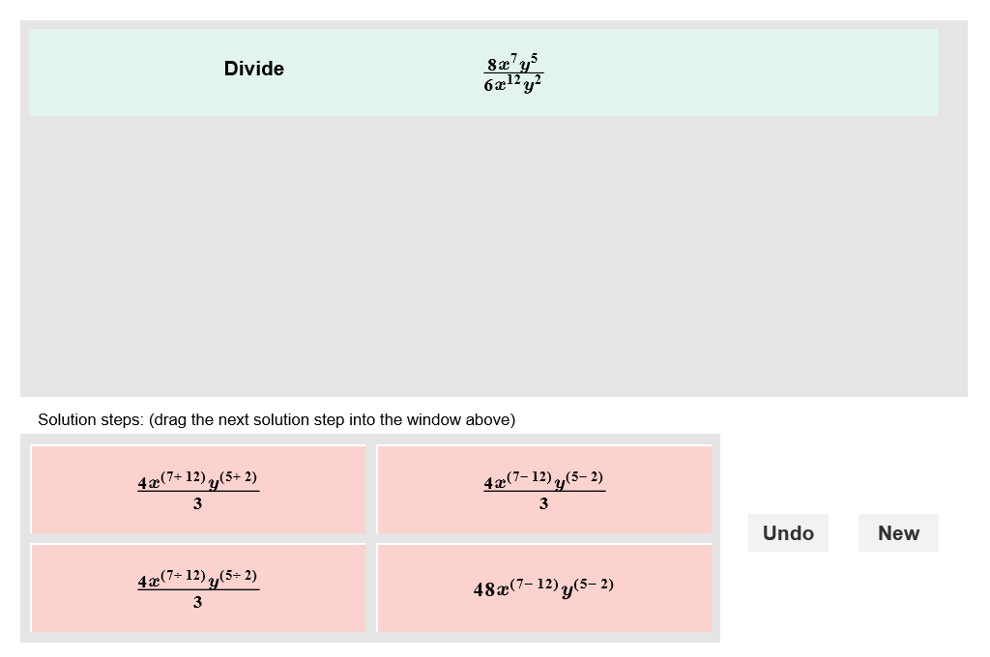

1. Click **New**. You should now see the following expression in the Gizmo:
2. Simplify the fraction made by the given coefficients.  =

 = _________  = _________

1. Use the rule for dividing two exponential expressions to simplify the fractions shown to the right.
2. Use your answers from above to help you choose the correct first step in the Gizmo. Notice the negative exponent in the numerator. What does this tell you to do?

1. Choose the last correct step. What is the answer?
2. Click **New**. Work through more problems in the Gizmo. Be sure to read feedback as you do.

**(Activity continued on next page)**

**Activity (continued from previous page)**

1. Simplify each expression below. Write all your steps in the space below each problem.
2. 
3. 
4. 
5. 
6. 
7. 