Name: Date:

Student Exploration: Dividing Polynomials Using Synthetic Division

Vocabulary: Remainder Theorem, synthetic division

Prior Knowledge Questions (Do these BEFORE using the Gizmo.)

- Use long division to divide 102 by 8. Show your work.

- What does your answer tell you about how 8 is related to 102?

Gizmo Overview
In the Dividing Polynomials Using Synthetic Division Gizmo, you’ll divide a polynomial by a binomial with synthetic division, which is a shortcut for long division.

Here’s how the Gizmo looks at first:

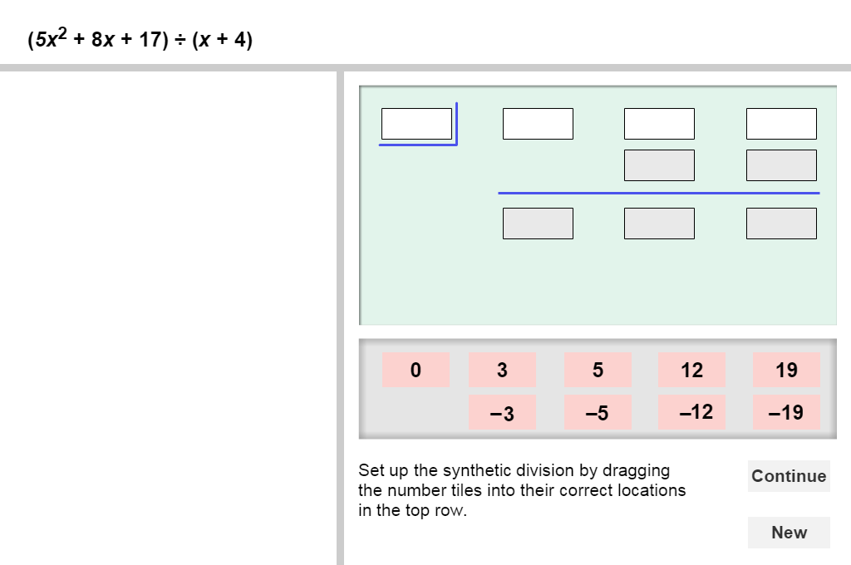
The polynomials for you to divide are here.

Model the synthetic division by dragging the number tiles into the white cells above.

As you drag tiles into the cells, the long division version appears in this space.

Read and follow the feedback and instructions that appear here.
Click New to go to a different problem.
Click Continue (when active) to go to the next step.

Continue until you find the quotient. Then click New for a new problem to work on.

Activity:  Finding the quotient | Get the Gizmo ready:  - You should see the problem (x² – 3x + 5) ÷ (x – 1). If not, click Refresh in your browser.
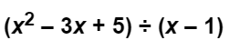
- When you begin, you should see the problem shown to the right.

- If the general form of the divisor is (x – a), what is the value of a for this problem?

a = Drag that tile into the first highlighted white cell at the top left.

- What are the coefficients of the terms in x² – 3x + 5 in order from left to right?

, , Drag those tiles in order to complete the first row.

- Click Continue. Drag the first coefficient of the trinomial into the white cell. Click Continue again. Drag the tile for the product of a and 1 into the white cell. Why is this number positive and the corresponding coefficient in the long division negative?

- Click Continue. Drag the sum of –3 and 1 into the white cell. Complete the synthetic division. Why do you add in synthetic division, but subtract in long division?

- Look at the quotient and remainder in the long division problem. How do the numbers in the last row of the synthetic division relate to this answer?

- Let P(x) = x² – 3x + 5. Find P(1) by substituting 1 for x. How does the result compare with the remainder? You just used the Remainder Theorem. It states that, when you divide P(x) by (x – a), the remainder is P(a).

- Click New. You should now see the problem (x² – 16) ÷ (x + 4). There is a gap in the degrees of the terms in x² – 16, so the polynomial must be rewritten as x² + 0x – 16.

- Drag the correct tiles into the cells. What is the quotient?

- What is the remainder? How do you know?

- Click New. Work through more problems in the Gizmo.

(Activity continued on next page)
Activity (continued from previous page)

- Use the Remainder Theorem to predict the remainder of each problem. Then use synthetic division to find each quotient. Write all your steps in the space below each problem.

- (x² – 3x – 54) ÷ (x – 9)

- (3x² + 20x – 16) ÷ (x + 8)

- (3x² – 144) ÷ (x – 12)

- (8x² + x) ÷ (x + 2)

- (x³ + 2x² – x + 6) ÷ (x + 4)

- (4x³ + x – 5) ÷ (x – 1)

