Name: ______________________________________ Date: ________________________

Student Exploration: Doppler Shift

Vocabulary: Doppler shift, frequency, pitch, sonic boom, sound waves, wavelength

Prior Knowledge Questions (Do these BEFORE using the Gizmo.)
Have you ever heard a siren on a moving ambulance, fire truck, or police car? If so, what happens to the sound as the vehicle passes by?

____________________________________________________________________________

____________________________________________________________________________

The change in the sound that you hear is called the Doppler shift.

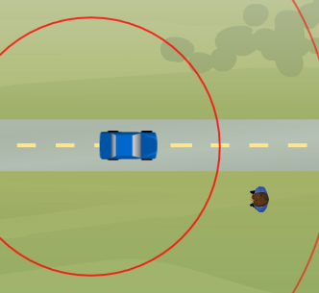
Gizmo Warm-up
The Doppler Shift Gizmo illustrates why the Doppler shift occurs. The Gizmo shows a vehicle that emits sound waves and an observer who will hear the sounds.

- Click the PLAY SAMPLE button (). (Check that the Gizmo’s sound and your computer’s speakers are on.)

What do you hear? _____________________________

_____________________________________________

- Click Play () and observe the sound waves emitted from the moving car. Click Pause () and compare the sound waves in front of and behind the car. What do you notice?

_________________________________________________________________________

- Use the Ruler to measure the wavelength, or the distance between the lines, of the waves in front of and behind the car. (Note: The red circles represent every thousandth wave.)

Wavelength in front of car: ____________ Wavelength behind car: ____________

- Why do you think the waves in front of the car have a shorter wavelength than the waves behind the car? ____________________________________________________________
_________________________________________________________________________

Activity A:  The Doppler shift | Get the Gizmo ready:  - Click Reset ().  - Check that f_{source} is set to 500 Hz and v_{sound} is set to 340 m/s, close to the actual speed of sound.  - Set v_{source} to 0 m/s. | 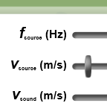

Introduction: The pitch of a sound, or how shrill or deep it is, is related to the frequency of the sound waves. The greater the number of sound waves passing by a point each second is, the higher the frequency and the pitch will be. The unit of frequency is the hertz (Hz).

Question: What causes the Doppler shift?

- Observe: With the car’s velocity (v_{source}) set to 0 m/s, click Play. Notice the sound waves moving away from the car in all directions.

    - Increase the frequency of the sound waves by moving the f_{source} slider to the right.

How does this affect the spacing of the waves? _____________________________

When the wavelength of the waves is short, the sound will be high in pitch.

    - Now decrease the frequency by moving the f_{source} slider all the way to the left.

How does this affect the spacing of the waves? _____________________________

Sound waves that are spaced far apart will produce a lower, deeper pitch.

- Measure: Click Reset. Set the frequency (f_{source}) to 1000 Hz. Change the velocity of the sound source (v_{source}) to 200 m/s. (The car is now an airplane.) At upper right, turn on the Observed frequency (Hz) checkbox.

Drag the observer onto the road. Click Play, and then click Pause when the sound waves first reach the observer.

    - What is the frequency of sound waves in front of the plane? ___________________

    - Click Play, and then click Pause just after the plane has passed the observer. What is the frequency of sound waves behind the plane? __________________________

- Summarize: Based on what you have learned, how will the sound that the observer hears change as the airplane passes by? Explain your answer.

_________________________________________________________________________

_________________________________________________________________________

_________________________________________________________________________

Activity B:  Faster than the speed of sound | Get the Gizmo ready:  - Click Reset ().  - Set f_{source} to 300 Hz.  - Check that v_{sound} is set to 340 m/s. | 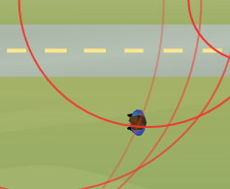

Introduction: On October 14, 1947, the Air Force test pilot Chuck Yeager became the first man to officially travel faster than the speed of sound in level flight. Modern fighter jets can fly nearly three times the speed of sound.

Question: What happens when objects travel faster than the speed of sound?

- Observe: Some jet planes can travel faster than the speed of sound. Place the observer below the road, and set the velocity of the plane (v_{source}) to 500 m/s. Click Play.

Observe for a while, and then click Pause. What do you notice? ______________________

_________________________________________________________________________

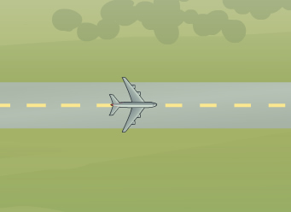
- Make a sketch: Click Reset. The red circles represent every thousandth sound wave. To see more waves, turn on Display additional waves. Click Play and observe.

Sketch the sound waves in the diagram at right.

- Infer: Think about what the observer would experience as the jet flew by.

- Describe what the observer would see and hear as the plane flew by. ____________

___________________________________________________________________

___________________________________________________________________

- Supersonic aircraft produce a loud noise called a sonic boom. Look at the waves hitting the observer. Based on what you see, what causes a sonic boom?

___________________________________________________________________

___________________________________________________________________

- At major sporting events in America, a flight squadron such as the Blue Angels often flies over the stadium in a tight formation at supersonic speeds. Would spectators in the stands hear the jet planes first or see them first? Explain your reasoning.

___________________________________________________________________

___________________________________________________________________

Activity C:  Measuring the frequency change | Get the Gizmo ready:  - Click Reset. | 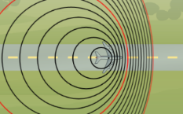

Question: What factors affect the magnitude of the Doppler shift?

- Observe: Using the Gizmo, try to determine how each factor (f_{source}, v_{source}, and v_{sound}) affects the observed Doppler shift. Based on what you have observed, how will each of these actions affect the magnitude of the Doppler shift?

- Increasing the frequency of the sound (f_{source}): ______________________________

___________________________________________________________________

- Increasing the velocity of the source (v_{source}): _______________________________

___________________________________________________________________

- Increasing the speed of sound (v_{sound}): ____________________________________

___________________________________________________________________

- Measure: Set f_{source} to 500 Hz, v_{source} to 200 m/s, and v_{sound} to 340 m/s. Turn on Observed frequency, and drag the observer into the middle of the road.

- Click Play, and then click Pause just before the airplane reaches the observer. What is the frequency observed by a person in front of the airplane? _____________
- Click Play, and then click Pause just after the airplane has passed the observer. What is the frequency observed by a person behind the airplane? _______________
- To measure the magnitude of the Doppler shift, divide the frequency of sound waves in front of the plane by the frequency behind the plane. What do you get? _________

- Gather data: For each combination, measure the frequencies of the sound waves in front of and behind the moving sound source. Then divide the first number by the second number to calculate the Doppler shift magnitude. In the first experiment, find the effect of frequency.

f_{source} (Hz) | v_{source} (m/s) | v_{sound} (m/s) | Frequency in front of source (Hz) | Frequency behind source (Hz) | Doppler shift magnitude
300 | 200 | 340
1000 | 200 | 340

(Activity C continued on next page)
Activity C (continued from previous page)

Now gather data to determine the effect of the sound source velocity.

f_{source} (Hz) | v_{source} (m/s) | v_{sound} (m/s) | Frequency in front of source (Hz) | Frequency behind source (Hz) | Doppler shift magnitude
500 | 100 | 340
500 | 300 | 340

Finally, gather data to see the effect of the speed of sound. (Note: The speed of sound in Earth’s atmosphere ranges from about 274 m/s to 355 m/s.)

f_{source} (Hz) | v_{source} (m/s) | v_{sound} (m/s) | Frequency in front of source (Hz) | Frequency behind source (Hz) | Doppler shift
500 | 200 | 300
500 | 200 | 500

- Analyze: Look carefully at the Doppler shifts for each experiment.

- What effect did increasing the frequency of the sound (f_{source}) have on the magnitude of the Doppler shift? ___________________________________________________
- What effect did increasing the velocity of the sound source (v_{source}) have on the magnitude of the Doppler shift? __________________________________________
- What effect did increasing the velocity of sound (v_{sound}) have on the magnitude of the Doppler shift? ________________________________________________________

- Think and discuss: Why did the magnitude of the Doppler shift increase as the velocity of the sound source increased, but decreased as the velocity of sound increased? If possible, discuss your answers with your classmates and teacher.

_________________________________________________________________________

_________________________________________________________________________

_________________________________________________________________________

_________________________________________________________________________

_________________________________________________________________________

_________________________________________________________________________

