Name: Date:

Student Exploration: Earthquake-Proof Homes

Vocabulary: base isolation, bedrock, earthquake, fault, foundation, foundation clips, frame, landfill, liquify, natural disaster, reinforced door, shatterproof glass, wetlands

Prior Knowledge Questions (Do these BEFORE using the Gizmo.)
The image shows a house in San Francisco damaged by the Loma Prieta earthquake in 1989.
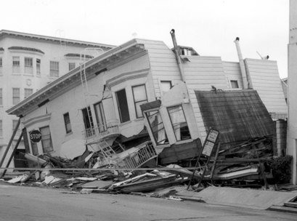
- Why do you think the house fell down?

- What do you think a builder could do to make a house less likely to fall down in an earthquake?

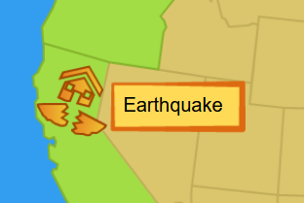
Gizmo Warm-up
An earthquake is a type of natural disaster. A natural disaster is a sudden event that can destroy homes and hurt people. With the Disaster-Proof Homes Gizmo, you can try to build a house that won’t fall down in an earthquake.

- Select Earthquake. What is a fault?

- Select Next. Watch what happens in San Francisco.

- What is an earthquake?

- Why do you think many earthquakes happen in San Francisco?

Activity A:  Earthquake damage | Get the Gizmo ready:  - If necessary, select Earthquake on the map.  - Click Next until you get to the Location choice. | 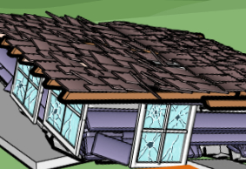

Introduction: San Francisco is a city in California that has many earthquakes. In 1906, a large earthquake started a fire that destroyed much of the city. Another large earthquake hit the city in 1989. This earthquake damaged bridges, highways, and houses.

Question: How do earthquakes damage a house?

- Predict. Check that you are on the Location screen. Select Location 1 – Bedrock. Your first house will be built on bedrock, or layers of solid rock below the soil. From the Saved houses area, drag house A into the building site. House A is a basic house.

What do you think will happen to house A in an earthquake?

- Test: Click Test house and then click Play (). After the earthquake, what damage can you see?

- Describe: Select Show house interior to see the inside of the house. What damage do you see inside the house?

- Assess: Select Show damage report. Don’t worry about the different components now. The Score describes how well the house stood up in an earthquake by comparing the cost of repairs to the cost of the house. (100% is great, 0% is bad.) How did the house do?

Cost of repairs: House cost: Score:

- Infer: Do you think this house would do a good job of protecting the people inside?

Explain.

Activity B:  Earthquake-proof house | Get the Gizmo ready:  - If necessary, select Earthquake on the map.  - Navigate to the Build screen. | 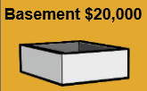

Goal: Design a house to survive an earthquake.

- Predict: From the Build screen, click Reset house. Now it’s your turn! Your challenge is to build a house that can get through an earthquake with the least amount of damage.

What materials do you think you might find in an earthquake-proof house?

- Build: To start your house, select a Foundation. The foundation is the base of the house. Then select options for the frame, walls, roof type, and roof material. If you want, you can add “extras” to the house after choosing the roof.

List the features of your house below. What is the cost of the house?

Foundation |  | Roof material
Frame |  | Extras
Walls

- Test: Click Test house and then click Play.

- How does the outside of the house look?

- Select Show house interior. How does the inside of the house look?

- Select Show damage report. What was the score of your house?

- Experiment: Select Build. Try to build a house with a score above 80%. When you succeed, select Save house. Which features did you choose?

Foundation |  | Roof material
Frame |  | Extras
Walls

What is the cost of the house? What is the score?

(Activity B continued on next page)
Activity B (continued from previous page)

- Compare: Select Build and then click the right arrow until you see the Extras. Experiment by building a house with each of the extra components. Explain how each “extra” feature of the house helps in an earthquake.

Foundation clips:

Shatterproof glass:

Reinforced door:

Of these three components, which do you think is most important?

Explain:

- Experiment: Select Build and drag house A into the building site. Add foundation clips to the house. House A has a wooden frame. Test this house, then test the concrete and steel frames. Turn on Show damage report and record the score of each house.

Wood frame: Concrete frame: Steel frame:

- Experiment: Test the four types of walls. Then test the three types of roof materials.

Which wall was the worst? Which roof was the worst?

- Draw conclusions: Compare the material that was the worst for the frame, the material that was the worst for walls, and the material that was worst for the roof.

What do these materials have in common?

Flexible materials like wood and steel are better in earthquakes than materials that don’t bend. Concrete, brick, and tile are likely to crack and crumble when shaken.

- Explore: Build a house with a springs foundation and foundation clips. This foundation is also called a base isolation foundation. What do you notice when you test this house?

In a base isolation foundation, the bottom part of the foundation shakes with the ground, but the top part does not move as much. Base isolation foundations are expensive and mainly used for large buildings. Only Japan has many homes with base isolation foundations.
Activity C:  Landfill | Get the Gizmo ready:  - If necessary, select Earthquake on the map.  - Click Next until you get to the Location choice. | 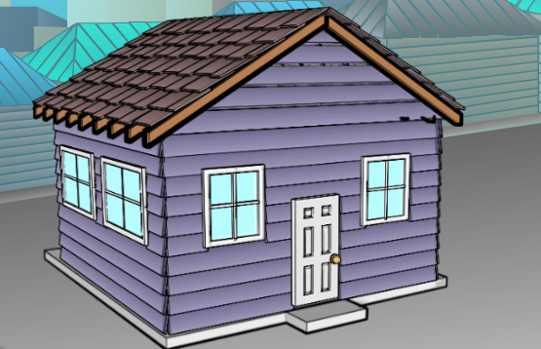

Introduction: Some parts of San Francisco used to be marshes, or wetlands. These areas were filled in with soil to form dry land. This type of ground is called landfill. Houses and even tall buildings are built on landfill in San Francisco.

Question: How does the location affect how much earthquake damage occurs?

- Predict: Which location do you think will be better for building an earthquake-proof house, bedrock or landfill?

- Observe: Select Location 2 – Landfill. Build a house that you think will do well in an earthquake. Select Test house and click Play. Observe the outside and inside of the house.

What happens?

In some landfill areas, the shaking of an earthquake can cause solid ground to liquify, or act like a liquid. When this happens, houses can sink into the ground and break apart.

- Compare: Turn on Show damage report. Record the Cost of repairs and Score for the house in the landfill location. Then select Location, go to Location 1, and test the same house in the bedrock location. Record the Cost of repairs and Score for this location.

Landfill house |  | Bedrock house
Cost of repairs |  | Cost of repairs
Score |  | Score

- Analyze: Which location is better in an earthquake?

Explain your choice.
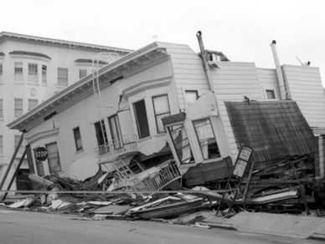

- Apply: Remember the collapsed house from the beginning of this lesson? What kind of ground do you think this house was built on? Explain.

