Vocabulary: Earthquake-Proof Homes

Vocabulary
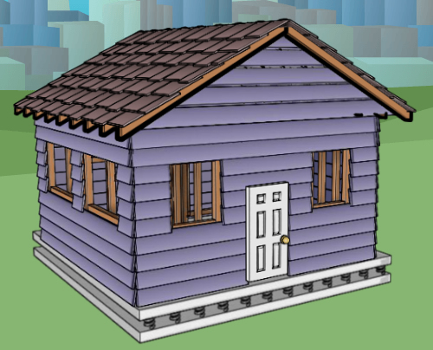

House with a base isolation foundation
- Base isolation – a type of foundation designed to keep a building from shaking in an earthquake.
  - A base isolation foundation has three parts.
    - The bottom layer shakes with the ground.
    - The top layer and building do not shake.
    - The two layers are connected by rubber pads, springs, or sliders that allow the top and bottom layers to move separately.

- Bedrock – solid rock underneath soil.

- Earthquake – a sudden shaking of the ground.
- Large earthquakes can damage buildings, roads, and bridges.

- Fault – a crack between two sections of bedrock.
  - Earthquakes happen when the bedrock on either side of a fault moves.

- Foundation – the base of a building.

- Foundation clips – metal brackets that attach the house to the foundation.

- Frame – the “skeleton” that supports a house.

- Landfill – a wetland that people fill with soil to make dry land.
- Many parts of San Francisco are built on landfill.

- Liquify – act like a liquid.
- During an earthquake, landfill areas may liquify. Houses in these areas may fall down or sink into the ground.

- Natural disaster – a natural event that causes major destruction or death.
  - Examples of natural disasters include earthquakes, floods, hurricanes, and fires.
  - Natural disasters are not caused by people.

- Reinforced door – a door that is made stronger by using materials like steel.

- Shatterproof glass – glass that is made more flexible by adding layers of plastic.

- Wetland – an area where shallow water covers the ground, such as a swamp or marsh.

