Name: ______________________________________ Date: ________________________

Student Exploration: Earthquakes 2 – Determination of Epicenter

[NOTE TO TEACHERS AND STUDENTS: This exercise assumes that you have a data table and graph made while using the Earthquakes 1 – Recording Center Gizmo. If you do not have those, or have never used that Gizmo before, do that first.]

Vocabulary: body wave, earthquake, epicenter, fault, focus, P wave, S wave, seismic wave, seismogram, seismograph

Prior Knowledge Questions (Do these BEFORE using the Gizmo.)
Three dogs meet in a park. Each dog is attached by a leash to its owner (triangles).

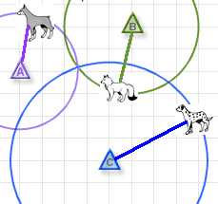
- What does each colored circle represent? ________________

__________________________________________________

- Where could all the dogs meet in one place? Draw this point on the diagram.

- Is there another spot where all three dogs could meet? ______

Explain: ___________________________________________

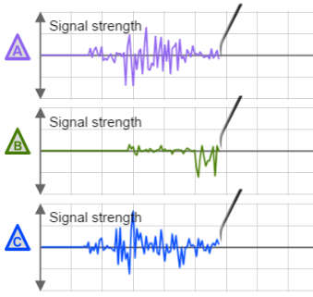
Gizmo Warm-up
When you used the Earthquakes 1 – Recording Station Gizmo, you learned how to find the distance from a recording station to the epicenter. With the Earthquakes 2 – Determination of Epicenter Gizmo, you will use data from three recording stations to find the exact location of the epicenter.

Click Play (), and then click Pause () when the seismograms are complete. Compare the three seismograms.

- Which recording station is closest to the epicenter? ______

How do you know? _________________________________________________________

- Which recording station is farthest from the epicenter? ______

How do you know? _________________________________________________________

Activity:  Locating the epicenter | Get the Gizmo ready:  - Click Reset ().  - Click Play, and then click Pause when the seismograms are complete. | 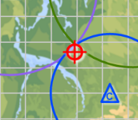

Goal: Based on three seismograms, locate the epicenter of an earthquake.

- Prepare: To complete this activity, you will need the table and graph you made in the Earthquakes 1 – Recording Station Student Exploration. Take this out now.

- Measure: Turn on Show time probe. On each seismogram, locate the first P-wave and the first S-wave. Measure the time interval (∆t) for each seismogram, and then use your graph to find the distance of each station to the epicenter.

Station | Time interval (∆t) | Distance to epicenter (km)
A
B
C

- Locate: Turn on the Show station A checkbox. Set the Radius to the distance of station A from the epicenter, based on your table above. Look on the circle on the map.

Where could the epicenter be located? __________________________________________

- Locate: Turn on the Show station B checkbox. Set the Radius to the distance of station B from the epicenter. Look on the two circles on the map.

Which two places could the epicenter be located now? _____________________________

_________________________________________________________________________

- Locate: Turn on the Show station C checkbox. Set the Radius to the distance of station C from the epicenter. If you did everything right, you should see the epicenter symbol (). If you do not, recheck all of your distances. (You may need to adjust each radius slightly.)

Relative to the three circles, where is the epicenter located? _________________________

_________________________________________________________________________

- Practice: Click Reset. Try to locate at least five more epicenters. Each time you locate an epicenter, click the Tools palette and click Screen shot. Right-click the image, choose “Copy Image,” and paste the image into a blank document to turn in with this sheet.

