Vocabulary: Elapsed Time

Vocabulary

- 24-hour clock – a system of keeping time that divides the day into one 24-hour period rather than two 12-hour intervals.
  - The 24-hour clock is also known as “military time.”
  - To convert to the 24-hour clock, add 12 hours to all PM times starting at 1:00 PM.
    - For example, on the 24-hour clock, 4:30 PM is called 16:30.
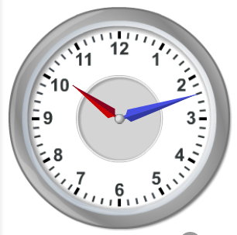
Analog clock
- Analog clock – a clock that uses angles to indicate time.
  - Most analog clocks have “hands” that move around a round clock face to show the current hour and minute. Many also have a third hand for seconds.
  - Standard wall clocks, such as the ones shown in the Elapsed Time Gizmo™, are analog clocks. Digital clocks are not analog.

- Elapsed time – the time that passes between two events.
  - For example, the elapsed time between 1:30 PM and 5:30 PM is 4 hours.

