Vocabulary: Electromagnetic Induction

Vocabulary

- Current – the flow of electrical charge.
  - In a metal wire, current is the flow of negatively charged particles (electrons).
  - In many applications, “conventional current” is shown as the theoretical flow of positive charge in a wire.
  - Current is measured in amperes (A).
  - In equations, the symbol for current is I.

- Electric field – a region in space that surrounds charged object.
  - Charged objects and moving magnets within the electric field experience a force.
  - Vectors in the electric field represent the direction and magnitude of the electromagnetic force on a positively charged particle.

- Electromagnetic induction – the process of creating a current in a circuit by a changing magnetic field.

- Magnetic field – a region in space that surrounds a magnet or moving charged particle.
  - Magnets and moving charges within the magnetic field experience a force.
  - Magnetic field lines show the direction magnetic objects such as iron filings or compass needles will align to.
  - Magnetic forces are greatest where the magnetic field lines are closest together.

- Magnetic flux – a measure of the strength of the magnetic field through a given area.
  - Informally, the magnetic flux is proportional to the number of magnetic field lines that cross a given area.
  - The symbol for magnetic flux is “Φ_{M}.”
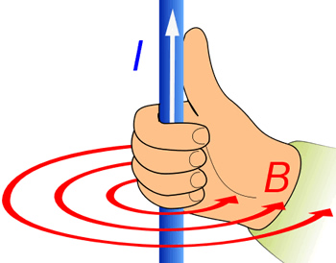

Right-hand rule

- Right-hand rule – a way to visualize the magnetic field produced by an electric current.
  - The thumb points in the direction of conventional (positive) current, while the fingers show the direction of the magnetic field.
  - The electric field produced by a moving magnet can be visualized with a “left-hand rule” in which the thumb of the left hand points in the direction the north pole of a magnet is moving and the fingers represent the electric field.

- Vector – a quantity that has both magnitude and direction.
  - Vectors are represented graphically as arrows.
    - The magnitude of the vector is shown by the length of the arrow.
    - The direction of the vector is shown by the direction of the arrow.
  - Vector quantities include displacement, velocity, acceleration, and force.
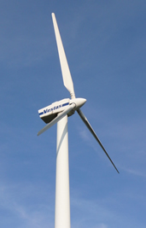

Wind generator

- Voltage – a measure of the electrostatic potential energy in a circuit.
  - Just as pressure causes water to flow through a pipe, voltage can be thought of as “electrical pressure” that causes electrical charge to flow through a circuit.
  - Voltage is measured in volts (V).
  - In equations, the symbol for voltage is V.

- Wind generator – a device that converts wind energy to electricity.
  - Most wind generators consist of a turbine, or propeller, that is connected to an electrical generator.

