Name: ______________________________________ Date: ________________________

Student Exploration: Element Builder

Vocabulary: atom, atomic number, electron, electron dot diagram, element, energy level, ion, isotope, mass number, neutron, nucleus, periodic table, proton, radioactive, valence electrons

Prior Knowledge Questions (Do these BEFORE using the Gizmo.)

- What are some of the different substances that make up a pizza? _____________________

_________________________________________________________________________

- What substances make up water? _____________________________________________

- What substances make up an iron pot? _________________________________________

Elements are pure substances that are made up of one kind of atom. Pizza is not an element because it is a mixture of many substances. Water is a pure substance, but it contains two kinds of atom: oxygen and hydrogen. Iron is an element because it is composed of one kind of atom.

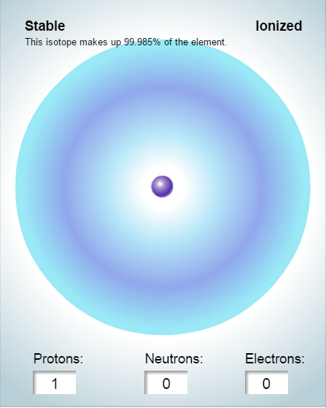

Gizmo Warm-up
Atoms are tiny particles of matter that are made up of three particles: protons, neutrons, and electrons. The Element Builder Gizmo shows an atom with a single proton. The proton is located in the center of the atom, called the nucleus.

- Use the arrow buttons () to add protons, neutrons, and electrons to the atom. Press Play ().

  - Which particles are located in the nucleus?

_________________________________

  - Which particles orbit around the nucleus?

__________________________________

- Turn on Show element name. What causes the element name to change? _____________ _________________________________________________________________________
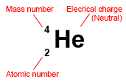

Activity A:  Subatomic particles | Get the Gizmo ready:  - Use the arrows to create an atom with two protons, two neutrons, and two electrons.  - Turn on Show element name. | 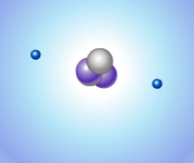

Question: What are the properties of protons, neutrons, and electrons?

- Observe: Turn on Show element symbol and Element notation. Three numbers surround the element symbol: the mass number (A), electrical charge (no number is displayed if the atom is neutral), and the atomic number (Z).

- Investigate: Watch how the numbers change as you add or remove particles.

    - Which number is equal to the number of protons in the atom? __________________

    - How can you calculate the number of neutrons (N) in an atom? _________________

___________________________________________________________________

    - Which particle (proton, neutron, or electron) has a positive charge? ______________

Negative charge? ______________ No charge at all? ______________

- Analyze: An isotope is an alternative form of an element. Each isotope of an element has the same number of protons, but a different number of neutrons. The isotope is represented by the atomic symbol and mass number, such as He-4. Some isotopes are stable, while others are radioactive, which means the atoms decay over time and emit radiation.

    - What are the stable isotopes of carbon? ___________________________________

    - What are the stable isotopes of nitrogen? __________________________________

    - List two radioactive isotopes of oxygen: ___________________________________

- Practice: Use the Gizmo to answer the following questions.

    - How many electrons are in a neutral atom of lithium? ______

    - How many neutrons are in an atom of Mg-25? ______

    - What is the mass number of an atom with 5 protons and 7 neutrons? ______

    - When at atom is charged, it is called an ion. How many electrons are in O²⁻? ______

    - How many electrons are in Mg²⁺? ______

Activity B:  Electron arrangements | Get the Gizmo ready:  - Create a neutral hydrogen atom (1 proton, 0 neutrons, 1 electron).

Question: How are electrons arranged around the nucleus of an atom?

- Observe: Add electrons to the atom until you have used all the available electrons. How are the electrons arranged? ______________________________________________________
_________________________________________________________________________

- Analyze: Electrons are arranged in orbits called energy levels. The Gizmo shows all of the first two energy levels but only part of the third energy level.

- How many electrons can fit in the first energy level? ___________

- How many electrons can fit in the second energy level? ___________

- How many electrons fit in the part of the third energy level shown? ___________

- Observe: Click Reset (). The electrons in the outermost orbit, called valence electrons, help to create chemical bonds. Create a lithium atom (3 protons, 4 neutrons, 3 electrons).

How many valence electrons are in a neutral lithium atom? ___________

- Diagram: Turn on Show electron dot diagram. The valence electrons of an atom are shown in an electron dot diagram. Each dot represents a valence electron.

Draw the electron dot diagram for neutral lithium: ___________

- Practice: Turn off Show electron dot diagram. Use the Gizmo to create a neutral atom of each of the following elements. Draw an electron dot diagram for each. When you are finished, turn on Show electron dot diagram and check your answers.

H He Li Be B C N

O F Ne Na Mg Al Si

- Extend your thinking: Many chemical properties are determined by the number of valence electrons. Elements with the same number of valence electrons will have similar properties.

Which element has similar properties to lithium? _________ Beryllium? _________

Explain: __________________________________________________________________

Extension:  The periodic table | Get the Gizmo ready:  - Create a neutral hydrogen atom.  - If you have access to a periodic table, open it now. (Not required.) | 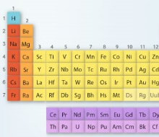

Question: The 117 or so known elements are arranged in the periodic table. Why does the periodic table have the shape it has?

- Form a hypothesis: Look at the first three rows of the periodic table below.

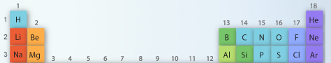

Why do you think the elements are arranged the way that they are? ___________________

_________________________________________________________________________

- Draw diagrams: Create an electron dot diagram for each of the elements below. Use the Gizmo to help you do this. To check your work, turn on Show electron dot diagram.

H He

Li Be B C N O F Ne

Na Mg Al Si P S Cl Ar

- Analyze: What do the elements in each column of the periodic table have in common?

_________________________________________________________________________

_________________________________________________________________________

- Draw conclusions: How is the periodic table organized? ____________________________

_________________________________________________________________________

_________________________________________________________________________

_________________________________________________________________________

