Name: Date:

**Student Exploration:** **Ellipses**

**Vocabulary:** conic section, ellipse, foci of an ellipse (focus points), major axis, minor axis, Pythagorean Theorem, standard form of the equation of an ellipse, vertices of an ellipse

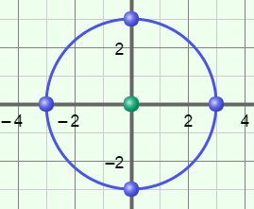**Prior Knowledge Questions** (Do these BEFORE using the Gizmo.)

1. The figure shown to the right is a circle with center at (0, 0). What is the relationship between the points on the circle and its center?

1. 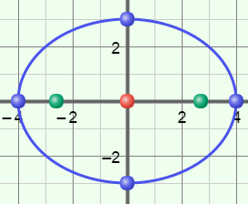The “stretched” circle shown to the right is called an **ellipse**. What is the relationship between the points on the ellipse and its center (0, 0)?

**Gizmo Warm-up**

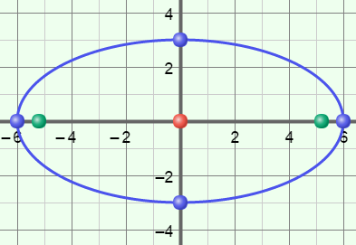Circles and ellipses are **conic sections**, shapes formed when a plane intersects a cone. In the *Ellipses* Gizmo, you can explore ellipses in the coordinate plane and their equations in standard form.

You can vary the values of ***a***, ***b***, ***h***, and ***k*** in the ellipse equation by dragging the sliders. (To quickly set a slider to a value, type the value in the text box to the right of the slider, and hit **Enter**.)

1. In the Gizmo, graph  +  = 1 by setting ***a*** to 4, ***b*** to 4, ***h*** to 0, and ***k*** to 0.
2. What is the shape of the graph?
3. Slowly increase the value of ***a*** with the slider. How does the shape change?

1. Vary ***a*** and ***b***. How does the ellipse look when the larger denominator is:
   1. Under *x*2?
   2. Under *y*2?

|  |  |  |
| --- | --- | --- |
| **Activity A:**  **Ellipses centered at the origin** | Get the Gizmo ready:   * Be sure the **CONTROLS** tab is selected. * Set ***a***to 6, ***b*** to 4, ***h***to 0, and ***k***to 0. | 132SE4 |

1. An ellipse is defined by two fixed points called the **foci of the ellipse**, or focus points. In the Gizmo, the foci are the green points on the graph. Vary the top slider, currently called ***a***. Where are the foci located when the larger denominator is:
2. Under *x*2?
3. Under *y*2?
4. Reset ***a*** to 6. Click on **Explore geometric definition**. The values of *L*1 and *L*2 represent the distance from each of the foci to any (*x*, y) point on the ellipse.
5. Drag the purple point around the ellipse. What is true about the value of *L*1 + *L*2?

1. Vary the value of ***a*** and drag the purple point again. Is this always true?
2. Consider the diagram of the ellipse, to the right. The line segment passing through the foci, with endpoints on the ellipse, is called the **major axis**. The two endpoints are called the **major vertices**. This ellipse has a horizontal major axis.

**(–*a*, 0)**

**(*a*, 0)**

**(*c*, 0)**

**(–*c*, 0)**

***a***

***c***

***c***

1. What are the coordinates of the major vertices?

and

1. The distance from the center of an ellipse to each focus point is usually called *c*. So, in this ellipse, with a center at (0, 0), the foci are the points at (–*c*, 0) and (*c*, 0). What is the distance from each focus point to the major vertex at (*a*, 0)?

Distance from (*c*, 0) to (*a*, 0) = Distance from (–*c*, 0) to (*a*, 0) =

1. What is the sum of the distances you just found, from the two foci to (*a*, 0)?
2. Based on what you found above, fill in the blanks below to write the definition of an ellipse.

Definition: An ellipse is the set of all (*x*, *y*) points for which the sum of the distances from the foci to (*x*, *y*) is and equal to .

**(Activity A continued on next page)**

**Activity A (continued from previous page)**

1. The **standard form of the equation of an ellipse**, if it has its center at the origin, is written  +  = 1. (This is often written  +  = 1 if the major axis is vertical, so *a* > *b*.)
2. Set ***a*** to 5 and ***b*** to 4. What is the equation of this ellipse?
3. The line segment through the center of the ellipse, perpendicular to the major axis, with endpoints on the ellipse, is called the **minor axis**. The endpoints are called the **minor vertices** of the ellipse.

What are the coordinates of the minor vertices? and

1. 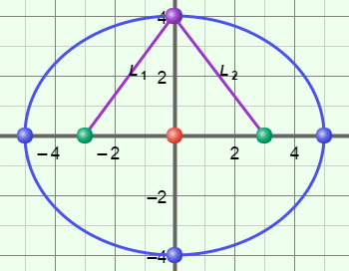Drag the purple point to (0, 4). What is the relationship

between the two right triangles you have created?

1. Based on this, explain why *L*1 = *L*2.

1. In general (using letters), what is the distance from a focus point to a minor vertex of an ellipse? Select **Show Pythagorean relationship** to check.
2. 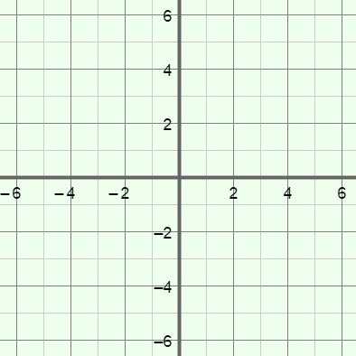Sketch the ellipse given by the equation  +  = 1. Label the major and minor vertices with their coordinates.
3. To the right, find *c*, the distance from the center to each focus, using the Pythagorean relationship of *a*, *b*, and *c*.
4. Plot and label the foci with their coordinates. Then check your ellipse by graphing it in the Gizmo.
5. 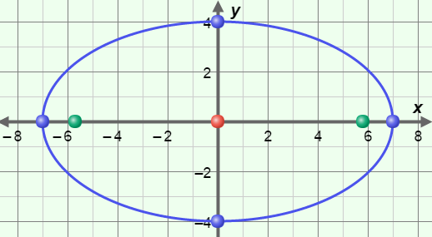Consider the ellipse shown to the right. Write the equation of this ellipse in the space below.

Check your answer by graphing it in the Gizmo.

|  |  |  |
| --- | --- | --- |
| **Activity B:**  **Translating an ellipse** | Get the Gizmo ready:   * Be sure the **CONTROLS** tab is selected. * Set ***a***to 6, ***b*** to 4, ***h***to 2, and ***k***to 3. | 132SE8 |

1. With the values above, you have graphed the ellipse given by  +  = 1.
   1. Mouseover the center of the ellipse. What are its coordinates?
   2. How do these coordinates relate to the values of *h* and *k*?

Try other values of *h* and *k* to confirm this is always true.

1. 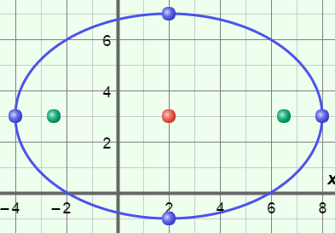Reset ***h*** to 2 and ***k*** to 3 to graph  +  = 1 again. This graph is shown below.
2. Find the distance between each major vertex and the center at (2, 3).
3. Find the distance between each minor vertex and the center at (2, 3).
4. Where do you find those values in the equation of the ellipse?

Try other values of *a* and *b* to see if this is always true.

1. 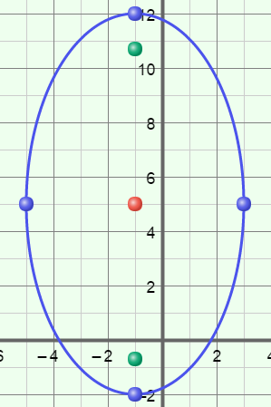Consider the ellipse graphed to the right.
2. In the space to the right, write the equation of this ellipse, in standard form.
3. Explain your answer.

Check your answer by graphing it in the Gizmo.

**(Activity B continued on next page)**

**Activity B (continued from previous page)**

1. Graph the ellipse defined by the equation  +  = 1.
2. 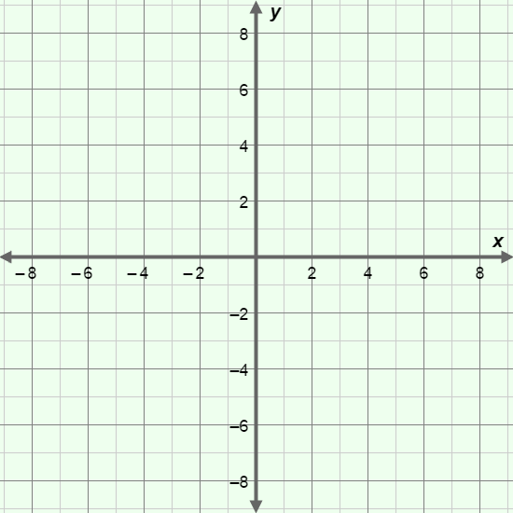Label the center and the major and minor vertices with their coordinates.
3. In the space below, use the Pythagorean relationship to determine the value of *c*.
4. Using the value of *c*, find and label the coordinates of the foci on the graph. Check your work in the Gizmo.
5. Consider an ellipse with a vertical major axis measuring 16 units and a horizontal minor axis measuring 9 units with the center located in the third quadrant.
6. 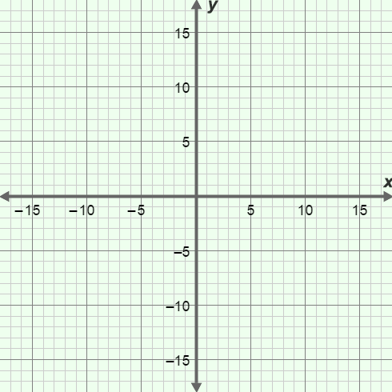In the space to the right, write an equation for such an ellipse.
7. Explain your answer.

1. Sketch this graph on the grid to the right. Check your graph in the Gizmo.
2. Consider the values *a* = 13, *b* = 7, and *c* = 12.
3. Explain why an ellipse does not exist with these *a*, *b*, and *c* values.

1. Find a value for *b* so the ellipse will exist.
2. In the space to the right, write an equation for an ellipse with these new values, with center at (–2, –1) and a horizontal major axis.