Name: ______________________________________ Date: ________________________

Student Exploration: Energy Conversions

Vocabulary: chemical energy, electrical current, energy, fossil fuel, global warming, gravitational potential energy, hydroelectricity, kinetic energy, light, nonrenewable resource, nuclear energy, renewable resource, sound, thermal energy

Prior Knowledge Questions (Do these BEFORE using the Gizmo.)

- What are sources of electricity? List as many as you can. ___________________________
_________________________________________________________________________
_________________________________________________________________________

- Where do people and other animals get energy to move around? _____________________
_________________________________________________________________________

- Where do plants get energy to live and grow? ____________________________________
_________________________________________________________________________

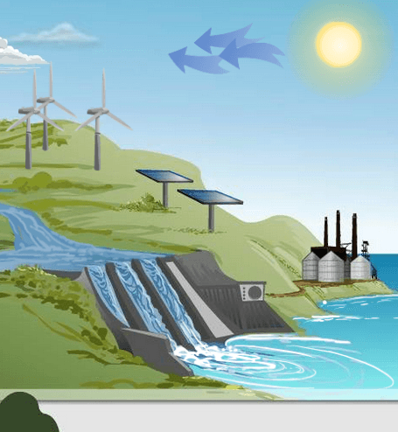
Gizmo Warm-up
In the Energy Conversions Gizmo, be sure Information mode is selected. Click on each of the different items in the scene and read about each one.

- Which object converts sunlight into sugars?

__________________________________________

- Which object converts wind power to electricity?

__________________________________________

- Which object converts light to electricity? ________________________________________

- Which object converts electricity to light? ________________________________________

Activity A:  Energy Paths | Get the Gizmo ready:  - Select the Path mode. | 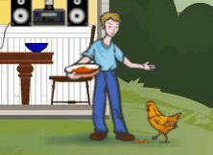

Question: Where do we get energy to run, climb, play, and do all the other things we do?

- Form hypothesis: Where do you think we humans get energy? _______________________

_________________________________________________________________________

- Create a path: You will now form an energy path to see where our energy comes from.

    - Click on the person and read. Where do people get energy? __________________

    - Now click on the chicken. Where does the chicken get energy? ________________

    - Click on the corn. Where does the corn get energy? _________________________

    - Click on the Sun. How does the Sun get energy? ____________________________

___________________________________________________________________

    - Fill in the energy path below starting with the Sun.

______________ → ______________ → ______________ → ______________

- Apply: Click Reset and then click on the toaster. Using the Gizmo, create four energy paths to explain how the toaster could get its energy. (One path will only have three objects.)

    - ______________ → ______________ → ______________ → ______________

    - ______________ → ______________ → ______________ → ______________

    - ______________ → ______________ → ______________ → ______________

    - ______________ → ______________ → ______________ → ______________

- Analyze: Where does each path begin? _________________________________________

- Draw conclusions: What would life on Earth be like without the Sun? __________________

_________________________________________________________________________

_________________________________________________________________________

Activity B:  Energy Conversions | Get the Gizmo ready:  - Click Reset.  - Check that Path mode is still selected. | 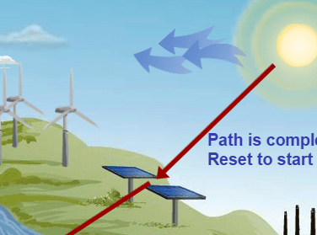

Question: How is energy changed from one form to another?

- Classify: Energy is the ability to exert force and cause change. Energy has many forms:
- Kinetic energy is energy of motion. All moving things have kinetic energy.
  - Sound is energy of vibrating materials or air molecules.
  - Thermal energy is the energy of tiny moving particles. As an object heats up, particles move faster and thermal energy increases.
- Gravitational potential energy is stored energy that exists based on the position of an object. The higher an object is, the greater its gravitational potential energy.
- Electrical current is energy that comes from moving charged particles.
- Light is electromagnetic waves that are visible to the eye.
- Chemical energy is energy that is stored in the bonds holding atoms together.
- Nuclear energy is energy released when atoms split apart or join together.

- Create path: Create an energy path in the Gizmo, starting at the Sun. For each step of the path, describe the energy conversion that takes place. The first one is done for you. Discuss your answers with your classmates and teacher.

Energy Path | Energy conversion
____Sun_____  ____________  ____________  ____________ | Nuclear energy is converted to light and thermal energy.

- On your own: Create at least two more paths on the Gizmo. List the energy conversions that happen along each path. Record your work on separate paper or in your notebook.

- Apply: Where in the Gizmo (and in real life) do the following energy conversions occur?

Chemical to thermal to electrical current: ________________________________________

Gravitational potential to kinetic to electrical current: _______________________________
Extension:  Renewable Energy | Get the Gizmo ready:  - Click Reset.  - Select the Information mode. | 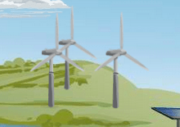

Introduction: Over 80% of our energy comes from the burning of fossil fuels such as oil, gas, and coal. Fossil fuels are fairly cheap and plentiful, but there are several problems:
- Fossil fuels are nonrenewable resources. That means there is a limited supply. Once the world runs out, there is no way to get more.
- Burning fossil fuels adds carbon dioxide to the air. Most scientists agree that this causes the gradual warming of Earth’s climate, or global warming.

Question: What types of energy do not harm our environment?

- Describe: Four examples of renewable resources are featured in the Energy Conversions Gizmo. These resources are produced all the time, so they will not run out. Read about each energy source, and then explain how each is produced in your own words.

  - Wind power: _________________________________________________________

___________________________________________________________________

___________________________________________________________________

  - Water power (also called hydroelectricity): ________________________________

___________________________________________________________________

___________________________________________________________________

  - Solar power: _________________________________________________________

___________________________________________________________________

___________________________________________________________________

  - Ethanol: ____________________________________________________________

___________________________________________________________________

___________________________________________________________________

- On your own: Learn more about one of these renewable resources using the internet or by reading library books. Explain its advantages and disadvantages to your teacher and class.

