Name: ______________________________________ Date: ________________________

Student Exploration: Energy of a Pendulum

Vocabulary: conservation of energy, gravitational potential energy, kinetic energy, pendulum, potential energy, velocity

Prior Knowledge Questions (Do these BEFORE using the Gizmo.)

- A toy car is about to roll down a track, as shown below. At what point do you think the car will reach its greatest speed?

Mark this point on the image.

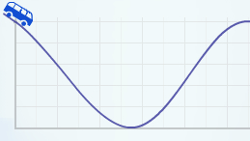

- A pendulum consists of a weight that is suspended from a pivot. At what point will the pendulum below move fastest?

Mark this point on the image.

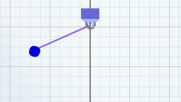

- What do these two situations have in common? ___________________________________

_________________________________________________________________________

Gizmo Warm-up
Objects have several types of energy. Potential energy depends on an object’s position or shape. Kinetic energy is the energy of movement. The Energy of a Pendulum Gizmo allows you to explore how the amounts of these types of energy change for a pendulum in motion.
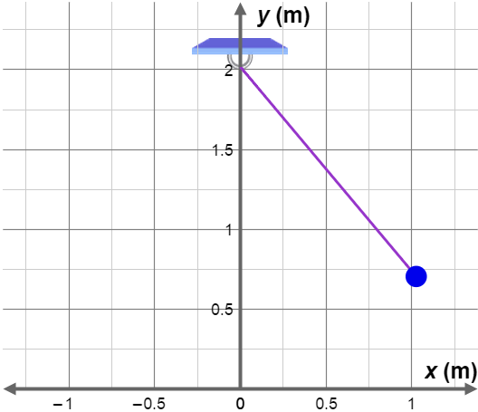
- On the DESCRIPTION pane, change the initial angle (θ) to 40 degrees. Click Play (). How does the velocity (speed and direction) of the pendulum change as it swings from right to left?

______________________________________

______________________________________

- On the image at right, mark the point where the pendulum swings fastest with an X. Then, circle the two points where the velocity is zero.

Activity A:  Potential and kinetic energy | Get the Gizmo ready:  - Click Reset ().  - Check that m is 0.5 kg, L is 2.0 m, g is 9.8 m/s², and θ is 40 degrees. | 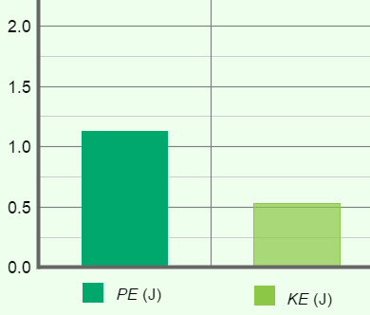

Introduction: An object that is a certain height (h) above the ground has the potential to do work, and therefore has potential energy. This type of potential energy is called gravitational potential energy (GPE, or PE for short). The unit of energy is the joule (J).

Question: How are potential and kinetic energy related?

- Observe: Select the BAR CHART tab. Click Play and observe. What do you notice about the gravitational potential energy (PE), kinetic energy (KE), and total energy (TE)?

_________________________________________________________________________

_________________________________________________________________________

_________________________________________________________________________

- Measure: Click Reset. Turn on Show numerical values.

- What is the gravitational potential energy? ____________________

- What is the kinetic energy? ____________________

- What is the total energy? ____________________

- Measure: Click Play, and then try to click Pause () when the pendulum is in the middle of its swing. (This might require several tries.)

- What is the gravitational potential energy now? ____________________

- What is the kinetic energy now? ____________________

- What is the total energy? ____________________

- Analyze: At any given time, what can you say about the total energy of the pendulum?

_________________________________________________________________________

_________________________________________________________________________

This illustrates the principle of conservation of energy. In a closed system, energy can be converted from one form to another, but the total amount of energy remains the same.

(Activity A continued on next page)
Activity A (continued from previous page)

- Interpret: Click Reset. Select the GRAPH tab and turn on the PE and KE checkboxes. Click Play, wait about 4 seconds, and then click Pause.

What is the relationship between potential and kinetic energy? _______________________

_________________________________________________________________________

- Match: The graph below shows the potential and kinetic energy curves for a pendulum. Label each pendulum image with the corresponding letter on the graph (A, B, or C).

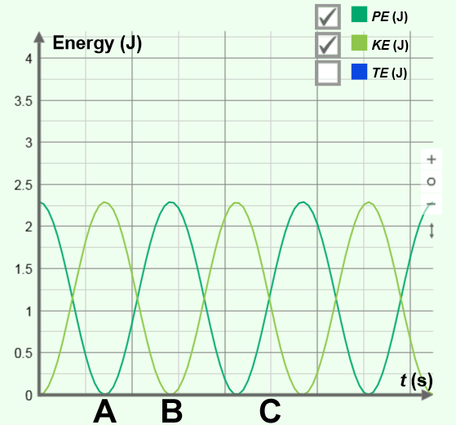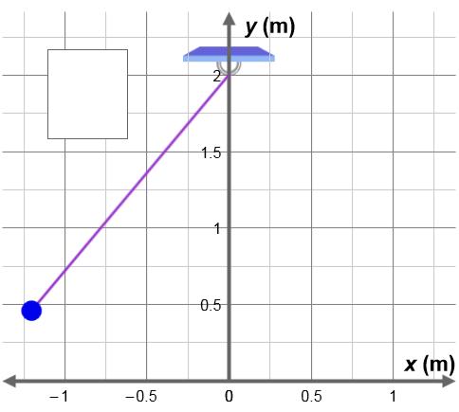

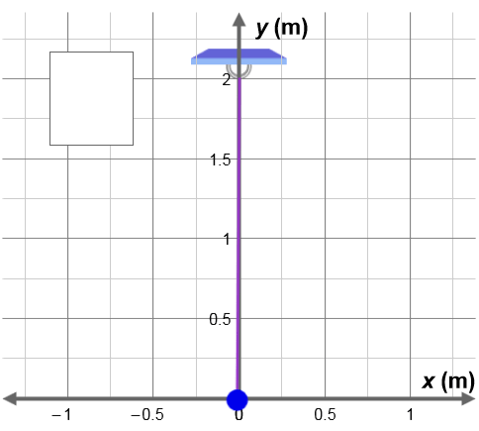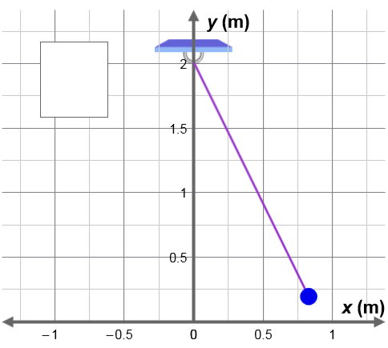

- Apply: Suppose a pendulum starts with a potential energy of 100 J. Assuming the pendulum has a height of 0 m at the bottom of its swing, what is its maximum kinetic energy? Explain.

_________________________________________________________________________

_________________________________________________________________________

_________________________________________________________________________

Activity B:  Calculating potential energy | Get the Gizmo ready:  - Click Reset.  - Set m to 1.0 kg, L to 1.0 m, and g to 1.0 m/s². (Note: You can set the slider values directly by entering values into the text boxes.)  - Set θ to 0 degrees. | 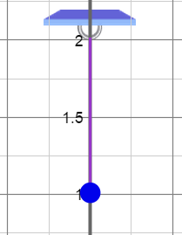

Question: How is gravitational potential energy calculated?

- Observe: Select the BAR CHART tab, and check that Show numerical values is on.

What is the potential energy of the pendulum? ____________________________________

- Gather data: Record the potential energy of the pendulum for each of the following sets of values for m, L, and g. Record the height (h) of the pendulum as well. (Because the pendulum’s pivot is 2 m above the ground, the height is equal to 2 meters – L meters.)

m (kg) | L (m) | h (m) | g (m/s²) | PE (J)
0.5 kg | 1.0 m |  | 6.0 m/s²
1.0 kg | 1.2 m |  | 2.0 m/s²
0.3 kg | 1.1 m |  | 1.0 m/s²
0.2 kg | 1.5 m |  | 3.0 m/s²

- Find a pattern: What is the relationship between the potential energy of a pendulum and the values for mass (m), height (h), and gravitational acceleration (g)?

_________________________________________________________________________

_________________________________________________________________________

- Make a rule: Write an expression for potential energy based on m, h, and g. Test your expression using the Gizmo.

PE =

- Apply: What is the potential energy of a pendulum with a mass of 0.7 kg, a height of 0.3 m, and a value of g equal to 9.8 m/s²?

_________________________________________________________________________

Check your answer using the Gizmo. (Hint: Set the length of the pendulum to 1.7 m.)

Activity C:  Kinetic energy and velocity | Get the Gizmo ready:  - Select the DESCRIPTION tab.  - Set m to 1.0 kg, L to 1.3 m, g to 1.0 m/s², and θ to –40 degrees. | 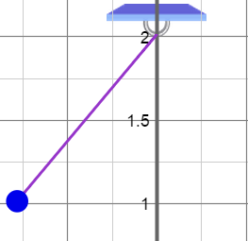

Question: How is potential energy converted to kinetic energy?

- Observe: Select the BAR CHART tab, and check that Show numerical values is on.

- What is the height of the pendulum? ____________________

- What is the potential energy of the pendulum? ____________________

- What is the kinetic energy of the pendulum? ____________________

- Observe: Click Play, and then click Pause when the pendulum is at the bottom of its swing.

- What is the approximate height of the pendulum now? ____________________

- What is the potential energy of the pendulum? ____________________

- What is the kinetic energy of the pendulum? ____________________

- Calculate: The formula for kinetic energy is as follows:

Based on this formula, what is the velocity (v) of the pendulum at the bottom of its swing? Show your work.

Velocity = ______________

- Apply: Click Reset. Set m to 1.0 kg, L to 2.0 m, g to 9.8 m/s², and θ to –40 degrees. What is the maximum velocity of this pendulum? Show your work. (Hint: The exact height of the pendulum is now 0.468 m.)

Velocity = ______________

