Vocabulary: Erosion Rates

Vocabulary

- Climate – the general pattern of weather in a region over an extended period of time.
  - Climate is the average weather over a long period, typically 30 years or more.
  - Climate includes factors such as temperature, precipitation, humidity, wind, snowfall, and cloud cover.

- Erosion – a surface process in which soil, rocks, and other materials are removed and transported to another place.
  - Erosion can be caused by gravity water, ice, or wind.
Sandstone

- Precipitation – any form of water that falls from clouds to the ground.
  - Examples of precipitation include rain, snow, sleet, and hail.

- Sandstone – a type of rock made from cemented sand grains.
  - Sandstone can form from sand grains that pile up on beaches, in shallow bodies of water, and in deserts.
  - Some types of sandstone are mostly quartz and are very resistant to chemical weathering. Other types contain minerals, such as feldspar, that can weather into clay.
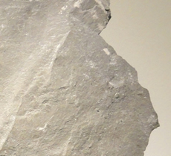
Shale

- Shale – a type of rock composed of clay and silt grains.
  - Shale forms when sediments deposited underwater are compacted.
  - Shale is a relatively soft rock that breaks down more quickly than other types of rocks.

- Valley – a low-lying area between hills that was created by erosion. Most valleys contain a river or stream flowing across the valley floor.

- Vegetation – all of the plant life in a given location.
  - Plants help slow erosion in many ways. Plant roots form “nets” that hold soil in place. Plants also shield the soil from direct rain.

- Weathering – a process in which rocks at Earth’s surface are gradually broken down into smaller pieces, eventually turning into soil.

