Name: ______________________________________ Date: ________________________

Student Exploration: Evolution: Natural and Artificial Selection

Vocabulary: artificial selection, breed, chromosome, evolution, fitness, genotype, mutation, natural selection, phenotype

[Note to teachers and students: This Gizmo was designed as a follow-up to the Evolution: Mutation and Selection Gizmo. We recommend doing that activity before trying this one.]

Prior Knowledge Question (Do this BEFORE using the Gizmo.)
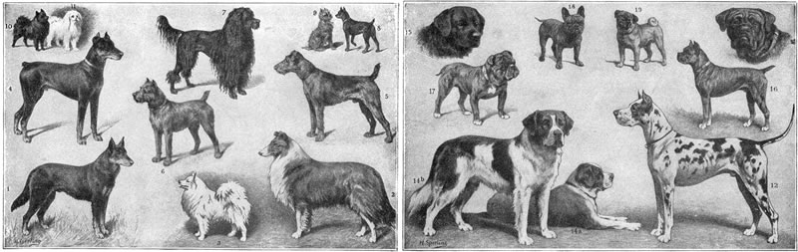
This illustration from an old textbook shows some of the over 150 different dog breeds that can be seen around the world today. How do you think all of these different breeds were developed?

____________________________________________________________________________

____________________________________________________________________________

____________________________________________________________________________

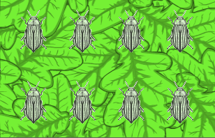
Gizmo Warm-up
Dog breeds and other varieties of domesticated animals were developed through artificial selection. Over many generations, breeders selected which animals to mate in order to select for desired traits. The Evolution: Natural and Artificial Selection Gizmo allows you to try your hand at breeding insects with a variety of colors. To begin, select the Artificial selection option.

- Drag the 10 insects into the breeding alcoves on the left side of the Gizmo.

    - How many breeding pairs are there? ____________________

    - How many offspring are produced? ____________________

- Circled insects have mutations, or changes to their DNA. How many of the offspring insects in this generation have mutations? ____________________
Activity A:  Genotype and phenotype | Get the Gizmo ready:  - Select Natural selection. | 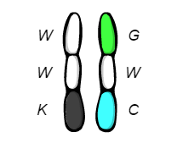

Question: How are genes inherited and modified over many generations?

- Observe: The fitness of an insect is a measure of how well it is adapted to its environment.

    - What is the initial Average fitness of these insects? _________________________
    - Click Play (), and observe the simulation for several generations. What occurs in each generation? _____________________________________________________
___________________________________________________________________

___________________________________________________________________

    - Increase the Sim. speed by one level. Click Pause () after 30 generations. What is the Average fitness now? ____________________________________________

- Analyze: Set the Sim. speed to its slowest level. Click Play, and then Pause when the offspring appear. Choose a pair of parents in which both parents have a different color.

    - Move your cursor over a parent insect. The genes that control color make up an insect’s genotype, while its actual color is its phenotype. Fill in the genotypes and phenotypes of each parent below.

Parent 1 Parent 1 Parent 2 Parent 2
genotype phenotype genotype phenotype
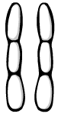
Red = _______ Red = _______
Green = _______ Green = _______
Blue = _______ Blue = _______

Now list the genotypes of each of the four offspring below.

Offspring 1 Offspring 2 Offspring 3 Offspring 4

(Activity A continued on next page)
Activity A (continued from previous page)

- Explain: Each rod-shaped structure is a chromosome. Real chromosomes contain hundreds or even thousands of genes. The simplified chromosomes shown in this Gizmo only contain genes that determine the insects’ colors.

How are the chromosomes of the offspring related to the chromosomes of the parents?

_________________________________________________________________________

_________________________________________________________________________

- Investigate: Any insect that has a mutation will be circled. Place your cursor on an insect with a mutation to examine its genotype. (If there are none in this generation, click Play and then Pause when a mutation appears.)

    - Examine the genotype of the mutated insect as well as the genotypes of its parents to determine what the mutation is. What new gene appeared? __________________
    - Do you think this mutation is helpful, harmful, or neutral for the insect? Explain.

___________________________________________________________________

    - Click Play, and then click Pause after the birds have finished eating. Did the mutated insect survive? _______________________________________________________

- Observe: Increase the Sim. speed by two levels. Click Play, and wait for a while. (Note: At faster simulation speeds, only the surviving offspring are shown.) What do you notice?

_________________________________________________________________________

_________________________________________________________________________

_________________________________________________________________________

- Explain: In wild populations, evolution is often caused by natural selection. Based on what you have observed, how does natural selection occur? _____________________________
_________________________________________________________________________
_________________________________________________________________________

_________________________________________________________________________

Activity B:  Artificial selection | Get the Gizmo ready:  - Select Artificial selection.  - Set the Mutation rate to 2.0. | 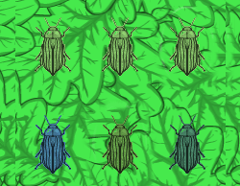

Question: How can a species be changed through artificial selection?

- Set a goal: In this activity, your goal is to develop insects that are any color you would like.

What color do you want your insects to be? ______________________________________

- Make a plan: Follow the directions in the Gizmo to produce five generations of insects.

    - How would you describe the process of artificial selection? ____________________

___________________________________________________________________

___________________________________________________________________

    - How will mutations be useful in achieving your goal color? _____________________
___________________________________________________________________
___________________________________________________________________
    - What strategy will you use to produce insects of your desired color? _____________ ___________________________________________________________________
___________________________________________________________________

- Run Gizmo: Use the Gizmo to produce insects that match your goal color. (This will take patience!) When you are satisfied, click the camera () to take a snapshot. Right-click the image and choose Copy Image, then paste the snapshot into a blank document that you will turn in with this worksheet.

How many generations did it take for you to develop your insects? ____________________

- Compare: If possible, compare your insects to the insects developed by your classmates. What different colors of insects can be developed using artificial selection? _____________
_________________________________________________________________________
_________________________________________________________________________

(Activity B continued on next page)
Activity B (continued from previous page)

- Explain: One of the tallest dog breeds is the Great Dane, which stands over a meter tall. One of the shortest is the Pomeranian, which stands about 20 centimeters tall. Based on what you have learned about artificial selection, how were these two breeds developed?

_________________________________________________________________________

_________________________________________________________________________

_________________________________________________________________________

_________________________________________________________________________

- Collect data: Use the Red, Green, and Blue sliders to match the Background color as closely as possible to phenotype of the insects. Select Natural selection.

Click Play, and then click Pause when the Average fitness first exceeds 90%. Record the number of generations in the table below, and then repeat for a total of five trials.

Trial | 1 | 2 | 3 | 4 | 5 | Mean
Number of generations to achieve 90% fitness

- Calculate: Add up the number of generations and divide by five to find the mean number of generations required to reach at least 90% fitness. Fill in the last column of the table.

- Analyze: Which process tends to occur more quickly, natural selection or artificial selection? Why do you think this is so?

_________________________________________________________________________

_________________________________________________________________________

- Summarize: How are the processes of natural selection and artificial selection similar? How are they different? If possible, discuss your answer with your classmates and teacher.

_________________________________________________________________________

_________________________________________________________________________

_________________________________________________________________________

_________________________________________________________________________

_________________________________________________________________________

Activity C:  Mutation rates | Get the Gizmo ready:  - Click Reset (). Be sure Natural selection is selected.  - Set Red to 100, Green to 255, and Blue to 50. | 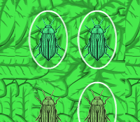

Question: How does the mutation rate affect a population’s ability to adapt to its environment?

- Gather data: Change the Mutation rate to 0.1 and the Sim. speed slider to its lowest setting. Click Play, and then click Pause when the offspring appear. Record the number of mutations (circled offspring), and then repeat for two more trials. Do this for each mutation rate listed in the table, then calculate the mean number of mutations for each mutation rate.

Mutation rate | Trial 1 | Trial 2 | Trial 3 | Mean
0.1
1.0
10.0

How does the mutation rate relate to the number of mutations in each generation? _________________________________________________________________________

- Form hypothesis: How do you expect the rate of mutations to affect the ability of the bug population to adapt to its environment? __________________________________________
_________________________________________________________________________

- Gather data: Click Reset. Set the Mutation rate to 0.1, and move the Sim. speed slider to a faster setting. Click Play, and then click Pause when the Average fitness is 90% or greater. Record the number of generations required to reach 90% fitness in the table below.

Mutation rate | Number of generations to 90% average fitness |  |  | Mean
 | Trial 1 | Trial 2 | Trial 3
0.1
0.3
0.5
1.0
3.0
5.0
10.0

(Activity C continued on next page)
Activity C (continued from previous page)

- Analyze: How does the mutation rate affect the speed at which a population adapts to its environment? ______________________________________________________________
_________________________________________________________________________
_________________________________________________________________________

- Think and discuss: You may have noticed that above a certain mutation rate the time required for a population to adapt to its background may increase. Why do you think this is so? If possible, discuss your answer with your classmates and teacher.

_________________________________________________________________________

_________________________________________________________________________

_________________________________________________________________________

_________________________________________________________________________

- Apply: Scientists doing artificial breeding experiments often use radiation or other methods to increase the mutation rate. Why is a high mutation rate useful? _____________________
_________________________________________________________________________
_________________________________________________________________________

- Investigate: Use the Gizmo to develop a population of insects that are well adapted to their environment. (Average fitness is above 90%.) Change the Mutation rate to 0.1, and run the simulation. Then, observe the population with a Mutation rate of 10.0.

    - What do you notice? __________________________________________________

___________________________________________________________________

___________________________________________________________________

    - If a population is already well-adapted to its environment, will most mutations be helpful or harmful? Explain. _____________________________________________
___________________________________________________________________

___________________________________________________________________

