Name: Date:

Student Exploration: Exponential Growth and Decay

Vocabulary: exponential decay, exponential growth

Prior Knowledge Questions (Do these BEFORE using the Gizmo.)
A pair of jeans costs $40 and the sales tax is 5%.

- How much is the sales tax? How much is the total bill?

- What did you multiply together to find the sales tax?

- What can you multiply by $40 to find the total bill, including tax?

Explain.

Gizmo Warm-up
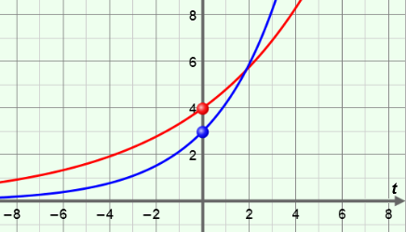
In an exponential growth (or decay) function, as x increases, the y-values grow (or decrease) by a constant percent. In the Exponential Growth and Decay Gizmo, you can explore the effects of C and r in the function y = C(1 + r)^{t}.

To vary the values of C and r, drag the sliders. To enter a specific value, click on the number in the text field, type in the new value and hit Enter.

- Use the slider to vary the value of r.

  - Describe the graph when r is greater than 0.

  - Describe the graph when r is less than 0.

- Use the slider to vary the value of C. What point does C correspond to on the graph?

Activity A:  Exponential growth | Get the Gizmo ready:  - Select the CONTROLS tab.  - Unselect all checkboxes. | 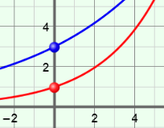

- In the Gizmo, set C to 5.00 and r to 0.20 to graph the function y = 5(1 + 0.2)^{t}. Then select the TABLE tab.

- Graph the function on the grid below. Then fill in the missing y-values in the table. (You can adjust the MIN and MAX values in the Gizmo table if you like.)
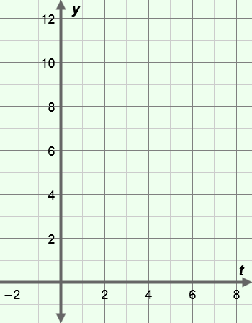
y = 5(1 + 0.2)^{t}
t | y
0
1
2
3
4

- What is the initial value of the function (y-value when t = 0)?

- Each time t increases by 1, what happens to the y-values? (By what percent do they increase?)

Explain.

- What part of the formula represents the initial value?

- What part of the formula represents percent of growth?

The function y = 5(1 + 0.2)^{t} is an example of an exponential growth function because the y-values increase by the same percent each time x increases by 1.

- Jacob currently has a summer job earning $8 per hour. Each summer he is guaranteed a 5% increase over the previous summer.

- What is the initial value of Jacob’s hourly rate?

- By what number is his hourly rate multiplied each year?

Explain.

- What function models Jacob’s hourly rate, y, in year t?

Explain.

- Use the Gizmo to check your function. Adjust your answers above if needed.

(Activity A continued on next page)
Activity A (continued from previous page)

- The function y = 100(1.07)^{t} represents the money in a bank account after t years.

- What is the initial balance of the account?

- What is the annual interest rate for the account?

- Explain your answers.

- Nina deposits $400 in an account that earns 4% interest, compounded annually.

- What is the initial value of the account?

- What function represents the balance after t years?

- What is the value of the account after 5 years? (Use a calculator.)

- Graph your function in the Gizmo. (Hint: Enter C = 4 in the Gizmo and let y = the balance of the account in hundreds.) Check your answer using the TABLE tab.

- Select Show probe. Drag the probe slowly to the right. When will Nina have more than $600? (Click and drag the graph, or click – to zoom out.)
- About how long will it take for the balance to double?

- Suppose Nina started with $600 in the same account (with a 4% interest rate, compounded annually) instead of $400.

- What function represents her balance after t years?

- Graph your function in the Gizmo. (Use C = 6.) Drag the probe slowly to the right. About how long will it take the balance to double?
- How long will it take to double if the initial deposit is $800?

- What do you notice about the time it takes the balance to double?

- What do you think would change the “doubling time”?

Explain.

Activity B:  Exponential decay | Get the Gizmo ready:  - Be sure the CONTROLS tab is selected and that all boxes are unchecked. | 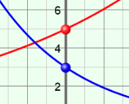

- In the Gizmo, set C to 5.00 and r to –0.20 to graph the function y = 5(1 – 0.20)^{t}. Then select the TABLE tab.

- Graph the function on the grid below. Then fill in the missing y-values in the table. (You can adjust the MIN and MAX values in the Gizmo table if you like.)
y = 5(1 – 0.20)^{t}
t | y
0
1
2
3
4

- What is the initial value of the function (y-value when t = 0)?
- Is the function increasing or decreasing from left to right?
- Each time t increases by 1, by what percent is the y-value changing?

Explain.

This is an example of an exponential decay function because the y-values are decreasing by the same percent each time x increases by 1.

- Select Show additional function. Graph y = 5(1 + 0.20)^{t} along with y = 5(1 – 0.20)^{t}.

- What do the two graphs have in common?

- How are the graphs different?

- A computer is purchased for $1000 and depreciates (loses value) by 15% each year.

- What percent of value does the computer retain each year?

- Write a function that models the value of the computer after t years.

Explain.
(Activity B continued on next page)
Activity B (continued from previous page)

- Use the function y = 98(0.93)^{t} to answer the following questions.

- What is the y-intercept of the function?

- What is the value of r? Explain.

- In 2000, the population of Dullville was about 95,000. Over the next decade, the population decreased by 18%. For the questions below, assume this rate of decay will continue.

- What function models the population after t decades?
- Graph your function in the Gizmo. (Hint: Let y = population in thousands. To enter the initial value, type 95 in the field next to the C slider and hit Enter.) Then select Show probe and drag it to the right.

About what will the population be after 30 years (t = 3 decades)?

- Roughly when will the population be half the initial population?

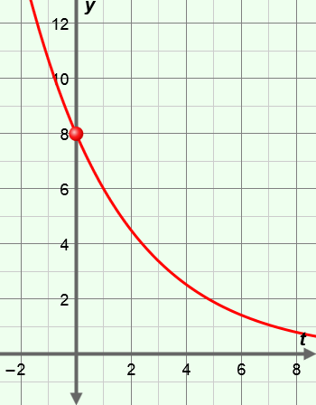
- Use the graph to the right to answer the following questions.

- What is the initial value?

- What is the percent of change per year?

- What function is graphed here?

Explain.

Check your answer in the Gizmo.

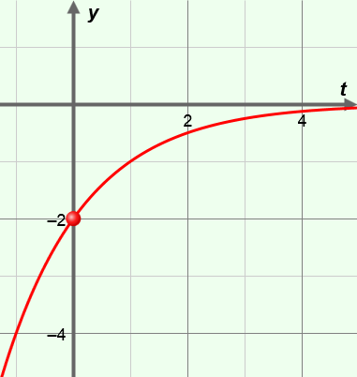
- Challenge: Consider the graph to the right.

- What function is graphed here?

- Explain your reasoning.

Check your answer in the Gizmo.

Activity C:  Applications | Get the Gizmo ready:  - Select the CONTROLS tab.  - Select Show probe. | 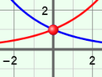

- Consider the function y = 64(1.29)^{t} to answer the following questions.

- What is the initial value? Percent of change per year?

- Is this an exponential growth or decay function?

Explain.

- Sandra deposits $1500 into an account that earns 2% interest compounded annually.

  - Write a function that models the balance after t years.

  - What is the balance after 7 years? (Use a calculator.)

  - Check your answers in the Gizmo. Correct any mistakes as needed. (Hint: The Gizmo allows you to type in values for C from –100 to 100. For this problem, you can enter C = 15 and let y = the balance of the account in hundreds.)

  - Use the probe to estimate how long it takes for the balance to double.

- Jason buys a car for $24,000. The car depreciates (loses value) at a rate of 18% each year.

  - What function models the value of the car after t years?

  - What is the value of the car after 6 years? (Use a calculator.)

  - Check your answers in the Gizmo. (Use C = 24.) Fix any mistakes above, if needed.

  - About when will the car be worth half its initial value? (Use the probe.)

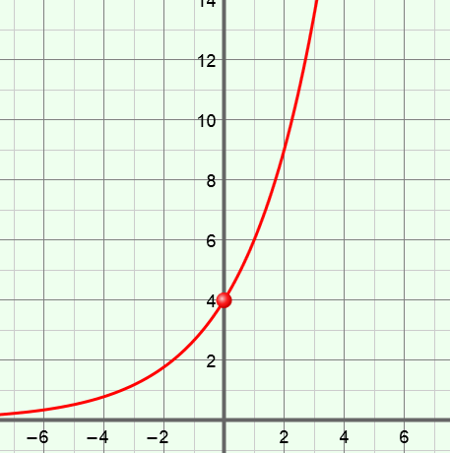
- Use the graph to the right to answer the following questions.

- What is the initial value?

- What is the percent of change per year?

- What function is graphed here?

Explain.

