Name: ______________________________________ Date: ________________________

Student Exploration: Exponents and Power Rules

Vocabulary: base, exponent

Prior Knowledge Questions (Do these BEFORE using the Gizmo.)

- Complete the following pattern:

4³ = 4 • 4 • 4 = 64 4² = 4 • 4 = ________ 4¹ = ________ 4⁰ = 1
1
1
1
1
1
4^{–3} = = 4^{–2} = = 4^{–1} = =

- Simplify the following: x³ • x² = (x • x • x) • ( _____ • _____ ) = x

- In the problem above, what did you do with the two original exponents, 3 and 2, to get the exponent in the final product?

Gizmo Overview
In the Exponents and Power Rules Gizmo, you will simplify expressions with exponents, step-by-step. An exponent is a number, written to the right of and just above a number or expression (called the base), that indicates how many times the number or expression is multiplied by itself.

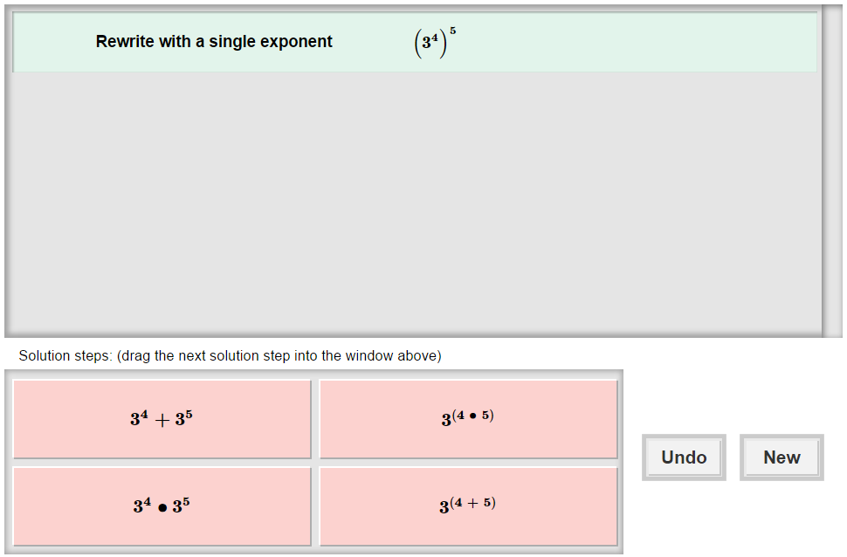
Here’s how the Gizmo looks at first:

The expression for you to simplify is here.

The tiles give you four choices for the next step. Choose the one you think is correct and drag it into the white area above.
Click New to go to a different problem.
Click Undo to undo your last choice.
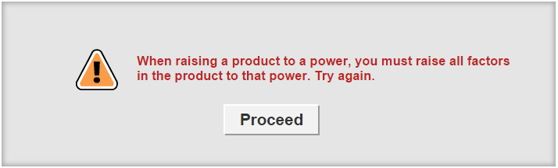
Read your feedback in the Gizmo. (No feedback is given for correct answers.)

Click Proceed to go to the next step.

Activity:  Simplifying expressions with exponents | Get the Gizmo ready:  - You should see the expression (3⁴)⁵. If not, click Refresh in your browser.

- When you begin, you should see the expression shown to the right at the top of the Gizmo.

- First, write x⁵ as the product of repeated factors. x⁵ =

- Now, write (3⁴)⁵ as the product of repeated factors. (3⁴)⁵ =
- How can you simplify the product above so it has a single exponent?
- In the Gizmo, choose the correct step. If your choice is incorrect, read the given feedback and try again. What is the simplified final answer?
- Use both words and variables to write a general rule for raising a power to a power.

Words:

Variables: (xª)^{b} =

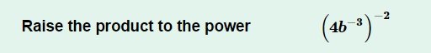
- Click New. You should now see the expression shown at the right in the Gizmo.

- Each factor in parentheses (4 and b⁻³) is raised to the –2 power. How can you rewrite this expression to show that? Select that tile in the Gizmo.
- You should now have 4⁻²(b⁻³)⁻². How does each factor of this product simplify?

4⁻² = __________________ (b⁻³)⁻² = __________________

- Choose the last correct step. What is the simplified final answer?

- How is a negative exponent different from a positive exponent?

- Click New. Work through more problems in the Gizmo. Be sure to read the feedback in the Gizmo along the way.

(Activity continued on next page)
Activity (continued from previous page)

- Simplify each expression below. Write all your steps in the space below each problem.

- (5x⁴)²

- (–3r⁵)³

- (2m⁶)^{–4}

- (3a³b⁵)⁴

- (6m^{–4}n⁷)²

- (–2r^{–2}s³)^{–6}

