Name: Date:

Student Exploration: Fast Plants® 1 – Growth and Genetics

Note to teachers and students: The Fast Plants® Gizmo was created in collaboration with the Wisconsin Fast Plants Program of the University of Wisconsin-Madison. These lessons can be used independently or in conjunction with classroom Fast Plants experiments.

Vocabulary: allele, dominant allele, Fast Plants, gene, genetics, genotype, heterozygous, homozygous, offspring, phenotype, pollen, pollinate, Punnett square, recessive allele, trait

Prior Knowledge Questions (Do these BEFORE using the Gizmo.)

1. What do plants need to survive?

- How do plants reproduce?

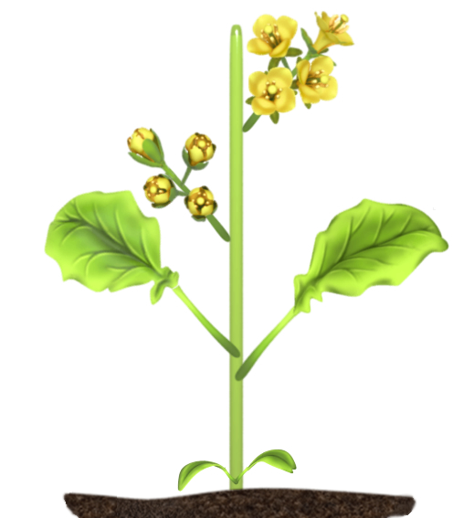
Gizmo Warm-up
Several common vegetables, including Bok choy, napa cabbage, and turnips, are varieties of a plant called Brassica rapa. Fast plants are a rapid-cycling variety of Brassica rapa that was developed at the University of Wisconsin. These plants have short growing cycles and are ideal for classroom use. In the Fast Plants® 1 – Growth and Genetics Gizmo, you will learn about the life cycle and genetic traits of Fast Plants.

In the Gizmo, drag seed packet A to container 1 and seed packet B to container 2. Click Play (), and then Pause () after about 10 simulated days.

- A plants traits are its characteristics. Drag the magnifying glass over container 1. Describe the traits of these plants.

- Drag the magnifier over container 2. How do these plants differ from the container 1 plants?

Activity A:  The Fast Plants® life cycle | Get the Gizmo ready:  - Click Reset (). Plant seeds A in container 1.  - Turn on Show hints. | 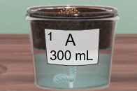

Introduction: Fast Plants® are grown in wicking systems, typically made of nested plastic containers. The larger container is the water reservoir. Water from the reservoir travels through the wick into the soil, where roots draw the water into stems and leaves.

Question: How do Fast Plants grow and reproduce?

- Grow: With seeds A in container 1, click Play. Click Pause on day 17.

- Is the container full of water? If not, drag the water bottle to the container.
- Do the plants look like they are too crowded? If so, use the tweezers to pull out a few plants and discard them in the waste hole.

- Pollinate: The bee stick should be active at the bottom of the Gizmo. A bee stick is a dead bee glued on a toothpick. Drag the bee stick through the flowers.

- What happens to the appearance of the bee stick as it is dragged through the flowers?
The bee’s hairy thorax (middle section) is covered in pollen. Pollen is produced by male reproductive organs in the flower. Each grain of pollen contains a sperm cell.

- What happens to the flowers?

The orange color represents flowers that are pollinated, or fertilized. (In reality, pollinated flowers do not turn orange. This is done to show pollination in the Gizmo.)

- Grow: Turn on Auto-watering. This will keep the containers full of water automatically. Click Play, and then Pause around day 24. Use the magnifier to observe the plants.

- What do you notice happening at the top of the plants?

Pollinated flowers develop into long, thin seedpods.

- Click Play, and then Pause at day 38. Is the container filled with water?

This is not a mistake. At this time, the auto-watering system turns off so the plants can dry out and the seeds do not rot.

(Activity A continued on next page)
Activity A (continued from previous page)

- Harvest: Click Play and let the simulation run until it ends on day 44. Fast Plants® are unique because they have very quick life cycles, going from seed to mature seedpod in only six weeks. Grab an empty seed bag and place it on the counter. Then, use the tweezers to carefully grab one seedpod from the dried plants. (This may take a few tries.) Release the seedpod over the empty bag.

- What happens?

The seed bag now contains seeds that are the offspring of the parent A seeds.

- Click on the seed bag. Type a two-letter label for the seed bag and write a description. Congratulations! You have completed the life cycle of a Fast plant.

- Compare: Plant the A seeds in container 1 and the offspring seeds in container 2. Click Play and then Pause after 10-15 days. Use the magnifier to observe the plants in each container.

- How do the offspring plants compare to the parent plants?

- Do all of the offspring plants have the same traits?

- Experiment: The Gizmo allows you to see how several different factors influence the growth of the plants. For example, you can click on the light to try low-light or no-light conditions. You can also try growing the plants with and without water or in normal or crowded conditions. Using the Gizmo, see how each of these factors affects the growth of the plants.

- How does low light affect the growth of the plants?

- How does no light affect the plants?

- In normal light conditions, how well do plants grow when there are 10 plants in the container compared to when there are only 6 plants in the container?

- What happens to the plants if they are not pollinated?

- On your own: Turn off Auto-watering. Use the Gizmo to measure how quickly the plants consume water as they grow. What did you find? (You can write your answer on the back of this worksheet or share your findings with your classmates and teacher.)
Activity B:  Patterns of inheritance | Get the Gizmo ready:  - Click Start over. Plant seeds A in container 1 and B in container 2. Turn on Auto-watering.  - A calculator is recommended for this activity. | 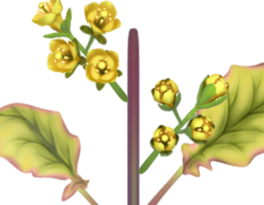

Introduction: From 1854 to 1863, an Austrian monk named Gregor Mendel patiently conducted a series of experiments crossing varieties of pea plants. His experiments led to his discovery of the basic laws of genetics. You can use Fast Plants to discover many of the same patterns that Mendel observed in his pea plants.

Question: How do the traits of offspring plants relate to the traits of parent plants?

- Grow: Click Play. Click Pause on day 15. Use the tweezers to remove a few plants from each container. Use the magnifying glass to observe the plants, paying attention to the colors of the leaves and stems. Describe them below.

“A” plants

Stems:

Leaves:

“B” plants

Stems:

Leaves:

Note: The purple edges of the leaves on the A plants are an artifact of the stem color. The leaves themselves are green.

- Pollinate: Move the bee stick through the B plants and then through the A plants. This brings pollen from the B plants to the flowers of the A plants. Once the A plants have been pollinated, drag the B plant container to the waste hole.

Click Fastplay () and wait until day 44. Move an empty seed bag to the counter, then use the tweezers to grab a seedpod and add seeds to the bag. Label the bag “F1.”

What traits do you think the F1 plants will have?

- Grow: Click Reset. Plant the F1 seeds in container 1 and click Play. Click Pause on day 15.

What are the traits of the F1 plants? Stem: Leaves:

- Infer: In his pea plant experiments, Gregor Mendel discovered that some traits appear to dominate over others. Which traits seem to be the dominant traits in Fast Plants®? Explain.

(Activity B continued on next page)
Activity B (continued from previous page)

- Pollinate: Use the bee stick to pollinate the F1 plants with pollen from other F1 plants. Then, grow the plants until day 44. Harvest a seedpod and place it in a bag. Label this bag F2.

  - What traits do you think the F2 plants will have?

  - Do you think all of the F2 plants will be the same?

- Grow: Click Reset. Plant the F2 seeds in container 1 and container 2. Click Play and grow for about 15 days. Do not thin the plants. Observe the plants with the magnifying glass.

What do you notice?

- Collect data: Select the clipboard. The clipboard gives the number of plants with each set of traits, or phenotype. Fill in the first row of the table below to show your results.

Trial | Purple stem, green leaf | Purple stem, yellow leaf | Green stem, green leaf | Green stem, yellow leaf | Total
1
2

Click Reset, plant the F2 seeds again, and then grow the plants to day 15. Fill in the second row with the new results. In general, were the results consistent or did they vary?

- Add data: In the upper-left corner of the clipboard, select Add class data. This adds data from an additional 980 plants grown from the same parent plants. Fill in the table below.

Trial | Purple stem, green leaf | Purple stem, yellow leaf | Green stem, green leaf | Green stem, yellow leaf | Total
1

- Analyze: Add up all of the plants with purple stems. Divide this value by 10 to find the percentage. Do the same for green-stem, green-leaf, and yellow-leaf plants.

What is the percentage of purple-stem plants? Green-stem plants?

What is the percentage of green leaf plants? Yellow-leaf plants?

In general, about what percentage of plants have each dominant trait?
Activity C:  Fast Plants® genetics | Get the Gizmo ready:  - Plant seeds A in container 1 and B in container 2.  - Check that Auto-watering is turned on. | 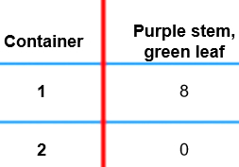

Introduction: Mendel discovered that traits are controlled by what he called factors (today called genes). Genes may have two or more variants, or alleles. Organisms carry two alleles for each trait. The combination of alleles carried by the organism, or its genotype, determines its phenotype. Alleles may be dominant or recessive. If one dominant and one recessive allele are present for a trait, only the dominant allele will be expressed in the phenotype.

Question: What determines the traits of Fast Plant parents and offspring?

- Understand: Fast Plants have two alleles for stem color and two alleles for leaf color.

The alleles for stem color are named after anthocyanin, a purple pigment:
- ANL (purple stem)
- anl (non-purple, no anthocyanin)
The leaf color alleles are named after the recessive yellow-green phenotype.
- YGR (green leaves)
- ygr (yellow-green leaves)

Click Play to grow the plants. Which alleles do you think are in plant A?

Which alleles do you think are in plant B?
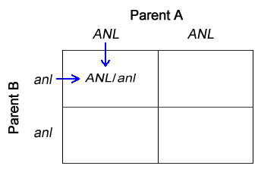

- Model: When the two alleles are the same, the individual is homozygous for that trait. An individual with two different alleles for a trait is heterozygous for that trait. Both plants A and B are homozygous for each trait: Plant A’s genotype is ANL/ANL, YGR/YGR. Plant B’s genotype is anl/anl, ygr/ygr.

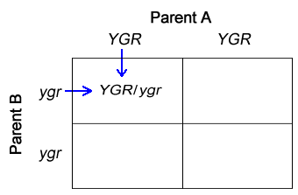
When the plants reproduce, one allele from each parent is passed to the offspring plant. You can model this process with a Punnett square. In a Punnett square, the parent alleles are written on the left edge and top edge. The possible offspring allele combinations are then written in the four boxes.

The Punnett squares to the right show the inheritance of stem color and leaf color for the offspring of plant A and plant B. The first box in each square has been filled in for you. Fill in the remaining boxes.

What will be the genotype of the offspring plants?

What will be the phenotype of the offspring plants?

(Activity C continued on next page)
Activity C (continued from previous page)

- Test: Click Reset. Plant the F1 seeds, which are the offspring of plants A and B. (If you do not have an F1 bag, create one by pollinating plant A with pollen from plant B, then harvest seeds from plant A.) Click Play, and then Pause after about 10 days. Select the clipboard.

Does the phenotype of the F1 plants match what you predicted in question 2?

- Model: Click Reset. The F1 plants are heterozygous for each trait and have the genotype ANL/anl, YGR/ygr. You can predict the offspring of these parents using a dihybrid Punnett square, shown below. Each possible combination of parent alleles is shown on the top and sides of the square. Write the alleles of the offspring plants in the boxes.
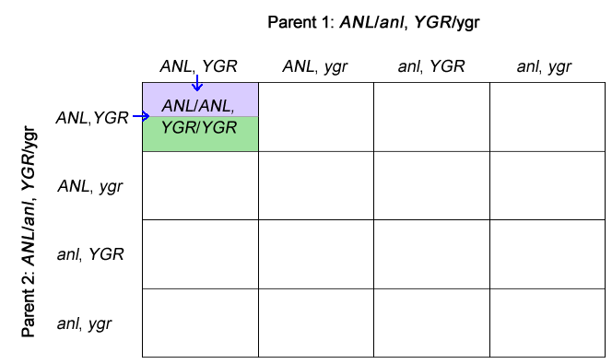

- Predict: There are 16 possible offspring in the Punnett square for two traits. Each represents one of four phenotypes. Draw a horizontal line through each box of the Punnett square. Color in the top half with the stem color (purple or green) and the bottom half with the leaf color (green or yellow). Then, count the boxes that represent each phenotype. To find the percentages, divide each value by 16 and then multiply by 100.

Phenotype | Purple stem, green leaf | Purple stem, yellow leaf | Green stem, green leaf | Green stem, yellow leaf
Number of boxes
Percentage

- Test: Plant the F2 seeds in both containers. (If you do not have an F2 bag, create one by pollinating the F1 plants, then harvesting seeds from the F1 plants.) Click Play, and then Pause after about 10 days. On the clipboard, turn on Add class data.

Do the phenotype percentages of the F2 plants match your prediction? Explain.

