Vocabulary: Fast Plants® 1 – Growth and Genetics

Vocabulary

- Allele – one of two or more forms that a gene could take.

- Dominant allele – an allele that is always expressed when it is present.
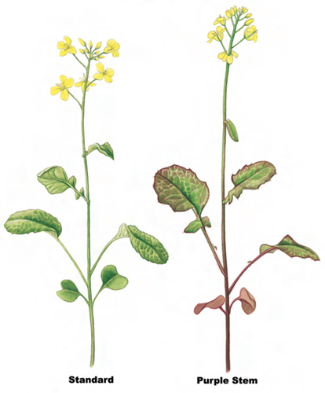
  - Dominant alleles are usually represented by capital letters, such as ANL.
  - If an organism is heterozygous for a trait, the phenotype will be that of the dominant allele.

- Wisconsin Fast Plants® – common name for a rapid-cycling subspecies of Brassica rapa, developed at the University of Wisconsin-Madison as a model organism for research.
  - Fast Plants have a very short life cycle, taking about 44 days to grow from a seed to producing mature seeds.
  - Fast Plants have several traits that are controlled by a single gene, making them ideal for Mendelian genetic studies.

- Gene – a segment of DNA that determines or helps to determine a trait.
  - Most genes give instructions for building a particular protein.
  - Unlike the traits studied in this Gizmo, many familiar traits are determined by more than one gene.

- Genetics – the study of heredity, or how traits are passed from parents to offspring.

- Genotype – the genetic makeup of an organism.
  - The genotype describes the alleles that are present in an organism.
  - For example, a Fast Plant may have the genotype ANL/anl, YGR/ygr.

- Heterozygous – having two alleles that are different.

- Homozygous – having two alleles that are the same.

- Offspring – a new living thing produced by one or two parents.

- Phenotype – the physical appearance of an organism.
  - For example, a Fast Plant with the genotype ANL/ANL will have the purple-stem phenotype, shown above.

- Pollen – tiny grains that contain sperm cells.

- Pollination – the transfer of pollen from the anther to the stigma, leading to fertilization.
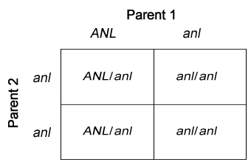
- Punnett square – a diagram that shows the possible offspring of two parents.
  - Punnett squares allow you to determine the probability of each offspring genotype.
  - For example, the Punnett square at right shows the offspring from an ANL/anl plant and an anl/anl plant. It shows that about half the offspring will be ANL/anl and half will be anl/anl.

- Recessive allele – an allele that is not expressed when the dominant allele is present.
  - Recessive alleles are usually represented by lowercase letters, such as anl.
  - If an organism is heterozygous for a trait, the phenotype will be that of the dominant allele rather than the recessive allele.

- Trait – a characteristic of an organism.
  - Examples of traits include stem color, leaf color, leaf shape, stem height, and many others.

