Vocabulary: Fast Plants® 2 – Mystery Parent

Vocabulary

- Chi-squared test – a statistical test that is used to determine the probability that the deviation of a set of results from the expected results is due to chance.
  - To conduct a chi-squared test, first the χ² value is determined. This is the sum of the squared deviations divided by the expected values. The χ² value is then used to determine how probable it is that the deviations were due to chance.
  - If the probability that the deviation was caused by chance is very low (usually less than 5%), that means that the underlying hypothesis behind the prediction is probably wrong. In that case, the hypothesis may be rejected.
  - The chi-squared test can only be used to reject a hypothesis. It cannot be used to confirm that a hypothesis is correct. Even if the results are likely given a certain hypothesis, there may be other hypotheses that fit the data better.

- Degrees of freedom – the number of values in a statistical calculation that can vary.
  - For example, suppose there are four possible phenotypes for the 100 offspring of two parents. If the numbers of the first three phenotypes are known, then the number of the last phenotype can be determined from the other three and therefore is not free to vary on its own. In this case there are 3 degrees of freedom.
  - In general, the degrees of freedom will be equal to the total number of possible outcomes minus one.

- Deviation – the difference between the observed value and the expected value.
  - Deviation (d) is equal to the observed value (o) minus the expected value (e):
d = o – e.
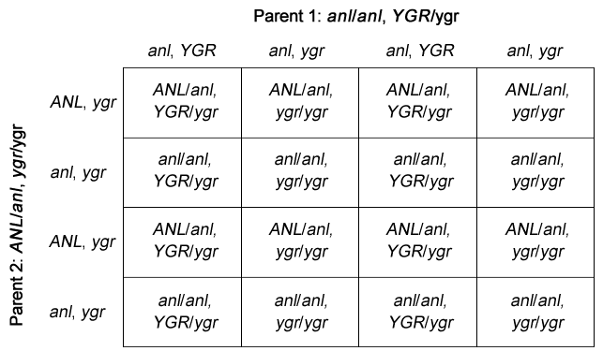
- Dihybrid Punnett square – a Punnett square that shows the inheritance of two traits.
  - Each parent produces four possible combinations of alleles.
  - For example, the dihybrid Punnett square at right shows the possible offspring of an anl/anl, YGR/ygr parent and an ANL/anl, ygr/ygr parent.

- Rosette-dwarf – a variety of Wisconsin Fast Plants® that grows shorter than normal plants and has leaves clustered at the bottom of the stem.

