Name: Date:

Student Exploration: Feel the Heat

Vocabulary: calorimeter, conductor, controlled experiment, dissolve, endothermic, exothermic, insulator, solute, solution, solvent, surroundings, system

Prior Knowledge Questions (Do these BEFORE using the Gizmo.)
Eduardo hurts his knee during a basketball game. The trainer applies a cold pack, which gets cold after being squeezed. The next day, Eduardo’s friend Beth is going sledding. Beth buys some hand warmers and puts them into her gloves. All morning, her hands stay toasty warm.

- How do you think these devices work?

- Where do you think the “cold” and the heat comes from?

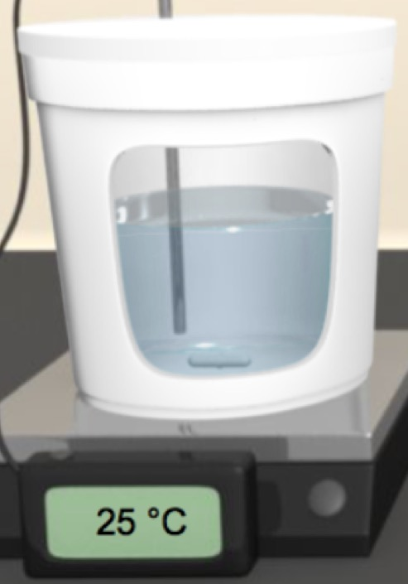
Gizmo Warm-up
As you saw with the instant cold pack and the hand warmers, some reactions absorb energy while others release it. In the Feel the Heat Gizmo, you will explore these energy changes while making your own hot and cold packs.

To begin, select the TEST POWDERS tab. Drag a bottle of NaC₂H₃O₂ (sodium acetate) from the shelf. Using the sliders, decide how much water and powder to add. Note the beginning temperature, and then press Play () to see what happens.

- Did the temperature go up or down?

- Experiment with different powders until you find one that produces the opposite effect.

What powder did you use?

When a powder dissolves in water a solution is formed. The powder is the solute and the water is the solvent. Oftentimes energy changes accompany the formation of a solution. When added to water, some powders cause the resulting solution to get hot, while others make it cold. Some powders don’t produce a temperature change at all. When energy changes do occur, they can be put to good use.
Activity A:  Molecular view | Get the Gizmo ready:  - Click Reset ().  - Drag a bottle of NaC₂H₃O₂ from the shelf. | 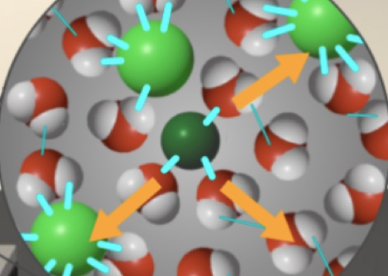

Introduction: The reactions in this activity are performed within a calorimeter, an insulated device that keeps heat from escaping, enabling you to accurately record temperature changes.

Question: Why does the temperature change when a powder is dissolved in water?

- Observe: Turn on Show molecular view, and notice the water molecules. Set the Water volume to 100 mL and the Powder mass to 20 g, and then click Play. Click Pause () after adding the powder. You should now see show some sodium acetate in the water.

- What color represents the bonds between the particles of NaC₂H₃O₂?

- Click Play. Watch the animation a few times. What happens to the NaC₂H₃O₂ bonds?
- What happens to the bonds between water molecules?

- What color are the new bonds that form between the solute and solvent?

- Investigate: In the animation, the purple arrows represent energy that is being absorbed from the water, while the orange arrows show energy that is being released into the solution.

- Replay the animation, carefully noting the purple arrows. What does this absorbed energy do?
- Now replay the animation but focus on the orange arrows. What occurs every time an orange arrow is released?
- Fill in the blanks: When bonds are broken, energy is .
When new bonds form, energy is .
- Based on the arrow sizes, do you think more energy is absorbed in breaking bonds, or is more energy released when new bonds form?
- Which bonds do you think are stronger, the bonds that are broken or the bonds that are formed? Explain your reasoning.

(Activity A continued on next page)
Activity A (continued from previous page)

- Infer: Drag a bottle of KCl from the shelf. Add 20 g of KCl to 100 mL of water. Click Play and look once again at the molecular view.

- Did the temperature rise or fall?

- Compare the purple and orange arrows. Does more energy go into breaking bonds, or is more energy released when new bonds form?
- Which bonds are stronger: the bonds formed or the bonds broken?

Explain your reasoning.

- Think and discuss: Based on your observations, why do you think the temperature of the NaC₂H₃O₂ solution rose while that of the KCl solution fell?

- Think and discuss: If a solute has really strong bonds between its particles, would you expect the resulting solution to get hot or cold? Explain your reasoning.

- Infer: Some powders produce little to no temperature change when added to water. Find the powder that has the smallest effect on the temperature of the resulting solution.

- What is the identity of this powder?

- How do the purple and orange arrows compare?

- For this powder, how do you think the strength of the bonds that are broken compare to those that are formed?

- Predict: Set the water to 200 mL and the powder to 1 g. Test each powder, looking only at the molecular view each time. After carefully observing the arrows, predict the following.

Which powder do you think will produce the hottest solution?

Which powder do you think will produce the coldest solution?
Activity B:  Test powders | Get the Gizmo ready:  - Turn off Show molecular view.  - Click Reset. | 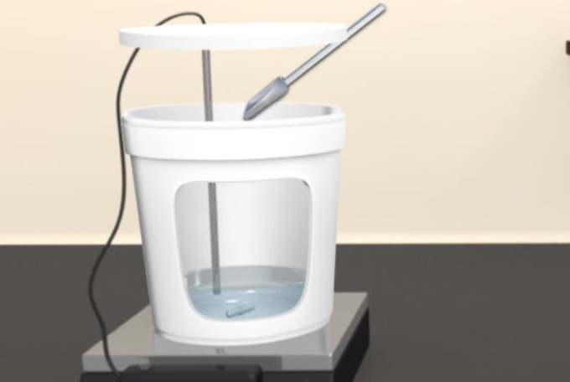

Introduction: In order to determine which combination of water and powder will produce the greatest temperature change, it is necessary to perform a controlled experiment. In a controlled experiment only one variable at a time is changed so its effect can be measured.

Question: Which combination of powder and water will produce the greatest temperature increase, and which will produce the greatest temperature decrease?

- Experiment: For the first controlled experiment, decide how much water you want to use. Add some powder. Note the temperature change. Keeping the water amount constant, add a different amount of the same powder and note the final temperature. Keep adjusting only the powder amount until you have discovered how it affects the solution temperature.

What relationship did you discover between the amount of powder used and the change in temperature?

- Experiment: For the next controlled experiment, repeat the above procedure, except this time keep the amount of powder constant and vary the amount of water.

What relationship did you discover between the amount of water used and the change in temperature?

- Collect data: For each substance, determine which combination of water and powder will give you the greatest temperature increase or decrease. Record data below.

Type of powder | Volume of water (mL) | Mass of powder (g) | Initial temp. (ºC) | Final temp. (ºC) | Temp. change (ºC)

Which powder produced the greatest temperature increase?

Which powder produced the greatest temperature decrease?

How do these results compare to the predictions you made at the end of activity A?

Activity C:  Create device | Get the Gizmo ready:  - Select the CREATE DEVICE tab.  - Choose LDPE and drag it to the appropriate box. | 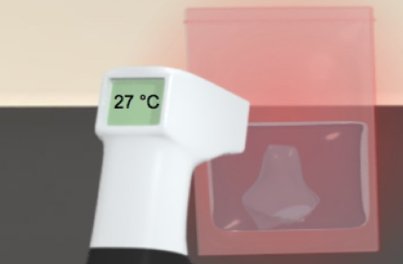

Introduction: In a hot pack, an exothermic reaction occurs, since energy is released from the system to the surroundings. In an endothermic reaction, energy is absorbed by the system, causing the surroundings to get colder. (The hot or cold pack can be defined as the system.)

Question: Would it be better to use a material that releases heat quickly or slowly?

- Experiment: Notice the five types of bag materials. LDPE, HDPE, and Mylar are types of plastic, while latex and neoprene are types of rubber. Find the combination of water and powder that produces the maximum temperature increase. To maintain a controlled experiment, use the same amounts of water and powder in each bag. Record data below:

Type of material | LDPE | HDPE | Latex | Mylar | Neoprene
Maximum temp. (ºC)

- Analyze: Use the above data table to answer the following.

- Which pack material got the hottest?

Why do you think the outside of this pack got hotter than the other ones?

- In which pack material did you see the lowest maximum temperature?

Why do you think the outside of this pack did not get as hot as the others?

- Apply: Turn on Show data to view a graph of the temperature distribution. Take a snapshot of the graph by clicking the camera icon, then paste it into a blank document to turn in.

- Write down your observations about the graph, noting any trends you see.

- What material would enable you to warm your hands the fastest?

- What material would keep your hands warm for the longest time?

(Activity C continued on next page)
Activity C (continued from previous page)

- Analyze: Heat will travel quickly through a conductor, but more slowly through an insulator. A good conductor will heat up quickly and cool down quickly. The best insulators take longer to warm up but then stay warm for a longer period of time.

- Which material is the best conductor?

- Which material is the best insulator?

- If the bag was made from a metal (like sturdy aluminum foil), do you think it would lose its heat faster or slower than the plastic bags? Explain your reasoning.

- Experiment: To construct a cold pack, choose the powder from activity B that produced the greatest temperature decrease. Just like with the hot pack, use the same amounts of water and powder in each pack. Test each of the five types of materials. Record data below:

Type of material | LDPE | HDPE | Latex | Mylar | Neoprene
Minimum temp. (ºC)

- Analyze: Use the above data to answer the following.

- Which material gave you the coldest pack?

- Which material would produce the longest-lasting cold pack?

- Compare: Take a snapshot of the graph by clicking the camera icon, then paste it into a blank document to turn in. Compare the temperature graphs for the cold and hot packs.

- Did the material that got the hottest also get the coldest?

- Did the material that stayed warm the longest also stay cold the longest?

- What do these observations tell you about the rate and direction of heat flow through each specific type of plastic?

- Interpret: Since hot packs release heat, you might assume that cold packs release cold. Use the definition of endothermic to explain why this view of cold packs is not accurate.

Extension:  Challenge | Get the Gizmo ready:  - Select the CREATE DEVICE tab. | 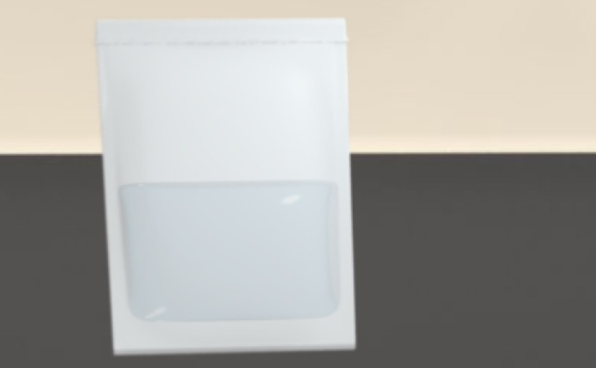

Introduction: Hot and cold packs can be used for a variety of purposes. A pack that is blistering hot or freezing cold might not always be the most practical. For example, a typical hot pack you might buy from the store will only reach a maximum temperature of around 54 ºC. If it gets much hotter it might burn the skin. Some packs are designed to heat or cool quickly, while others last for a longer period of time. In this activity, you will be challenged to design several different packs that each meet certain specifications.

Question: Can you make a hot or cold pack that will stay within a certain temperature range for a specified period of time?

- Think and discuss: Think about all the times a hot pack might be nice to have. List as many practical uses as you can for a hot pack.

- Think and discuss: Besides being used to reduce swelling, what are some other possible uses for a cold pack?

- Experiment: Use the Gizmo to design a hot or cold pack that meets each of the following requirements. When you solve the challenge, describe the bag material, type of powder, powder mass, and volume of water you used.

- The outside bag temperature reaches 54 ºC (but no higher) within 2 minutes.

- The temperature does not go above 50 ºC, and does not go below 40 ºC for at least 25 minutes.

- The temperature reaches 8 ºC in less than 2 minutes.

- The temperature does not go below 10 ºC, and stays below 20 ºC for at least 15 minutes.

