Vocabulary: Feel the Heat

Vocabulary

- Calorimeter – an insulated device where temperature changes within a reaction can be accurately measured.
  - Theoretically, no heat is lost to the surroundings in a calorimeter.

- Conductor – a substance that allows energy to pass through.
  - The best conductors transfer energy the fastest.
  - Metals tend to be better conductors than nonmetals.

- Controlled experiment – an investigation where only variable at a time is changed.
  - The purpose of a controlled experiment is to determine whether the variable being changed is producing an effect.
  - If more than one variable is changed simultaneously, the experimenter will be unable to determine which variable is producing the effect.

- Dissolve – to break down into particles of molecular or ionic size.

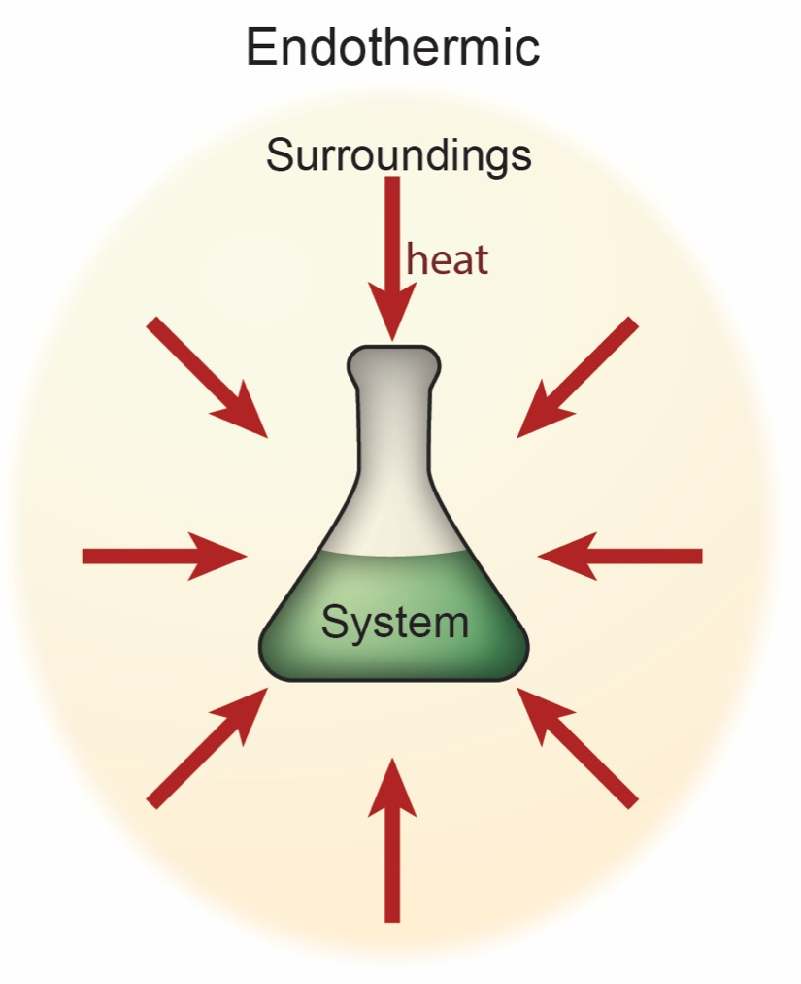
- Endothermic – a process in which the system absorbs energy from the surroundings.
  - The temperature of the surroundings decreases in an endothermic reaction.
  - In an endothermic reaction, the amount of energy absorbed to break bonds is greater than the amount of energy released if new bonds form.
  - Both physical and chemical changes can be endothermic.
  - Melting an ice cube and dissolving ammonium nitrate in water are both examples of endothermic processes.
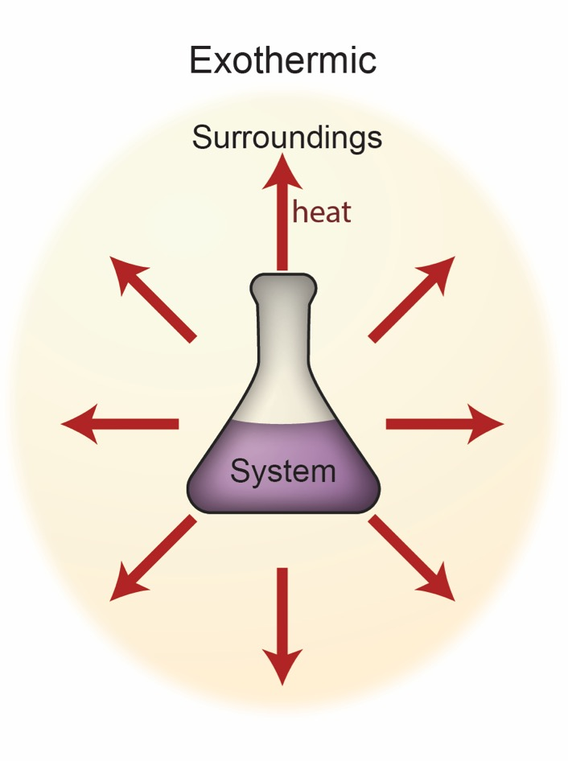
- Exothermic – a process in which energy is released from the system to the surroundings.
  - The temperature of the surroundings increases in an exothermic reaction.
  - In an exothermic reaction, the amount of energy released when new bonds form is greater than the amount of energy absorbed if bonds are broken.
  - Burning paper, dissolving calcium chloride in water, and the freezing of water are all examples of exothermic processes.
- Insulator – a substance that prevents the transfer of heat through a substance.
  - A good insulator will keep “hot” things hot and “cold” things cold.
  - Nonmetals tend to be much better insulators than metals.
  - A vacuum is the best insulator.

- Solute – a substance that is dissolved by another substance (the solvent).
  - In salt water, salt is the solute.
  - When dissolved, the solute will take on the physical properties of the solvent.
  - Solutes can be liquids, solids, or gases.

- Solution – a homogeneous mixture comprised of a solute dissolved within a solvent.
  - True solutions are always transparent.
  - In a solution, the solute will never settle out as long as temperature and concentration remain constant.
  - When a solution is made both solute-solute and solvent-solvent bonds are broken, and new solute-solvent bonds are formed.

- Solvent – a substance that dissolves another substance (the solute).
  - In salt water, water is the solvent.
  - Solvents are typically liquids.

- Surroundings – the part of the universe that does not include the system.

- System – the component of the universe being examined at a particular time.
  - In an open system, both mass and energy can enter or leave.
  - In a closed system, only energy can be exchanged.
  - In an isolated system, neither mass nor energy can escape or enter.

