Vocabulary: Finding Factors with Area Models

Vocabulary

- Composite number – a whole number that has more than two factors.
- For example, 28 is a composite number because it has six factors: 1, 2, 4, 7, 14, and 28.

- Factor – a whole number that divides another number without a remainder.
  - For example, the factors of 28 are 1, 2, 4, 7, 14, and 28.
- The factors of a number come in factor pairs, two numbers that multiply to that number.
  - The factor pairs for 28 are 1 and 28, 2 and 14, and 4 and 7.

- Prime number – a number that has two distinct factors, 1 and itself.
- For example, 17 is a prime number because it has only two factors: 1 and 17.
- 1 is not a prime number because it only has one factor.

- Prime factorization – the product of all the prime factors for a number.
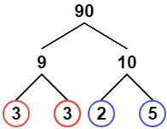
- For example, the prime factorization of 90 is 2 • 3 • 3 • 5, or, using exponents, 2 • 3² • 5.
- To find the prime factorization of a number, you can use a factor tree like the one shown to the right.

