Name: Date:

Student Exploration: Finding Patterns

Vocabulary: pattern, sequence

Prior Knowledge Questions (Do these BEFORE using the Gizmo.)
Marco is playing with his penny collection. First, he places a single penny on the table. Next, he adds two more to make a triangle of 3 pennies. He then adds three more pennies to create a triangle with 6 pennies.

- If Marco keeps adding pennies to make new triangles, how many pennies will the next two triangles have? (Hint: Draw pictures.)

- What is the pattern in the number of pennies added for each new triangle?

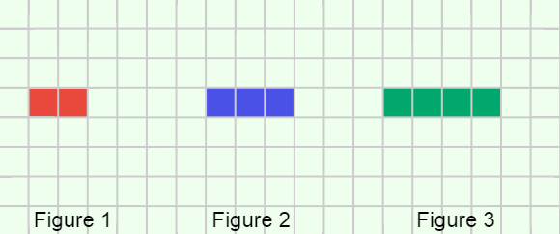
Gizmo Warm-up
If you count the pennies in each triangle
(1, 3, 6, etc.), you get an ordered list called a sequence. A sequence is a type of pattern, or arrangement of objects or numbers that follows a rule. The terms in many sequences increase (or decrease) according to a rule, such as “add 2” or “subtract 3.”

You can explore geometric patterns and sequences in the Finding Patterns Gizmo. The first pattern you see will look like the image above. (If not, click NEW until it does.)

- How many squares are colored in each figure?

Figure 1: Figure 2: Figure 3:

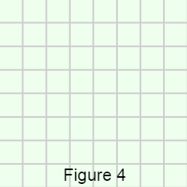
- How many squares will be colored in the next figure?

- Draw Figure 4 by clicking on the grid, one square at a time. Click CHECK to see if you were right. If you are incorrect, click TRY AGAIN until you have it right.

When you are done, sketch the correct figure in the grid to the right.

Activity:  Continuing the pattern | Get the Gizmo ready:  - Click NEW. | 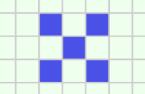

- In the space below, draw the shapes that make up the pattern you see. Below each figure, write the number of colored squares. (Leave Figure 4 blank for now.)

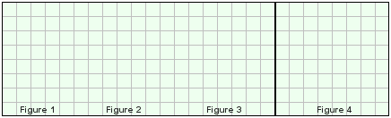

- How many squares do you think Figure 4 will have?

Explain your reasoning.

- Draw Figure 4 in the Gizmo, and click CHECK to see if you were right. Once you get the correct figure, draw it on the grid above.

- Turn on Show relationship between figures.

- What is the rule given for determining how many squares are in the figure?

- Look at the number line below the table. How does the number line indicate how many squares are in each figure?

- How many squares would be in the tenth figure of this pattern? Show your work in the space to the right.

Squares in the tenth figure:

(Activity continued on next page)
Activity (continued from previous page)

- Click NEW to generate two new patterns. For each pattern, do the following:
- Sketch the first three figures in the provided grids.
- List the number of shaded squares in each figure in the blanks, and calculate the number of shaded squares in Figure 4.
- Sketch Figure 4 and check your answer in the Gizmo.
- Write a rule for determining how many squares are in the next figure.

When you have finished this activity, keep solving more patterns in the Gizmo!
Pattern 1

Rule:

Pattern 2

Rule:

- Challenge: The Fibonacci Sequence is the sequence: 0, 1, 1, 2, 3, 5, 8, 13, 21, etc. Try to figure out how each number in the sequence is determined by the previous numbers.

- What is the rule for finding the next number in the Fibonacci sequence?

- What are the next three numbers in the sequence?

