Name: Date:

Student Exploration: Fingerprinting

Vocabulary: accidental whorl, arch, central pocket loop whorl, double loop whorl, fingerprint, fingerprint dust, latent print, loop, minutiae, patent print, plain arch, plain whorl, plastic print, radial loop, tented arch, ulnar loop, whorl

Prior Knowledge Question (Do these BEFORE using the Gizmo.)
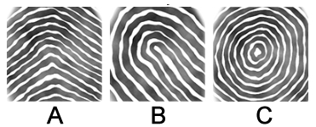
Fingerprints are complex patterns of ridges on the fingertips that help you to grasp and hold onto objects. At right are examples of the three main types of fingerprints. How would you describe each print?

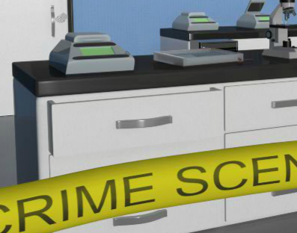
Gizmo Warm-up
Welcome to the CSI training lab! In the Fingerprinting Gizmo you will learn how to find, collect, classify, and match fingerprints collected from the crime scene to suspects.

Check that the Training mode is selected. In the crime lab, someone has come in and “stolen” valuable equipment, leaving their fingerprints behind. Your job is to find and collect the fingerprints. Click Continue to enter the lab.

- Click on the lab door. What do you notice?

- The smudge you see is a fingerprint. Drag and release the camera over the fingerprint to take a photograph. Now look at the definitions of the three types of crime-scene prints.

What kind of print is an impression in a soft substance such as wax?

What kind of print is formed from skin oils and is normally invisible?

Which print is formed from a visible substance transferred by the fingers?

Which type of print was found on the door?

Select your answer and click Check. Correct your answer if needed.
Activity A:  Collect prints | Get the Gizmo ready:  - Check that Collect prints is selected. | 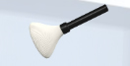

Introduction: Prints collected at a crime scene can be grouped into three categories. Patent prints are made when fingers transfer a visible substance, such as blood, onto another surface. Plastic prints are formed when an impression is made on a soft surface, such as wet paint. Latent prints are made by the oils of the finger and are invisible to the naked eye.

Question: How are fingerprints collected at a crime scene?

- Explore: Look for other visible prints by clicking on different parts of the crime lab. (Hint: There are two visible prints in total.) You can select Show all locations to see which parts of the lab you can see up close. Photograph and classify each print that you find.

- Observe: After finding the two visible prints, you will see a duster appear in the upper right corner. The duster spreads fingerprint powder, which sticks to the skin oils that make up latent prints, allowing them to be seen. Drag the duster into the lab to dust for prints.

Now search the room again. When you find a latent print, collect the print by dragging the roll of tape over the print. (Latent prints are collected using tape, which sticks to the fingerprint powder.) Collect and classify the three remaining prints.

- On what types of surfaces are latent fingerprints most likely to be found?

- Why do you think prints stick to these surfaces?

- Infer: Latent fingerprints are composed of skin oils.

- What might cause a person to leave faint or incomplete prints?

- If you wished to leave no fingerprints behind, what could you do?

- Apply: Once you have collected the rest of the prints, complete the following sentences.

- If you touch a partially melted candy bar, a print might form.

- If you dip your finger in ink and touch the wall, a print might form.

- If you hold a drinking glass, a print might form.
Activity B:  Classify prints | Get the Gizmo ready:  - After collecting the training scene prints, press Continue to go to the Classify prints step. | 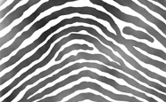

Introduction: While every fingerprint is unique, fingerprints tend to follow one of three patterns: arch, loop, and whorl. In this activity, you will identify the group and subgroup of each print.

Question: How are fingerprints classified?

- Observe: Read the descriptions of the three main pattern groups at the top of the screen.

How can you distinguish a loop from an arch?

- Describe: Within each group are two or more subgroups. At the top of the screen, select Arch subgroups, Loop subgroups, and Whorl subgroups.

- How can you distinguish a plain arch from a tented arch?

- How can you distinguish an ulnar loop from a radial loop?

Note: Because your thumbs are on opposite sides, left-hand ulnar loops resemble right-hand radial loops, and left-hand radial loops look like right-hand ulnar loops.

- Write a quick description of each whorl subgroup.

Plain whorl:

Central pocket loop whorl:

Double loop whorl:

Accidental whorl:

- Classify: There are three suspects in this “burglary.” Using the exemplar images, classify each of the suspect prints. To do this, drag each print into one of the subgroup bins on the right. Then classify each of the crime scene prints.

Why is it impossible to tell if a crime scene print is an ulnar loop or a radial loop?

Activity C:  Identifying minutiae and matching prints | Get the Gizmo ready:  - Once you have classified all of the training scene prints, click Continue or select Identify minutiae. | 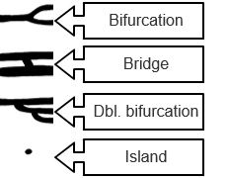
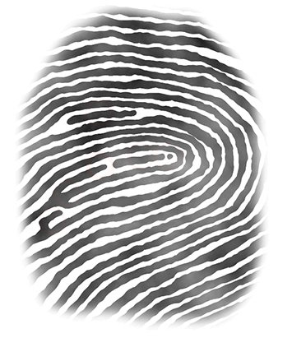
Introduction: While two fingerprints may belong to the same subgroup and may look very similar, how can you tell if they really came from the same finger? One way is to identify tiny details, called minutiae (my NEW she a). In this activity, you will learn how to find minutiae and use minutiae to match fingerprints. You will then be ready to solve crimes!

Question: Can fingerprints be used to solve a crime?

- Observe: Drag the first print into the large white box. What interesting details do you think might help to match this print to a crime scene print? Circle some of these in the image at right.

Look at the list of minutiae to the left of the print. Which minutiae do you see on the big print?

- Identify: To label minutiae, drag a label from the Minutiae list on the left to the correct spot on the print. Identify as many as you can find. Repeat this process for each print.

- Which minutiae did you find on the second print?

- Which minutiae did you find on the third print?

- Match: When you have found at least one example of each type of minutia, click Continue to move on to the Match prints section. Drag the first collected print to the main area.

- Which type of print is this?

- Select Jill Johnson, then click the right arrow until you find a print that looks identical to the collected print. Which print did you pick?
(Activity C continued on next page)
Activity C (continued from previous page)

- Identify: When you think you have a good match, click Find minutiae. To match the prints, you will need to identify three common minutiae in the two prints. Label minutiae that match in each print. After identifying the minutiae, the Gizmo will tell you if the prints match.

Which suspect print matched the collected print?

- Solve the case: Next to Compare, select Prints of the same subgroup to only see suspect prints of the same subgroup as the collected print. Match the remaining collected prints.

- Which suspect matched all of the collected prints?

- Click Solve crime, choose the suspect, and click Check. Were you correct?

Congratulations! You have completed your crime scene investigator (CSI) training as a fingerprint analyst. Now you are ready to solve “real” crimes!

- Apply: Under Mode, select Crime scene 1. This is a sinister case of sabotaged stew in a swanky restaurant. Use the procedures you have learned to collect fingerprints, classify fingerprints, and use minutiae to match collected fingerprints to suspect fingerprints.

Which suspect broke into the Glitzy Gala kitchen and sabotaged the stew?

- Apply: Select Crime scene 2, where Dorothy Dalrymple’s diamonds were burgled. Collect, classify, and match the fingerprints from this scene.

- Which suspect (or suspects) left prints in the bedroom?

- Which suspect is the most likely thief, and why do you think so?

- Think and discuss: Fingerprinting is great for proving that a person was at a crime scene, but it can’t solve every crime. What are some of the limitations of using fingerprints as evidence? If possible, discuss your thoughts with your classmates and teacher.

