Vocabulary: Fingerprinting
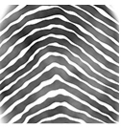

Arch
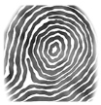

Central pocket loop whorl
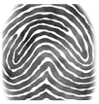

Accidental whorl
Vocabulary

- Accidental whorl – a type of fingerprint that includes two or more different patterns (other than a plain arch).
  - Accidental whorls include prints that do not fall into other print subgroups. They may include one or more characteristics from other patterns.

- Arch – a fingerprint pattern in which ridges enter one side of the print, curve upward and then downward, and then exit on the opposite side.

- Central pocket loop whorl – a type of pattern in which the ridges form a circular whorl inside a loop.

- Double loop whorl – a type of whorl pattern containing two separate loops.
  - Also referred to as twinned loops.

- Fingerprint – a distinct pattern of raised ridges found on the tip of a finger, or the impression made on a surface by these ridges.
  - No two people, not even identical twins, have the exact same fingerprints. Fingerprints remain the same throughout a person’s life.
  - Each person has ten unique fingerprints—one for each finger and thumb.
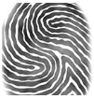

Double loop whorl
  - Other animals—such as chimpanzees, gorillas and koalas—have fingerprints.

- Fingerprint powder – a fine powder designed to stick to the skin oils that make up latent fingerprints.

- Latent print – an invisible print formed by the transfer of skin oils to another surface.
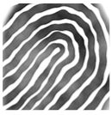

Loop
  - Latent prints tend to form on smooth, hard surfaces such as a glass or countertop.

- Loop – a fingerprint pattern containing ridges that enter from one side of the print and then curve around to exit on the same side of the print.

- Minutiae – small details in the ridge pattern that can help in matching two prints.
  - Some examples of minutiae include islands, bridges, lakes, and bifurcations.

- Patent print – a visible print made when a finger comes into contact with a visible substance such as blood, ink, or paint. The substance on the ridges of the finger is then transferred to another surface, leaving a stamp of the print.

- Plain arch – a type of arch containing ridges that curve gradually and do not form sharp peaks or angles.

Plain arch

- Plain whorl – a pattern in which the ridges form concentric circles.

- Plastic print – a visible, three-dimensional impression formed when a finger touches a soft material such as soap, clay, wet paint, or butter.
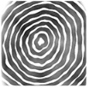

Plain whorl
- Radial loop – a type of loop fingerprint in which the ridges enter and exit from the direction of the thumb.
  - The ridges in a radial loop come from the direction of the radius, a bone on the thumb side of the forearm.

- Tented arch – a type of arch containing ridges that curve up sharply to form a distinct peak, like a tent.
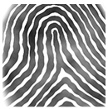

Tented arch

- Ulnar loop – a type of loop fingerprint in which the ridges enter and exit from the direction of the little finger.
  - The ridges in an ulnar loop come from the direction of the ulna, a bone on the little finger side of the forearm.

- Whorl – a fingerprint pattern that contains either a series of concentric circles or a combination of other patterns.

