Name: Date:

Student Exploration: Flood and Storm-Proof Homes

[Note to teachers and students. This lesson was designed to be used along with the Earthquake-Proof Homes lesson. You can do the lessons in any order.]

Vocabulary: flood, floodplain, foundation, frame, gable roof, hip roof, hurricane, levee, natural disaster, roof clips, stilts, storm surge

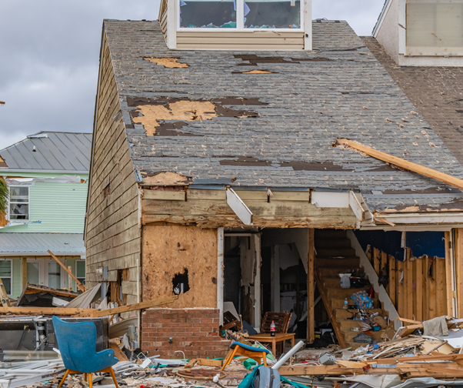
Prior Knowledge Questions (Do these BEFORE using the Gizmo.)
A hurricane is a storm with very strong winds. The image shows a house that was damaged by Hurricane Michael in 2018.

- In what ways was the house damaged?

- How do you think a house could be built to better survive a hurricane?

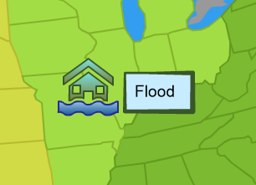
Gizmo Warm-up
A hurricane is a type of natural disaster. A natural disaster is a sudden event that can destroy homes and hurt people. In this lesson, you will try to build houses that can do well in floods and hurricanes.

- On the Gizmo, select Flood. What is a floodplain?

- Select Next and watch. What causes floods to occur?

- What happens during a flood?

Activity A:  Floods | Get the Gizmo ready:  - If necessary, select Flood on the map.  - Click Next until you get to the Location choice. | 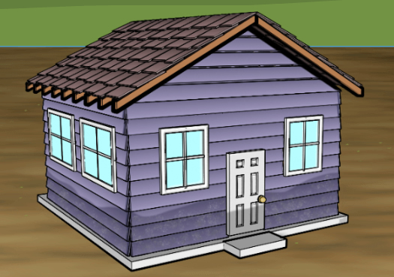

Introduction: St. Louis is a city next to the Mississippi River. Many parts of St. Louis and the surrounding area are built on a floodplain. When the river floods, these areas may fill with water. For any builder, the goal is to keep the flood waters out of the house.

Goal: Build a house to survive a flood.

- Compare: Check that you are on the Location screen. How much does each location cost?

Floodplain: Levee protection:

A levee is low dirt wall beside a river. The goal of a levee is to protect homes from floods. If the flood is really big, the water might go over the levee.

- Build: Select Location 1 – Floodplain. From the Saved houses area at bottom left, drag house A into the building site in the middle. House A is a basic house.

Look at the House cost at upper left. How much does house A cost?

- Test: Click Test house and then click Play () to see how this house does in a flood.

- What happens?

- Turn on Show house interior. What does the inside of the house look like?

- Turn on Show damage report. What is the cost of repairs?

- Build: Select Build. Select Reset house and click Yes. Try to build a house that can best survive a flood.

To start your house, select a Foundation. The foundation is the base of the house. Then select options for the frame, walls, roof type, and roof material. If you like, you can add “extras” to the house after choosing the roof. List the features of your house below.

Foundation |  | Roof type
Frame |  | Roof material
Walls |  | Extras

What is the cost of your house?

(Activity A continued on next page)
Activity A (continued from previous page)

- Test: Click Test house and then click Play. What is the score of your house?

- Experiment: Select Build. Try different options until you build a house with a perfect 100% score. When you succeed, select Save house. Which features did you choose?

Foundation |  | Roof type
Frame |  | Roof material
Walls |  | Extras

What is the cost of the house?

What is the one feature that will always give you a 100% score?

- Experiment: While building a house up on stilts can save a house from a flood, most builders don’t do this because it costs a lot of money. (In many cases, floodplains are places where people with less money live because the land is cheaper there.)

Build a house for less than $90,000. Can you build a house that gets a score of 80%?
If you can’t use a stilt foundation, which “extra” is most important?

Sandbags do not provide perfect protection, but they are better than nothing!

- Compare: Select Location and choose Location 2 – Levee protection. Remember that a levee is a low wall of dirt between houses and the river. Click Test house and run the simulation at least 10 times, or until you get a different result.

- What happens during most floods?

- What happens every so often?

Levees are designed to protect houses from most floods. But there is always a chance that there will be a flood so big that it goes right over the levee. In this case, the levee can trap the floodwater near houses and prevent it from flowing back into the river.

- Think and discuss: Suppose you are buying a house. You are choosing between two houses in the floodplain. Would you pay extra for a house built behind a levee? Explain.

Activity B:  Hurricanes | Get the Gizmo ready:  - Select Back to map.  - Select Hurricane. | 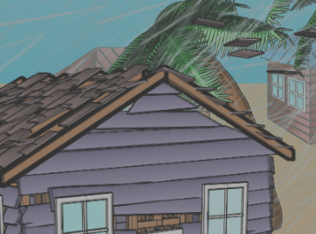

Introduction: Wilmington, NC is on the southeast coast of the United States. Any part of this coast can be hit by huge storms, called hurricanes. With winds that can blow over 157 miles per hour (250 km/h), hurricanes can destroy houses, roads, and other structures. The goal of a builder is to keep the wind and water on the outside of the house.

Goal: Build a house to stand up to a hurricane.

- Observe: Read about Wilmington, then press Next. What do you notice about the shape of a hurricane and how it moves?

- Compare: Click Next to get to the two location choices. How much does each location cost?

Inland: Beachfront:

Land on a beach is much more expensive than land farther from the ocean.

- Observe: Select Location 1 – Inland. Drag house A into the building site in the middle. Click Test house and then click Play.

- What happens?

- Turn on Show house interior. What does the inside of the house look like?

- Turn on Show damage report. What is the cost of repairs?

- Build: Select Build. Select Reset house and click Yes. Try to build a house that you think can best survive a hurricane. List the features of your house below. Then test the house.

Foundation |  | Roof type
Frame |  | Roof material
Walls |  | Extras

What is the cost of your house? What is the house’s score?
(Activity B continued on next page)
Activity B (continued from previous page)

- Experiment: Select Build. Try different options until you build a house with a score above 90%. When you succeed, select Save house. List the features of your house:

Foundation |  | Roof type
Frame |  | Roof material
Walls |  | Extras

What is the cost of the house? What was the score?

- Assess: Experiment with the Gizmo to determine the answers to these questions.

- Which “extra” is the most helpful?

Roof clips are pieces of metal that attach the roof to the walls. They can make the difference between the roof staying on the house or blowing away.

- Which roof is best, a gable roof or a hip roof?

A hip roof is slanted on all sides to allow wind to flow over the house.

- Compare: Select Location and choose Location 2 – Beachfront. Test the same house that you used for question 6.

- What was the score of the house on the beachfront?

- What happens to a house on the beach that does not happen inland?

- Which foundation works best at the beach?

On the beach, hurricanes can push ocean waves much higher than normal. This is called a storm surge. Building a house on stilts can keep it above the storm surge.

- Summarize: Remember the house from the start of the lesson? Explain to the owners how you would rebuild their house to better survive a hurricane.

