Vocabulary: Flood and Storm-Proof Homes

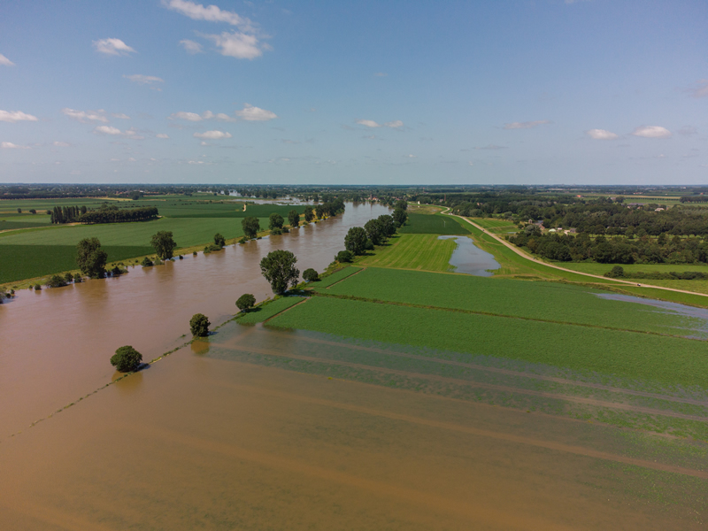

A floodplain during a flood
Vocabulary

- Flood – a natural disaster that happens when a river overflows and water covers the surrounding land.

- Floodplain – a flat area next to a river.
  - When a river floods, the floodplain fills with water.
  - Houses built in a floodplain can be damaged in a flood.

- Foundation – the base of a building.

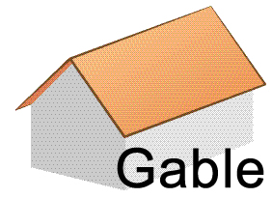
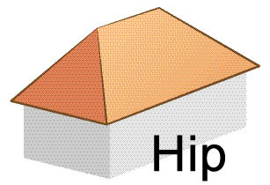
- Frame – the “skeleton” that supports a house.

- Gable roof – a simple roof with two angled sides.

- Hip roof – a roof in which all four sides are angled.

- Hurricane – a large, rotating storm with strong winds.
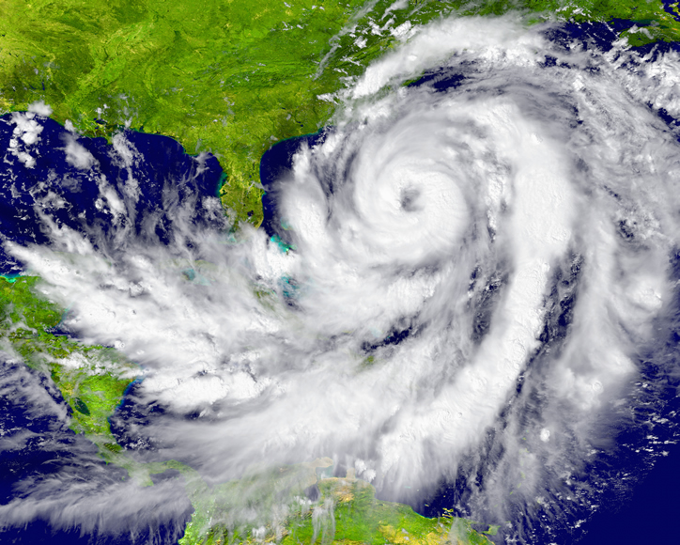

Huge hurricane near Wilmington, NC
- Hurricane wind speeds are at least 74 miles per hour (119 kilometers per hour).
- The strongest hurricane winds are greater than 155 miles per hour (250 kilometers per hour).
- In other parts of the world, hurricanes are called typhoons.

- Levee – a low wall built of soil along a river.
- The purpose of a levee is to prevent flooding.

- Natural disaster – a natural event that causes major destruction or death.
  - Examples of natural disasters include earthquakes, floods, hurricanes, and fires.
  - Natural disasters are not caused by people.

- Roof clips – metal brackets that attach the roof of the house to the walls.
  - Roof clips are also called hurricane clips or hurricane straps.
- Stilts – a foundation that raises a house above the ground.
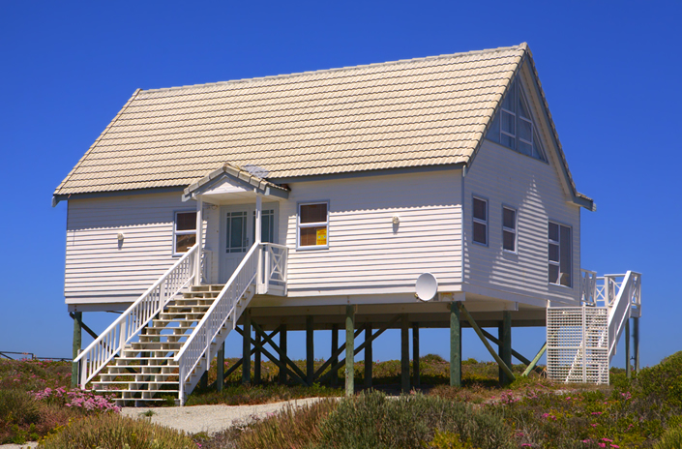

Beach house built on stilts
  - Houses on stilts are common near beaches and in floodplains.

- Storm surge – a rise in seawater level caused by a storm.
  - Winds from the storm can push water towards the shore, causing houses and roads to flood.

