Name: Date:

Student Exploration: Eyes and Vision 2 – Focusing Light

[Note to teachers and students: This Gizmo was designed as a follow-up to the Eyes and
Vision 1 – Seeing Color Gizmo. We recommend doing that activity before trying this one.]

Vocabulary: cornea, diameter, focus, iris, lens, optic nerve, pupil, retina

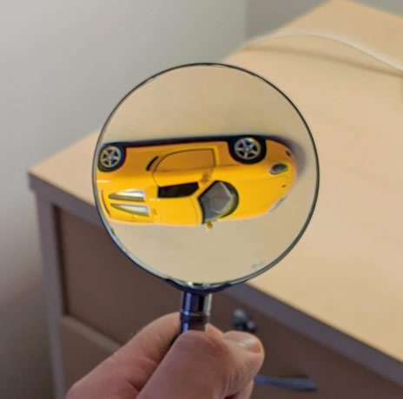
Prior Knowledge Questions (Do these BEFORE using the Gizmo.)
Javier is looking through a magnifying class at a toy car that is sitting on a table a few feet away. The car appears to be upside down.

- How do you think a magnifying glass makes objects appear upside down?

- How do you think an eye is similar to a magnifying glass?

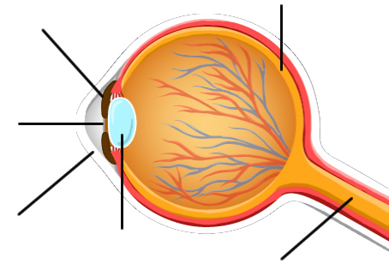
Gizmo Warm-up
Once light enters the eye, how is the light focused to make an image? You will answer this question in the Eyes and Vision 2 – Focusing Light lesson.

To begin, learn the names of the different parts of the eye. On the Eyes and Vision Gizmo, select the FOCUS tab. Turn on Show labels.

- Fill in the above diagram with the parts of the eye.

- Guess which parts of the eye have these functions. (Don’t worry if you are wrong.)

- Which part is an opening that allows light inside?

- Which part bends the light that enters the eye?

- Which part detects the light that goes into the eye?
Activity A:  The pupil | Get the Gizmo ready:  - On the FOCUS tab, turn off Show labels.  - Check that the Distance is 1.00 m and the Light intensity is 50%. Set the Lens roundness to 20%. | 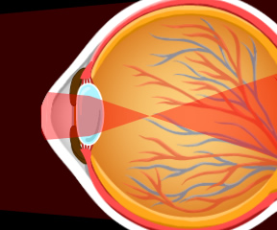
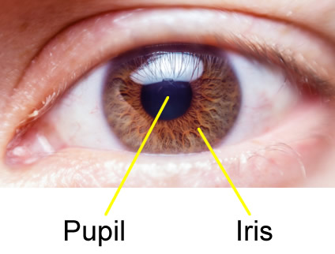
Introduction: Light first enters the eye through a clear, protective window called the cornea. Next, light passes through an opening called the pupil. The size of the pupil is controlled by a colorful structure called the iris.

Question: How does the eye control how much light gets inside?

- Predict: The distance across the pupil is its diameter. The diameter of the pupil changes in response to the brightness of the light.

In bright light, do you think the pupil diameter will get larger or smaller?

In dim light, do you think the pupil diameter will get larger or smaller?

- Observe: Turn on Show what the eye “sees.” Move the Pupil diameter slider back and forth. What do you notice about the apple?

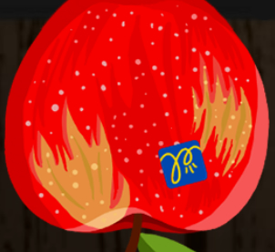

- Collect data: Change the Light intensity to the settings in the table below. Then, adjust the Pupil diameter until the brightness of the apple looks “normal,” like the image at right. Record the ideal pupil diameters below.

Light intensity % | Pupil diameter (mm) | Light intensity % | Pupil diameter (mm)
25% |  | 75%
50% |  | 100%

- Analyze: What does the data tell you about how pupil diameter responds to bright light?

- Apply: You walk outside into direct sunlight and your eyes hurt because it seems so bright. After a few seconds you see normally again. What is happening to your pupils? Explain.

Activity B:  The lens | Get the Gizmo ready:  - Set the Distance to 1.00 m, Light intensity to 50%, and Pupil diameter to 4.0 mm.  - Turn off Show what the eye “sees.” | 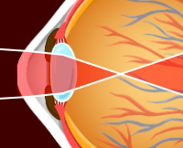
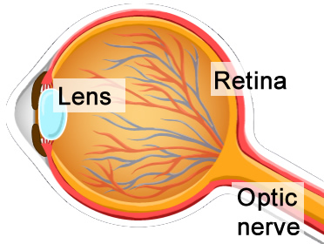
Introduction: Light passes through the pupil into the lens, a round structure that bends light. The light then forms an image on the retina at the back of the eye. The retina is a sheet of cells that detects light and sends signals through the optic nerve to the brain.

Question: How does the lens focus light that enters the eye?

- Observe: Set the Lens roundness to 100%. Look closely at the light that goes into the eye.

- What happens to the light when it passes through the lens?

- Look at the image of the apple on the retina. What do you notice about this image?

- Observe: Next to Show, select Ray trace. This shows what happens to a single ray of light reflected from the top of the apple and a single ray reflected from the bottom of the apple.

- Where does light from the top of the apple end up?

- Where does light from the bottom of the apple end up?

- Why is the image of the apple on the retina upside down?

- Explore: If you have ever used binoculars or a telescope, you may have noticed that what you see sometimes looks blurry. To see a sharp image, you may need to adjust the distance between the lenses. Unlike the glass lenses in binoculars, the lens in the eye is “squishy.” Small muscles change the shape of the lens to bring the image into focus.

Check that the Distance is 1.00 m. Set the Lens roundness to 20%. Turn on Show what the eye “sees.”

- Is the apple blurry or in focus?

- Reduce the Lens roundness to 0%. What happens?

- Increase the Lens roundness to 50%. What happens?

(Activity B continued on next page)
Activity B (continued from previous page)

- Predict: A lens bends light because it has a rounded shape. The rounder the lens, the more it bends light. Predict how the lens shape will change if the distance to the object changes.

If an object moves farther away, will the lens become flatter or rounder?

If an object moves closer, will the lens become flatter or rounder?

- Collect data: With the Distance slider, change how far the apple is from the eye. For each distance, find the lens roundness that produces the sharpest image. Record your results.

Distance (m) | Lens roundness (%) | Distance (m) | Lens roundness (%)
0.20 m |  | 0.80 m
0.40 m |  | 1.60 m

- Analyze: As an object gets farther away, how does the shape of the lens change to keep it in focus?

- Explore: Turn off Show what the eye “sees.” Next to Show, select Focus. Set the Distance to 0.50 m and the Lens roundness to 12%. This view shows two rays of light reflecting from the same place on the apple and both going through the lens.

- Do the two lines from the apple meet at the same spot on the retina?
- Do you think the apple will be in focus?

Check by selecting Show what the eye “sees.”

- Adjust the Lens roundness until the two focus lines meet at the same spot on the retina. Is the apple in focus now?
In general, the image will be in focus when all the rays of light from one point on the object meet at one point on the retina.

- Summarize: Explain how the lens changes shape to help us see near and distant objects.

