Name: ______________________________________ Date: ________________________

Student Exploration: Forest Ecosystem

Vocabulary: consumer, decomposer, inorganic, organic, organism, population, producer

Prior Knowledge Questions (Do these BEFORE using the Gizmo.)

- When a rancher puts cattle in a pasture, what happens to the amount of grass in it?

_________________________________________________________________________

- If someone adds thousands of small fish to a lake, how would the number of big fish change? __________________________________________________________________
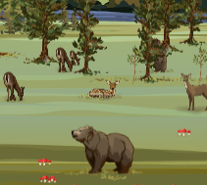
Gizmo Warm-up
The Forest Ecosystem Gizmo shows you the effects of adding organisms to, or taking them from, a forest. An organism is any living thing. To start, do the following:
- Click Advance year a couple times to see two years of growth.
- Remove all Deer from the forest by clicking the minus (-) button until none remain.
- Click Advance year a couple more times.

- Select the DATA tab. Select Pictograph and click the Tree to show the size of the tree population for the past several years.

  - How did removing deer affect the tree population? ___________________________

  - Why do you think this happened? ________________________________________

___________________________________________________________________

- Under Choose organism, select the Mushroom.

  - How did losing deer affect the mushrooms? ________________________________

  - Explain why this may have happened. ____________________________________

___________________________________________________________________

Activity A:  Trees | Get the Gizmo ready:  - Click Reset.  - Select the FOREST tab. | 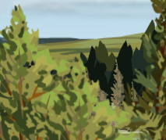

Question: What role do trees play in the forest?

- Form hypothesis: Where do you think trees get the nutrients they need to grow? _________

_________________________________________________________________________

- Predict: Based on your hypothesis, how will the tree population change if ALL other organisms (deer, bears, and mushrooms) are removed from the forest?

_________________________________________________________________________

- Analyze: Remove ALL organisms except trees. Click Advance year a few times and select the DATA tab. Was your prediction correct? Explain what you found.

_________________________________________________________________________

_________________________________________________________________________

- Draw conclusions: Substances that contain carbon and are produced by living things are called organic. Examples of organic materials are sugar, blood, protein, and fat. Other materials, like water, carbon dioxide, oxygen, and ammonia, are called inorganic.

Some living things, called producers, can produce the organic materials they need (like food) from inorganic matter. All other organisms are consumers; they consume organic matter since they cannot make it themselves.

Do your results show you that trees are producers or consumers? Explain. _____________

_________________________________________________________________________

_________________________________________________________________________

- Analyze: Click the FOREST tab. Click the plus (+) button for mushrooms several times. Click Advance year a few times. Select the DATA tab.

How did adding mushrooms affect trees? ________________________________________

- Extend: The mushrooms thrived without hurting trees. How could this happen? Try for two possible explanations. Write your ideas in your notebook or on the back of this sheet.

Activity B:  Bears | Get the Gizmo ready:  - Click Reset.  - Select the FOREST tab. | 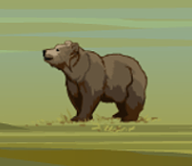

Question: How do bears get the nutrients they need to live?

- Explore: Using the Gizmo, try to figure out what bears depend on for nutrition.

- Form hypothesis: How do bears get the energy and nutrients they need? _______________

_________________________________________________________________________

- Predict: Based on your hypothesis, which population(s) would be hurt if bears were added?

_________________________________________________________________________

- Test: Click Reset. Click Advance year a couple times. Add as many bears to the forest as possible. Then go forward a couple more years. Select the DATA tab. Which populations were hurt by adding bears?

_________________________________________________________________________

- Classify: Are bears producers or consumers? Explain your reasoning. _________________

_________________________________________________________________________

_________________________________________________________________________

- Draw conclusions: An organism that breaks down organic matter into simpler materials (like carbon dioxide) is called a decomposer. Decomposers absorb nutrients from living things or the organic matter they leave behind. They do not need to kill to get their food.

Do your results suggest bears are decomposers? Explain your reasoning. ______________

_________________________________________________________________________

_________________________________________________________________________

- Challenge: Using the Gizmo, figure out what bears prefer to eat most. Write your results and reasoning in your notebook or on the back of this sheet.

Activity C:  Mushrooms | Get the Gizmo ready:  - Click Reset.  - Select the FOREST tab (if necessary). | 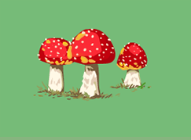

Question: How do mushrooms get the nutrients they need to grow?

- Explore: Use the Gizmo to test if mushrooms feed on living things. Describe your trials and results in your notebook or on the back of this sheet. What did you find?

_________________________________________________________________________

- Form hypothesis: How do mushrooms get their food? ______________________________

_________________________________________________________________________

- Predict: Based on your hypothesis, how will the mushroom population change when other organisms are added to the forest? Fill in the middle column below with your predictions.

Change | Predicted effect on  mushroom population | Actual effect on  mushroom population
Trees added
Deer added
Bears added

- Test: Test your predictions with three separate trials. Write the results in the last column of the table above. Paste snapshots of the three line graphs into a blank document.

- Classify: Do your experiments suggest that mushrooms are decomposers (organisms that break organic matter down to simpler, inorganic matter)? Explain.

_________________________________________________________________________

_________________________________________________________________________

_________________________________________________________________________

- Extend: If mushrooms were producers, how would your results in question 3 have been different? _________________________________________________________________
_________________________________________________________________________

