Name: ______________________________________ Date: ________________________

Student Exploration: Fraction Artist 2

Vocabulary: denominator, fraction, numerator

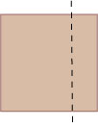
Prior Knowledge Questions (Do these BEFORE using the Gizmo.)

- Your friend agrees to give you half of a brownie. He then cuts it in two pieces as shown in this picture and gives you the piece on the right. What do you say to your friend?

___________________________________________________

___________________________________________________

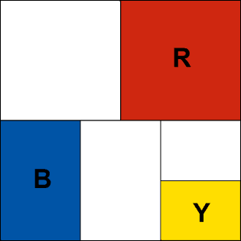
- Look at the painting shown to the right. Would you say that this painting is half red? Why or why not?

___________________________________________________

___________________________________________________

Gizmo Warm-up

Some modern art is composed entirely of lines and colors. Notice that the modern painting shown above was made by dividing the canvas into sections of different sizes. You can use the Fraction Artist 2 Gizmo to make your own modern paintings.
- Use the Gizmo to create your own original work of art!
- First divide the canvas into sections. (Click one of the four Divide canvas tools. Then click on the canvas.)
- Then add some color! (Click on one of the colors on the Paint canvas palette. Then click on the canvas.)

- As carefully as you can, sketch your painting in the square to the right. If you don’t have colored pencils, label the colored sections R (red), B (blue), or Y (yellow).

- Every painting needs a title. What’s the title of your painting?

__________________________________________________

Activity A:  Art school | Get the Gizmo ready:  - Click on the New Painting button. | 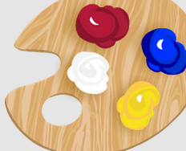

Welcome to Piet’s School for Young Artists! Follow these steps to get your Fraction Art degree.
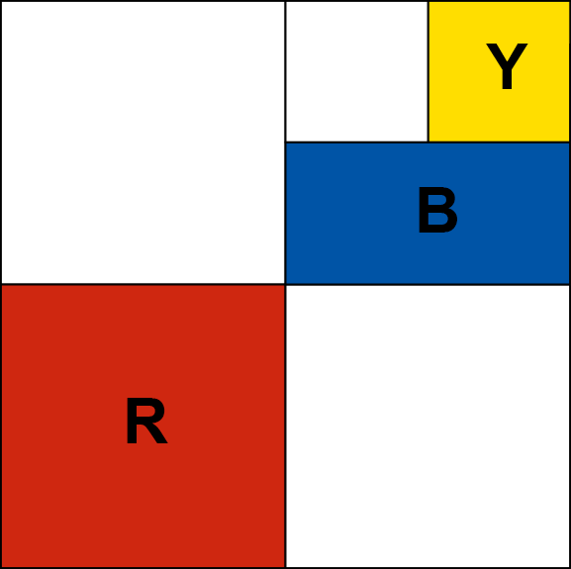
- First, a good artist needs painting skill. Use the Gizmo to create the painting shown here. Be sure to make yours exactly like it!

- An artist also needs imagination. Look at the red section in your painting. Try to imagine that your painting was completely filled with sections identical to that red one.

How many red sections would it take to completely fill your painting? __________

One red section covers one-fourth () of the painting’s area.

- Now imagine your painting was only made out of sections just like your blue section.

How many blue sections would it take to completely fill a painting? __________

What fraction of the painting’s area does one blue section cover? __________

- Click on Inspect Sections and move your mouse over the blue section. A grid shows your painting covered with sections that are the same size as the blue one. Use the grid to check your answers to the questions above. (Change your answers if necessary!)

- A student at another art school said that this painting is one-sixth yellow. Please teach this student how he could find the correct fraction for the yellow section without the Gizmo.

_________________________________________________________________________

_________________________________________________________________________

_________________________________________________________________________

Congratulations, you’ve earned your degree in Fraction Art! If you’ve made it this far, why not complete our challenge project and graduate with honors.

Challenge: Create a new painting that is one-third () red and one-twelfth () blue. Either paste a snapshot of it into a word-processing document, or sketch it on the back of this page.

Activity B:  Art contest | Get the Gizmo ready:  - Click on the New painting button. | 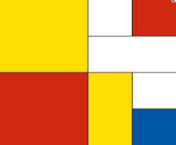

Dobro’s Art Supply store is holding a painting contest. The rules for the contest are:
  - Your painting must have exactly three non-white sections: one red, one blue, one yellow. (It can have as many white sections as you want.)
  - The red section must be twice as big as the blue section.
  - The blue section must be twice as big as the yellow section.

- Use the Gizmo to make a painting for the contest. When you are done:
- Draw your painting in the square to the right. If you don’t have colored pencils, label each colored section with R (red), B (blue), or Y (yellow).
- What fraction of your painting is:

red _________ blue _________ yellow _________

- The contest allows an artist to enter two paintings. Click New painting and make another entry. Try to make it as different from your first painting as possible. When you’re done:
- Draw your painting in the square to the right.
- What fraction of your painting is:

red _________ blue _________ yellow _________

- Look closely at the fractions you wrote for your paintings. Describe any patterns you see:

_________________________________________________________________________

_________________________________________________________________________

_________________________________________________________________________

- Your friend has made a painting that is red, blue, and yellow. Do you think her painting meets the contest rules? Why or why not?

_________________________________________________________________________

_________________________________________________________________________
Activity C:  The blue period | Get the Gizmo ready:  - Click on the New Painting button. | 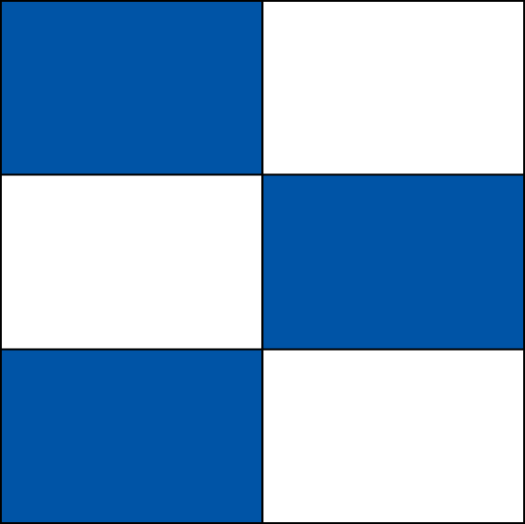
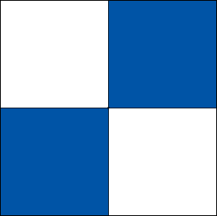
Mr. Cerulean is an art collector. He has hired you, the world-famous fraction artist, to make three more blue-and-white paintings for his collection.

- Mr. Cerulean’s two favorite paintings are shown to the right. What do they have in common?

_________________________________________________________________________

- Use the Gizmo to make three paintings for Mr. Cerulean. Follow these rules:
- Make each painting one-half blue and one-half white.
- Make one painting with three blue sections, one with four, and one with five.
- The blue sections of a painting cannot touch on the sides. (They can touch at the corners like they do in one of the paintings shown above.)

When you are done, draw your paintings in these squares. (Shade in the blue sections.)
3 blue sections 4 blue sections 5 blue sections

- Mr. Cerulean likes your paintings, but he needs you to convince him that your painting with five blue sections is really one-half blue. How would you explain this to him?

_________________________________________________________________________

_________________________________________________________________________

_________________________________________________________________________

Challenge: Mr. Cerulean wants to give a painting to his daughter, Rosa, but Rosa likes red.
- Pick a painting and add red sections so that it is one-fourth red and one-half blue.
- Paste a snapshot of Rosa’s painting into a document, or draw it on the back of this page.

