Name: ______________________________________ Date: ________________________

Student Exploration: Free Fall Tower

Vocabulary: accelerate, air resistance, free fall, gravity, terminal velocity, vacuum

Prior Knowledge Questions (Do these BEFORE using the Gizmo.)

- Patty climbs a tree. While sitting on a branch, she drops a leaf and an acorn at the same time. What would happen? ___________________________________________________
_________________________________________________________________________

- Patty decides to try another experiment. From the same branch, she drops a large, heavy rock and a small pebble. What would happen this time? ____________________________
_________________________________________________________________________

Gizmo Warm-up
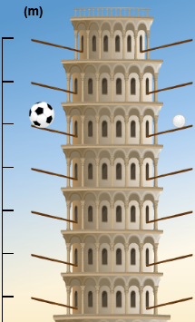
In the Free Fall Tower Gizmo™, drag a pair of objects (no parachutes) to the top of the tower, one to each platform. Check that Air is selected.

Click Play (). The objects are now in free fall, pulled to Earth by the force of gravity.

- What did you drop? __________________ __________________

- Did the objects fall at the same rate? ________________________

- Which object fell faster? __________________________________

- Click Reset (). Drop each possible combination of objects without parachutes.

  - Which object fell fastest? _________________ Slowest? _________________

  - Why do you think some objects fall faster than others? _______________________

___________________________________________________________________

___________________________________________________________________

Activity A:  Free fall in a vacuum | Get the Gizmo ready:  - Click Reset.  - Under Choose atmosphere, select Vacuum (no air). | 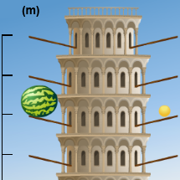

Question: A vacuum is a region with no air or any other matter. How do different objects fall through a vacuum?

- Form hypothesis: How do you think objects will fall when there is no air? _______________

_________________________________________________________________________

- Experiment: Drop the different objects from the top of the tower. What do you notice?

_________________________________________________________________________

- Observe: Click Reset. Drop the watermelon and the ping pong ball from the top of the tower. Watch the speedometers. They show each object’s speed in meters per second (m/s).

    - What do you notice? __________________________________________________

    - What is the final speed of each object? ___________________________________

    - An object is accelerating if its speed is changing. What can you say about the acceleration of objects falling in a vacuum? ________________________________
___________________________________________________________________

- Interpret: Select the GRAPH tab. The graph shows the speeds of the objects over time.
    - What do the lines on the graph look like? __________________________________
    - What does that tell you? _______________________________________________

- Extend your thinking: In 1971, Apollo 15 commander Dave Scott dropped a hammer and a feather on the Moon, which has no air. What do you think happened? Explain your answer.

_________________________________________________________________________

_________________________________________________________________________

_________________________________________________________________________ (If you are on a computer, click here to see a video of this experiment.)

Activity B:  Air Resistance | Get the Gizmo ready:  - Select the EXPERIMENT tab.  - Click Reset.  - Under Choose atmosphere, select Air. | 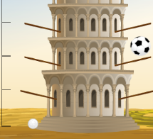

Question: How does air affect falling objects?

- Observe: In Air, drop the objects from different levels of the tower. Look carefully at the speedometers as the objects drop. What do you notice?

_________________________________________________________________________

- Form hypothesis: When objects fall through the air, they are pushed by a force called air resistance. How do you think air resistance affects falling objects?

_________________________________________________________________________

- Experiment: Each platform on the tower is 5 meters higher than the one below it. Drop the ping pong ball from the lowest (5 meter) platform, then the next platform (10 m) and so on. For each height, record the final speed of the ping pong ball in meters per second (m/s).

Height | 5 m | 10 m | 15 m | 20 m | 25 m | 30 m | 35 m | 40 m
Speed

- Analyze: As an object falls through air, the object does not get steadily faster but approaches Terminal Velocity.

  - What is the terminal velocity of the ping pong ball? ___________________________
  - Select the GRAPH tab. How does the graph show terminal velocity? _____________
___________________________________________________________________

- Compare: Drop the soccer ball and the golf ball from the top of the tower. Which ball was slowed down more by air resistance? ___________________________________________

- Extend your thinking: A soccer ball is heavier than a golf ball. Why do you think the soccer ball fell more slowly than the golf ball?

__________________________________________________________________________________________________________________________________________________

Activity C:  Parachutes | Get the Gizmo ready:  - Select the EXPERIMENT tab.  - Click Reset.  - Check that Air is still selected. | 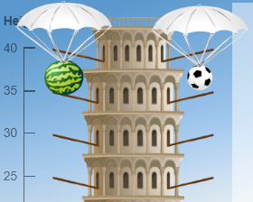

Question: How does a parachute affect a falling object?

- Observe: Drag objects with parachutes to the tower. (Parachutes look like little backpacks.) As the objects drop, click Open parachute(s). Compare how parachutes affect each object.

- Form hypothesis: How will a parachute change the air resistance and terminal velocity of an object? ___________________________________________________________________

- Collect data: Find the terminal velocity of each object when the parachute is open.

Ping pong ball with parachute: ___________ Soccer ball with parachute: _____________

Golf ball with parachute: ________________ Watermelon with parachute: ____________

- Analyze: The watermelon is heaviest, followed by the soccer ball, golf ball and ping pong ball. How does the weight of an object relate to how fast it falls with a parachute?

_________________________________________________________________________

- Interpret: Select the GRAPH tab. How does the graph show when the parachute is opened?

_________________________________________________________________________

- Predict: Will a parachute work in a vacuum? _________ Why or why not? ______________

_________________________________________________________________________

- Test: Use the Gizmo to test your prediction. Did the parachute work? __________________

- Summarize: What controls how fast an object falls? ________________________________

_________________________________________________________________________

_________________________________________________________________________

