Name: Date:

Student Exploration: Function Machines 1

Vocabulary: function, input, output

Prior Knowledge Questions (Do these BEFORE using the Gizmo.)

- Peter can buy 5 juice bottles for $10 or 6 juice bottles for $12. How much do you think he would pay for 7 juice bottles? Why?

_________________________________________________________________________

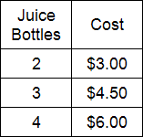
- Eve buys juice at a different store. The table at the right shows the cost when she buys 2, 3, and 4 bottles of juice. Is juice more expensive at Peter’s or Eve’s store? How can you tell?

_______________________________________________________

_______________________________________________________

Gizmo Warm-up
You are house-sitting for your uncle. One day you hear a noise from the basement. You walk down the stairs and discover a room filled with strange machines.

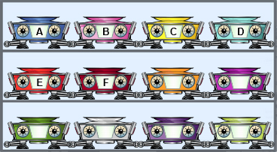
- In the Function Machines 1 Gizmo, drag Machine A to the blue stand. Above it is a row of numbers. Click on number 1 to drop it into Machine A.

What happens? _______________________________

- Click on 2, 3, and 4. What numbers come out?

2: _____ 3: _____ 4: _____

- What do you think will happen if you dropped 10 into Machine A? _____________________

Explain. __________________________________________________________________

_________________________________________________________________________

- Test your prediction by running 10 through Machine A. Were you correct? ______________

Activity A:  Machine investigation | Get the Gizmo ready:  - Click the Clear stands button.

You’ve decided to learn more about the strange machines in your uncle’s basement. Some machines are blank. You can program them with the Function Machine Programmer (FMP 500).

- Drag a blank machine to the FMP 500 (the gray machine at the lower right of the Gizmo). Using the dropdown menu and the up and down arrows, program the machine to “Add 1.”

  - Place the machine on the blue stand. Click the left clipboard above the machines.

  - Run the numbers 1, 2, 3, and 4 through the machine. Look at the table.

  - What does input mean? _______________________________________________

  - What does output mean? ______________________________________________

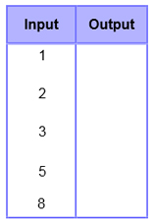
- Click Close. Drag the machine back to the FMP 500. Set it to “Add 6.”

  - Fill in the output values in the table at the right. Then use the Gizmo to check your answers.

  - What output would you get with an input of 11? _______

  - What output would you get with an input of 50? _______

  - What input would you need to get an output of 20? _______

  - Use the Gizmo to check your answers to B-D.

- If the table is still open, click Close. Then use the FMP 500 to reprogram the machine to “Multiply by 2.”

  - Fill in the missing values in the table at the right. Then use the Gizmo to check your answers.
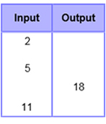
  - These input-output tables are sometimes called function tables. What do you think a function is?

________________________________________________

________________________________________________

________________________________________________

Activity B:  Mystery machines | Get the Gizmo ready:  - If the table is open, click Close.  - Click the Clear stands button. | 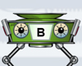

You have decided to discover the functions of Machines B-F.

- Drag Machine B to the left stand. Click the table clipboard (the one on the left).

  - Run numbers through Machine B until you think you know its function. What is it?

___________________________________________________________________

  - Close the table and drag one of the programmable machines (from the bottom two shelves) to the FMP 500. Program it with your guess for Machine B’s function.

  - Drag the programmable machine to the right stand. Click the table clipboard. Then click some numbers to run them through both machines.

  - Compare the two tables. If they are identical, your guess for Machine B’s function is correct. If they are different, try again to find Machine B’s function.

- Repeat the steps above for Machines C-F. Write their functions below.

Machine C: ____________________ Machine D: ____________________

Machine E: ____________________ Machine F: ____________________

- By now you’ve probably learned some strategies for discovering functions. Write a short letter to your uncle telling him about the strategies you used for finding the functions of his machines. (If you want, you can make up an example table to help explain your strategies.)

_________________________________________________________________________

_________________________________________________________________________

_________________________________________________________________________

_________________________________________________________________________

_________________________________________________________________________

_________________________________________________________________________

_________________________________________________________________________

Activity C:  Finding functions | Get the Gizmo ready:  - If the table is open, click Close.  - Click the Clear stands button. | 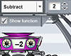

Your uncle has written back: “I must admit that you were clever to discover the functions of those six machines. But are you clever enough to discover the functions for these tables?”

Table 1 Table 2 Table 3
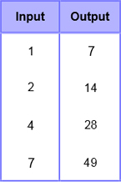
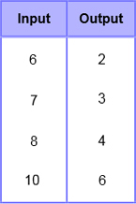
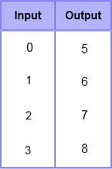

  - Use the programmable machines in the Gizmo to help you find the functions that created the three tables above. Then write them in the space below.

Table 1: _________ Table 2: _________ Table 3: _________

  - Functions can be written as function rules using the words “input” and “output.” For example, the function “+ 2” can be written as the function rule Output = Input + 2. Rewrite the three functions from Question 1 as function rules.

Table 1: ________________________________

Table 2: ________________________________

Table 3: ________________________________
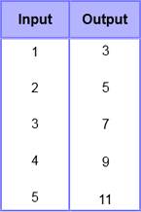

  - At the end of the letter your uncle wrote, “P.S. And here’s a tricky one for you. Good luck!”

- Use function machines to create the table at the right. (Hint: You must stack two machines on top of each other.)

- What two functions did you use? ________ and ________

- How do you think this could be written as a function rule?

________________________________________________

