Name: Date:

Student Exploration: Function Machines 2

Vocabulary: function, input, output

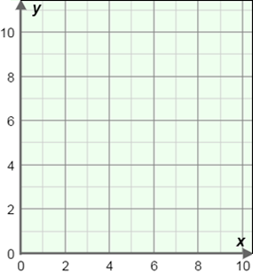
Prior Knowledge Questions
(Do these BEFORE using the Gizmo.)

On the graph at right, plot the points listed below.

- (2, 4)

- (3, 8)

- (6, 1)

- (9, 7)

- (0, 3)

Gizmo Warm-up
While house-sitting for your uncle, you discovered his secret function machines. He is now back from his vacation. “So,” he bellows, “show me what you learned about my machines!”

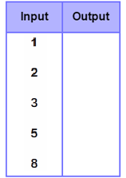
- In the Function Machines 2 Gizmo, drag one of the six blank machines to the FMP 500 (Function Machine Programmer 500) in the lower right part of the Gizmo. Program it to Multiply by 9.

- Drag the machine to the blue stand. Click the “0” to drop it into the machine.

What happened? _______________________________________

- Click the leftmost clipboard to open a table. Use the Gizmo to help you fill in the output values in the table to the right.

- Click Close, and then click Reprogram A-F. Use the Gizmo to find machine A’s function.

What is it? _________________

Check your answer by dragging machine A to the FMP 500 and selecting Show function.
Activity A:  Patterns in Tables | Get the Gizmo ready:  - If the table is open, click Close.  - Click the Clear stands button. | 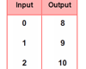

Seeing your interest in his machines, your uncle pulls some dusty notebooks of a shelf. The notebooks are filled with tables. He says, “Let’s try to discover the patterns in these tables.”

- Program a machine to Multiply by 4 in the FMP 500. Drag it to a stand and open the table.

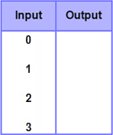
  - Use the Gizmo to complete the table at the right.

  - What pattern do you see in the output? ______________

_____________________________________________

  - Complete this description for the Multiply by 4 machine:
If the input is 0, the output is _____.
As the input increases by 1, the output increases by _____.

- Now program the machine to Multiply by 5. Use inputs of 0, 1, 2, and 3 to create a table. Then use your table to complete the description below:

If the input is 0, the output is _____.
As the input increases by 1, the output increases by _____.

- Program a machine to Add 6. Drag it to a stand and open the table.

  - Use the Gizmo to complete the table at the right.

  - Complete this description:
If the input is 0, the output is ____.
As the input increases by 1, the output increases by _____.

- What are the differences between the tables for multiplication functions and the tables for addition functions? (Hint: Compare the descriptions you wrote in questions 1, 2, and 3.)

_________________________________________________________________________

_________________________________________________________________________

_________________________________________________________________________

Activity B:  Graphing Functions | Get the Gizmo ready:  - If the table is open, click Close.  - Click the Clear stands button. | 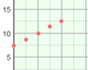

Your uncle says, “I’ve been thinking that it might be possible to take these function tables and graph them. Let’s give it a try!”

- Program a machine to Add 4 in the FMP 500. Click the table clipboard. Use inputs of 0-3 to create a table.

  - Click the clipboard with the graph on it. Move your mouse over the four points to see their coordinates.

  - Each input-output pair is graphed as a point. The __________ is the x-coordinate and the __________ is the y-coordinate.

- Set a machine to Add 5. Use inputs of 0-3 to create a table.

  - Can you make the graph for this table on your own? Try it on the coordinate grid to the right.

  - Now click the graph clipboard and check your graph.

  - What pattern do you see in the points? ___________

__________________________________________

  - How can you use the graph to find the output when the input is 4?

___________________________________________________________________

- Use a Multiply by 3 machine to create a table for inputs of 0-3.

  - Before clicking the graph clipboard, try graphing the table values using the coordinate grid to the right.

  - Now click the graph clipboard and check your graph.

  - How is this graph similar to the graph in question 2?

__________________________________________

__________________________________________

  - How is it different? ____________________________________________________

Activity C:  Graph Detective | Get the Gizmo ready:  - If the table or graph is open, click Close.  - Click the Clear stands button.

Your uncle thinks that it should be possible to identify a function from its graph. Is he right?

Function 1 Function 2
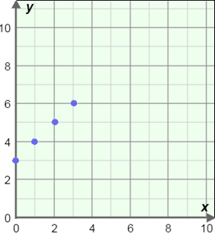
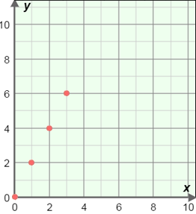

  - For each graph above, program a function machine in the FMP 500 to match. (Hint: It might help to write down a table for each graph first.) Write down the two functions below.

Function 1: _________ Function 2: _________

  - For each function, complete the descriptions below. (Hint: Again, a table might be helpful.)

Function 1: If the input is 0, the output is _____.
As the input increases by 1, the output increases by _________.

Function 2: If the input is 0, the output is _____.
As the input increases by 1, the output increases by _________.

  - Draw a line through the points on each of the graphs.

- Which line is steeper? _____________________________________________

- Go to question 2 and circle the part of each description that indicates steepness.

- Your uncle challenges you to make the steepest graph you can. Try this, using the machine programmer to try out different functions. What function is the steepest?

________________________________________________________________

