Vocabulary: Function Machines 2

Vocabulary

- Function – a rule that describes how to get an output value from an input value.
  - Functions can be used to create function tables (also called input-output tables).
  - An example of a function is Output = Input × 3.
    - The function table below shows five different input-output pairs for this function.
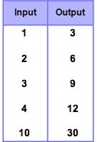
    - An additional input-output pair for this function would be (5, 15) because when you use 5 as the input, the function gives you 15 as the output.
      - Output = Input × 3
      - Output = 5 × 3
      - Output = 15

- Input – a number that goes into a function.
  - A function turns each input into a single output.

- Output – a number that comes out of a function.
  - The output depends on the input and the function rule.

