Name: Date:

Student Exploration: Geometric Sequences

Vocabulary: common ratio, explicit formula, geometric mean, geometric sequence,
recursive formula, sequence, term

Prior Knowledge Questions (Do these BEFORE using the Gizmo.)
Suppose you are given an allowance of $1 the first week of the year, and each week your allowance doubles. That is, $1 the first week, $2 the second week, $4 the third week, and so on.

- If your allowance doubles each week, what is your allowance for the first eight weeks?

$1 , $2 , $4 , , , , ,

- Starting with $1 in week 1, how do you calculate your allowances for other weeks?

- To find week 4 allowance, you have to take $1 and multiply it by 2 time(s).

- To find week 5 allowance, you have to take $1 and multiply it by 2 time(s).

- How do you calculate what your allowance will be in week 25?
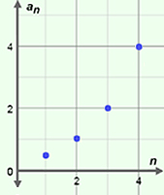
Gizmo Warm-up
A sequence is an ordered list of numbers. Each number in a sequence is called a term. In a geometric sequence, the ratio of any two consecutive terms is constant. The common ratio is the ratio of any term and the one before it. In the Geometric Sequences Gizmo, you can explore the effects of varying the first term (abbreviated a₁) and the common ratio (r) of a sequence on a graph.

To vary the values of a₁ and r, drag the sliders. To enter a specific value, click on the number in the text field, type the value, and hit Enter.

- In the Gizmo, a sequence is graphed. Vary the first term with the a₁ slider. How does this affect the graph?

- Next vary the common ratio with the r slider. As r increases, what happens to the graph?

Activity A:  Explicit formula | Get the Gizmo ready:  - Select the CONTROLS tab.  - Unselect all checkboxes. | 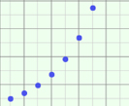

- Before using the Gizmo, consider a geometric sequence with a first term (a₁) of 0.5 and a common ratio (r) of 2. (Hint: Since r = 2, each term will be twice the previous term.)

- What are the first four terms of the sequence?

- In the Gizmo, set a₁ = 0.5 and r = 2. The graph in the Gizmo represents the sequence. Click and drag the graph downward to see more points. What are the first four points on this graph? (Place your cursor over any point to see its coordinates.)

First four points on the graph:

Select the TABLE tab. Each row of this table gives the coordinates of a point on the graph. Check your answers, and then return to the CONTROLS tab.

- The points in the graph of a sequence are called (n, a_{n}) instead of (x, y).

For each point, what does n mean?

What does a_{n} mean?

- What do you think are the coordinates of the 8th point?

Check your answer in the Gizmo, using either the graph or the table.

- Consider the geometric sequence with a₁ = 8 and r = 0.6. (Do not enter it in the Gizmo yet.) Use a calculator if you like. Note that the Gizmo rounds to the nearest hundredth.

- What are the first three terms of the sequence? (Round to the nearest hundredth.)

- What would you multiply the first term by to find the 6th term?

- What can the first term be multiplied by to find the nth term?

An explicit formula is a rule allowing direct calculation of any term in the sequence. The explicit formula for the nth term of an geometric sequence is a_{n} = a₁ • r ^{n – 1}.

- In the Gizmo, set a₁ = 8 and r = 0.6 and turn on Show explicit formula. Use the explicit formula to find a₇. Show your work in the space to the right. Then check your answer in the Gizmo.

(Activity A continued on next page)
Activity A (continued from previous page)

- In the Gizmo, graph the geometric sequence with a₁ = 2 and r = –3.

- What are the first four terms?

- How did the negative value of r affect the terms of the sequence?

Explain.

- How would the graph look if r = 1?

Explain.

Use the Gizmo to check your answer.

- Before using the Gizmo, consider the geometric sequence with a₁ = 4 and r = 0.5.

- Write the explicit formula for the nth term of the sequence.

- In the space to the right, use the explicit formula to find the value of a₅.

Enter the values of a₁ and r in the Gizmo and check your answer.

- If a₁ = –4, how would the graph change?

- What do you think is the value of a₅ of this new sequence?

Check your answers in the Gizmo.

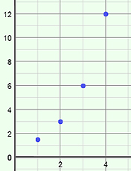
- A geometric sequence is graphed to the right.
(1, 1.5)
(2, 3)
(3, 6)
(4, 12)

- What are the first four terms?

- What is a₁? What is r?

- Write the explicit formula for a_{n}.

- What is a₇?
Show your work to the right.

Then check your answer in the Gizmo.

Activity B:  Recursive formula | Get the Gizmo ready:  - Be sure the CONTROLS tab is selected.  - Select Show explicit formula. | 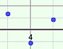

- Consider the geometric sequence 3, 6, 12, 24, … (Do not enter it in the Gizmo yet.)

- What is the value of a₁? What is the value of r?

- What are the next three terms of the sequence?

Explain.

- What is the explicit formula for the nth term?

Enter a₁ and r in the Gizmo. Check your answers and make necessary corrections.

- Use the explicit formula to find a_{8.} Show your work in the space to the right. Then check your answer in the Gizmo.

- In this sequence, the 16th term is 98,304. What is the 17th term?

Explain.

- If the 16th term is 98,304, what is the 15th term?

Explain.

- For this sequence, how can you find the nth term, a_{n}, if you know the previous term?

A recursive formula is a rule for finding a term in a sequence based on the previous term. In general, for a geometric sequence, the recursive formula is a_{n} = a_{n – 1} • r. That rule plus the value of the first term (a₁) defines the sequence.

- Before using the Gizmo, consider the sequence defined by a₁ = –8 and r = 0.5.

- What are the first four terms of the sequence?

- Fill in the recursive part of the rule for this sequence: a₁ = –8, a_{n} =

- In the space to the right, find a₈. Show your work, and round to the nearest hundredth. Then check your answer in the Gizmo.

(Activity B continued on next page)
Activity B (continued from previous page)

- Consider the geometric sequence –0.5, –1, –2, –4, … .

- Express this sequence both explicitly and recursively.

Explicit: Recursive:

- What is a₁₀? Check your answer in the Gizmo.

- Which formula works better for finding terms that are later in the sequence, like a₂₀?

Explain why.

- In a geometric sequence, a₃ = 100 and a₅ = 2500.

- What is r? Explain.
- What is a₄?

- If you take the square root of the product of a₃ and a₅, what is the result?
How does this compare to a₄?
The geometric mean of two numbers is the square root of their product. In the sequence above, a₄ is the geometric mean of a₃ and a₅.

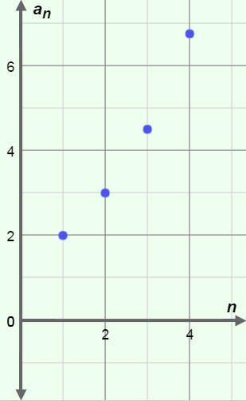
- The graph to the right shows the first four terms of a geometric sequence.
(1, 2)
(2, 3)
(3, 4.5)
(4, 6.75)

- What is a₁? What is r?

- Write the recursive formula for the sequence.

- What is the geometric mean of 2 and 4.5?

Explain.

