Name: ______________________________________ Date: ________________________

Student Exploration: Hearing: Frequency and Volume

[Note to teachers and students: This Gizmo involves listening to and comparing faint sounds. It is recommended that students use headphones and that the room is kept as quiet as possible.]

Vocabulary: decibel, equal-loudness curve, frequency, hertz, logarithm, pitch, threshold, volume

Prior Knowledge Questions (Do these BEFORE using the Gizmo.)

- A dog whistle emits a sound that dogs can hear but humans cannot. Why do you think dogs can perceive this sound? _____________________________________________________

- How do you think your ability to perceive different sounds might change as you age?

_________________________________________________________________________

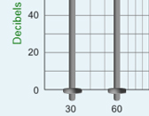
Gizmo Warm-up
Have you ever wondered how good your hearing is? The Hearing: Frequency and Volume Gizmo allows you to test how well you hear tones at different frequencies. The frequency of a sound wave is measured in hertz (Hz), where 1 Hz is equal to one wave passing each second. Frequency is related to the pitch of a sound, or whether it sounds high (like a whistle) or low (like a tuba).

Before you begin, be sure you are in a very quiet setting. Headphones are recommended for this Gizmo. Set the System volume to 1 and click the test button (). Adjust the System volume and your computer so that you hear a moderately loud tone when you click test.

- Drag the 60-Hz slider and the 4,000-Hz slider to the top and click Play for each sound.

Describe what you hear. _____________________________________________________

_________________________________________________________________________

- In general, how does the frequency of a sound relate to its pitch? _____________________

_________________________________________________________________________

_________________________________________________________________________

Activity A:  Create an equal-loudness curve | Get the Gizmo ready:  - Return all sliders to their minimum values.  - Turn on Show logarithmic grid and Show decibel values. | 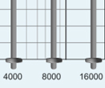

Introduction: The volume, or intensity, of a tone is measured in a unit called the decibel (dB). Decibels are the base-10 logarithm of the ratio of one volume to another. A 10-dB tone is 10 times more powerful than a 0-dB tone. A 20-dB tone is 10 times more powerful than a 10-dB tone and 100 times more powerful than a 0-dB tone.

Question: How well do you hear sounds of different frequencies?

- Calibrate: Set the 1,000-Hz slider to 10 dB and click PLAY. If you can’t hear anything, raise the System volume or increase your computer’s volume until the tone is barely perceptible.

- Observe: Move all of the sliders to 50 dB. Click Play full sequence (20 sec). What do you notice about the perceived volumes of the tones? _________________________________
_________________________________________________________________________

- Predict: Do you think humans hear low-frequency, medium-frequency, or high-frequency tones the best? Explain why you think so. ________________________________________
_________________________________________________________________________

- Compare: Play the 1,000-Hz tone and the 125-Hz tone. Both of these tones have the same volume in decibels. Which tone appears to be louder to you? ________________________

- Measure: Adjust the 125-Hz slider until the 125-Hz tone appears to be just as loud as the 1,000-Hz tone. At what decibel level is this the case? ______________________________

- Gather data: Repeat this procedure for each of the other tones in the Gizmo. Now when you click Play the full sequence, each tone should sound equally loud. Record the decibel level of each tone below (all frequencies in Hz):

30 | 60 | 125 | 250 | 500 | 1,000 | 2,000 | 4,000 | 8,000 | 16,000

(Activity A continued on next page)
Activity A (continued from previous page)

- Make a graph: Draw dots to mark the position of each slider on the graph below. Connect the dots to create an equal-loudness curve.

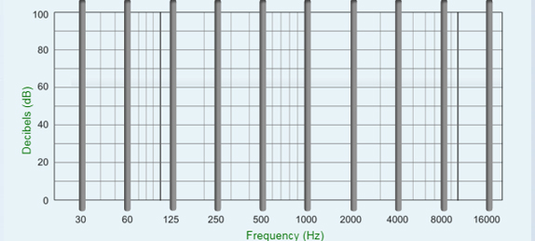

- Analyze: What does this equal-loudness curve show? ______________________________

_________________________________________________________________________

_________________________________________________________________________

- Think and discuss: How do you think your equal-loudness curve will change as you age? _________________________________________________________________________
_________________________________________________________________________

_________________________________________________________________________

- Experiment: If possible, have your teacher or another adult produce an equal-loudness curve. How does their curve compare to yours, and how did this compare to your prediction?

_________________________________________________________________________

_________________________________________________________________________

_________________________________________________________________________

_________________________________________________________________________

_________________________________________________________________________

Activity B:  Thresholds of perception | Get the Gizmo ready:  - Return all sliders to their minimum values.  - Check that the sound levels are still calibrated (see procedure at the start of activity A). | 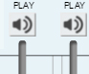

Introduction: A threshold is a minimum amount of a stimulus, such as sound, that can be perceived. In this activity, you will measure your sound thresholds at different frequencies.

Question: What are the faintest sounds that you can perceive?

- Predict: How do you think the equal-loudness curve you will create in this activity will compare to the equal-loudness curve you made in activity A? ________________________
_________________________________________________________________________

- Measure: Play the 1,000-Hz tone at 20 dB. Then decrease the decibels slightly and play the sound again. Adjust the decibels until you have found the faintest sound that you can hear.

What is the lowest volume that you can still hear the 1,000-Hz tone? __________________

- Gather data: Repeat this procedure for each of the other tones in the Gizmo. Record the minimum decibel level that you can perceive for each tone below (all frequencies in Hz):

30 | 60 | 125 | 250 | 500 | 1,000 | 2,000 | 4,000 | 8,000 | 16,000

- Make a graph: Draw the resulting equal-loudness curve on the graph below.

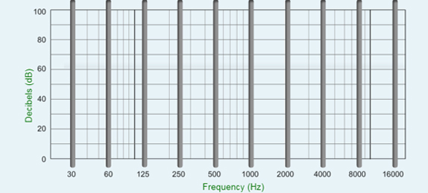

(Activity B continued on next page)
Activity B (continued from previous page)

- Analyze: How does the shape of this equal-loudness curve compare to the shape of the equal-loudness curve you created in activity A? ___________________________________
_________________________________________________________________________

_________________________________________________________________________

- Draw conclusions: Based on your investigations, how does your ability to perceive sound vary with pitch? ____________________________________________________________
_________________________________________________________________________

_________________________________________________________________________

_________________________________________________________________________

_________________________________________________________________________

- Apply: Humans can hear frequencies up to approximately 20,000 Hz, while dogs can hear frequencies up to around 60,000 Hz. What sound frequency would you expect to be emitted by a dog whistle, which can be heard by dogs but not by humans? Explain.

_________________________________________________________________________

_________________________________________________________________________
Extension:  Design an experiment | Get the Gizmo ready:  - Return all sliders to their minimum values.  - Check that the sound levels are still calibrated (see procedure at the start of activity A).

Introduction: The Hearing: Frequency and Volume Gizmo can be used for a science fair project or other experiment. The first step is to come up with a question to investigate.

Choose a question
Here are a few suggestions to get you started. You can choose a topic from this list or come up with a topic on your own.

- How does the hearing of boys compare to the hearing of girls?
- How does age (especially old age) affect hearing?
- Can teenagers hear sounds that adults cannot hear?
- Can dogs hear sounds that people cannot hear?
- Do people who go to loud events such as rock concerts have worse hearing than others?

Which question are you going to investigate? ________________________________________

____________________________________________________________________________

Design your experiment
The key to designing a successful experiment is to control your variables. Everything in your experiments should be the same except for the one variable you are investigating. If you are comparing the hearing of different people, be sure that each person uses the same computer with the same volume settings on the Gizmo and computer, the same headphones, and the same levels of background noise. Headphones are recommended over speakers. (Speakers can distort sounds.)

Before beginning the experiment, explain your project and experimental design to your teacher. If you are doing a science fair project, ask if there is any paperwork that you need to fill out. (Many science fairs require specific paperwork to be filed before beginning any project involving human or animal subjects.)

Briefly describe your experimental design: __________________________________________

____________________________________________________________________________

____________________________________________________________________________

____________________________________________________________________________

____________________________________________________________________________

(Extension continued on next page)
Extension (continued from previous page)

Carry out your experiment
A well-designed experiment isn’t any good unless you carry it out according to your plan. Gather data from as many subjects as possible. In general, the more data you collect, the more reliable your results will be. Analyze your data by comparing the equal-loudness curves for each subject. You can also calculate the average decibel levels for each frequency. Draw conclusions based on your data, not on what you expected to happen.

In the space below, summarize your results and state your conclusions: ___________________

____________________________________________________________________________

____________________________________________________________________________

____________________________________________________________________________

____________________________________________________________________________

____________________________________________________________________________

____________________________________________________________________________

Present your results
The last step is to present your experiment in a clear and visually appealing way. Include tables and graphs that show the trends in your data. If you are presenting at a school science fair, a nice touch might be to include a computer and headphones in your display so passersby can test their own hearing. (Setting this up in a quiet side room might be a good idea.) Good luck and have fun!

