Name: ______________________________________ Date: ________________________

Student Exploration: Heat Transfer by Conduction

Vocabulary: conduction, convection, insulate, radiation, thermal conductor, thermal energy, thermal insulator

Prior Knowledge Questions (Do these BEFORE using the Gizmo.)
Suppose two frying pans have been left on the stove with the burners on. One of the frying pans has a metal handle and the other has a wooden handle.

- Which handle do you think you could safely touch? ________________________________

- Why do you think one handle will be cooler than the other? __________________________

_________________________________________________________________________

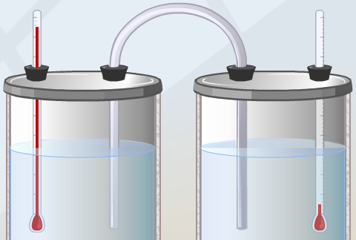
Gizmo Warm-up
Heat, also called thermal energy, can be transmitted through space (radiation), by moving fluids (convection), or through direct contact. This final method, called conduction, is explored in the Heat Transfer by Conduction Gizmo.

To begin, check that Aluminum is selected. Select the BAR CHART tab and turn on Show numerical values.

- What is the initial temperature of each beaker? Beaker A _________ Beaker B _________

- Click Play () and observe.

  - What happens to the temperature of Beaker A over time? _____________________

___________________________________________________________________

  - What happens to the temperature of Beaker B over time? ____________________

___________________________________________________________________

- Why do you think the temperatures of Beaker A and Beaker B changed as they did?

_________________________________________________________________________

_________________________________________________________________________

Activity A:  Measuring heat transfer | Get the Gizmo ready:  - Click Reset ().  - Check that Aluminum is selected. | 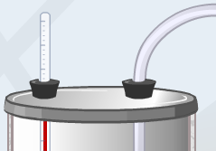

Question: How does the temperature difference between two containers relate to the rate of temperature change?

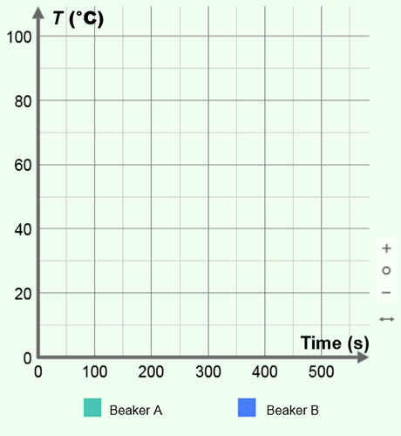
- Observe: Select the GRAPH tab and press Play. Wait until the temperatures of the two beakers are both close to 50 °C, and use the zoom out button (–) to see the whole graph. Sketch the graph in the space at right.

What does the graph show about the rate of temperature change over time?

_________________________________________

_________________________________________

_________________________________________

- Form hypothesis: How do you think the temperature difference between the beakers relates to the rate of heat transfer? ___________________________________________________
_________________________________________________________________________

- Gather data: Select the TABLE tab. Click Reset, and then click Play. Click Pause () every 100 seconds (does not have to be exact). Each time you click Pause, record the temperature of each beaker and their temperature difference in the table below. (To find the temperature difference, subtract the temperature of beaker B from that of beaker A.)

Time (s) | Beaker A temp. (°C) | Beaker B temp. (°C) | Temp. difference (°C)
0 s
100 s
200 s
300 s
400 s
500 s
600 s

(Activity A continued on next page)
Activity A (continued from previous page)

- Calculate: At each time, what is the sum of the temperatures in each beaker? ___________

- Apply: In this simulation, the beakers are perfectly insulated. This means that no thermal energy (heat) is lost to the outside environment. If the beakers were not perfectly insulated, how do you think the sum of their temperatures would change over time? Explain.

_________________________________________________________________________

_________________________________________________________________________

_________________________________________________________________________

- Compare: For each beaker, determine how much the temperature changed in the first 100 seconds and how much it changed between 500 and 600 seconds. Compare this to the temperature difference between the beakers at the start of each interval.

Value | 0–100 s interval | 500–600 s interval
Beaker A temperature change
Beaker B temperature change

Temperature difference between Beaker A and Beaker B at 0 seconds.
Temperature difference between Beaker A and Beaker B at 500 seconds.

- Analyze: How does the rate of temperature change depend on the temperature difference between the two beakers? ____________________________________________________
_________________________________________________________________________

_________________________________________________________________________

- Think and discuss: Why do you think the rate of temperature change does not stay constant over time? If possible, discuss your answer with your teacher and classmates.

_________________________________________________________________________

_________________________________________________________________________

_________________________________________________________________________

_________________________________________________________________________

Activity B:  Conductors and insulators | Get the Gizmo ready:  - Click Reset.  - Select the TABLE tab. | 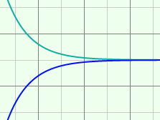

Introduction: Materials that allow heat to pass through easily are called thermal conductors. Materials that resist the transfer of heat are called thermal insulators.

Question: Which materials are the best conductors? Which are the worst conductors?

- Predict: In the Gizmo, you can use aluminum, copper, steel, or glass to connect the two insulated beakers.

    - Which material do you think will be the best thermal conductor? ________________

    - Which material do you think will be the best thermal insulator? ________________

- Gather data: With Aluminum selected, click Play. Click Pause after about 200 simulated seconds. Record the temperature of each beaker at 200 seconds. Next, calculate the temperature change of Beaker A. Repeat with each material to complete the table.

Material | Beaker A temp. at  200 seconds (°C) | Beaker B temp. at  200 seconds (°C) | Beaker A temp. change (°C)
Aluminum
Copper
Steel
Glass

- Analyze: What does your data indicate? _________________________________________

_________________________________________________________________________

- Classify: Which materials would you classify as thermal conductors, and which would you classify as an insulator? Which material was the best thermal conductor?

Thermal conductors: __________________ __________________ __________________

Thermal insulator: ________________ Best thermal conductor: ________________

- Apply: A good frying pan will transfer heat quickly from the stove burner to the food. Based on the results of the Gizmo, which material would be best for frying pans? ______________
Why? ____________________________________________________________________

