Name: ______________________________________ Date: ________________________

Student Exploration: Herschel Experiment

Vocabulary: electromagnetic radiation, infrared radiation, prism, ultraviolet radiation, visible spectrum

Prior Knowledge Questions (Do these BEFORE using the Gizmo.)
All stars emit electromagnetic radiation. Sunlight is part of the electromagnetic radiation emitted by the Sun.

- What happens when sunlight passes through a prism? _____________________________

_________________________________________________________________________

- The colors you see in a rainbow or when white light is separated is called the visible spectrum, shown at right. What is the order of colors in the visible spectrum?

_________________________________________________________________________
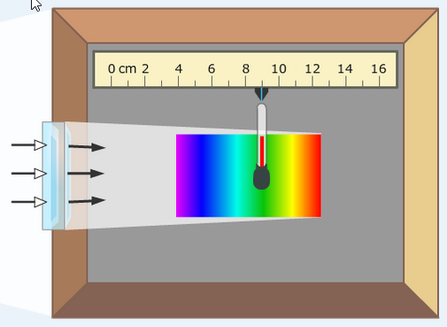

Gizmo Warm-up
William Herschel was a British astronomer famous for discovering the planet Uranus in 1781. While observing the Sun through various colored filters, Herschel noticed that the different filters seemed to transmit different amounts of heat. Herschel hypothesized that different colors in the visible spectrum have different temperatures. As he was testing this hypothesis in 1800, Herschel made a remarkable discovery.

The Herschel Experiment Gizmo allows you to reconstruct Herschel’s experiment. The Gizmo shows sunlight shining through a prism and into a box. A thermometer can be moved to different positions on the floor of the box. To begin, move the thermometer to 9 cm.

- Click Play (), and wait about 10 simulated minutes.

- What is the color of light where the thermometer is located? ___________________

- What is the temperature at this location? ___________________

- Move the thermometer to the blue light at 6 cm, and wait another 10 simulated minutes.

What is the temperature at this location? _________________________

Activity A:  Light and temperature | Get the Gizmo ready:  - Click Reset (). | 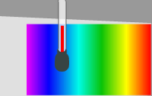

Question: Which part of the Sun’s spectrum has the highest temperature?

- Observe: What is the current Temperature in shade? _____________________________

- Predict: Which color of light do you think will yield the highest temperature? Explain.

_________________________________________________________________________

- Gather data: Click Play. Place the thermometer in each of the positions listed in the table for about 10 minutes. For each position, list the color and the thermometer temperature. (As you collect data, do not click Reset.) Leave the last column blank for now.

Position | Color | Temperature (°F) | ΔT (°F)
4 cm
6 cm
8 cm
10 cm
12 cm

- Calculate: The symbol ΔT stands for “change in temperature” and represents the difference between the temperature of that color and the temperature in the shade. To calculate ΔT for each position, subtract the temperature in the shade from the temperature in the table.

- Analyze: What does your data show? ___________________________________________

_________________________________________________________________________

_________________________________________________________________________

- Think and discuss: Why do you think some colors of light yield different temperatures than others? If possible, discuss your answer with your classmates and teacher.

_________________________________________________________________________

_________________________________________________________________________

_________________________________________________________________________
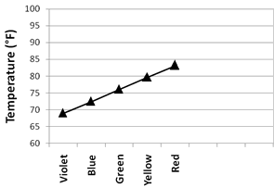

Activity B:  Invisible light | Get the Gizmo ready:  - Click Reset. | 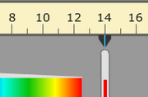

Introduction: After gathering data on the temperature of each color, William Herschel found that red was the hottest color of visible light. Herschel then moved the thermometer just past the red end of the visible spectrum.

Question: Is any energy transmitted beyond the edges of the visible spectrum?

- Observe: When you click Reset, the temperature in the shade changes.

What is the current Temperature in shade? _____________________________________

- Predict: A graph of temperature vs. color data might look like the graph at right. (Shade temp. = 68 °F.) Fill in the right side of the graph to show what you think the graph would look like beyond the red end of the spectrum.

Explain your graph: ____________________

____________________________________

____________________________________

- Test: Place the thermometer at 12 cm and press Play. Wait for about 15 minutes.

    - What is the temperature after 15 simulated minutes? _________________________

    - Move the thermometer to 13 cm. Wait for 10 minutes.

What is the temperature now? _________________________

- Evaluate: Is this the result you expected? Explain. _________________________________

_________________________________________________________________________

- Think and discuss: What do you think is happening here? ___________________________

_________________________________________________________________________

_________________________________________________________________________

(Activity B continued on next page)
Activity B (continued from previous page)

- Gather data: When Herschel did his experiment in 1800, he was astounded to find a higher temperature beyond the red end of the visible spectrum. He inferred that there must be a kind of invisible radiation beyond the red end of the spectrum. Herschel dubbed these invisible rays “caloric rays.” Today, it is called infrared radiation.

Click Play. Measure the temperature of each position for at least 10 simulated minutes to complete the table below. Calculate the ΔT values based on the temperature in the shade.

Position | Color | Temperature (°F) | ΔT (°F)
2 cm | None
3 cm | None
4 cm | Violet
12 cm | Red
13 cm | None
14 cm | None
15 cm | None
16 cm | None

- Analyze: Look at the data on both ends of the spectrum.

    - What is the peak temperature, and at what location does it occur? ______________

___________________________________________________________________

    - How far beyond the red end of the spectrum does infrared radiation cause significant heating? ____________________________________________________________
    - From this experiment, is there any evidence of radiation falling to the left of the violet end of the visible spectrum? Explain. _____________________________________
___________________________________________________________________

In fact, radiation does exist beyond the violet end of the visible spectrum. Ultraviolet radiation was discovered in 1801 by Johann Wilhelm Ritter.

- Draw conclusions: What was the importance of the Herschel experiment? ______________

_________________________________________________________________________

_________________________________________________________________________

