Vocabulary: Herschel Experiment

Vocabulary

- Electromagnetic radiation – energy made up of electric and magnetic waves that travel at the speed of light in a vacuum.
  - Examples of electromagnetic radiation include gamma rays, X rays, ultraviolet radiation, visible light, infrared radiation, microwaves, and radio waves.

- Infrared radiation – electromagnetic radiation with wavelengths that range from
0.7 μm to 300 μm (700 nm–30,000 nm).
  - Infrared waves are longer than visible light and shorter than microwaves.
  - Infrared radiation is felt as heat.
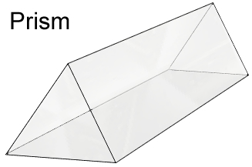

- Prism – an optical device made of clear glass or plastic that is used to divide white light into a spectrum of colors.
  - Prisms often have triangular bases and rectangular sides.

- Ultraviolet radiation – electromagnetic radiation with wavelengths that range from
0.01 μm to 0.4 μm (10–400 nm).
  - Ultraviolet waves are longer than X rays and shorter than visible light.
  - Ultraviolet radiation causes sunburn.

- Visible spectrum – the band of colors produced when white light is passed through a prism or similar device.
  - The sequence of colors in the visible spectrum is red, orange, yellow, green, blue, and violet. Red light has the longest wavelength, and violet light has the shortest wavelength.
  - Visible light has wavelengths that range from 0.4 μm to 0.7 μm (400–700 nm).

