Vocabulary: Holiday Snowflake Designer
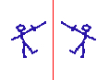

Axis of symmetry
Vocabulary

- Axis of symmetry – a line that separates mirror images.
  - If you fold an object along an axis of symmetry, each side will match perfectly.
  - All the snowflakes pictured below have six axes of symmetry.
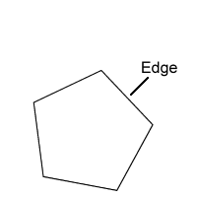

- Edge – a line segment that forms a side of a polygon.
  - A polygon is a closed shape with three or more straight sides. Examples of polygons include triangles, rectangles, pentagons, hexagons, etc.

- Reflection – a mirror image.

- Snowflake – a crystal of ice that falls through Earth’s atmosphere.
  - Snowflakes form when supercooled water vapor freezes in clouds. Once the core has frozen, more water vapor freezes onto the growing crystal to form a snowflake. Eventually the ice crystal falls to Earth.
  - Although their symmetry is not perfect, snowflakes generally have six axes of symmetry.
  - Wilson “Snowflake” Bentley (1865-1931) was a Vermont farmer who photographed thousands of snowflakes. Some of his images are shown below.

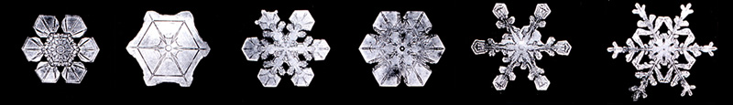

- Symmetry – a property of a figure in which one part perfectly matches another when the figure is transformed in some way.
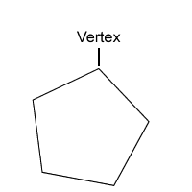

- Vertex – a point on a polygon where two edges meet.

