Name: ______________________________________ Date: ________________________

Student Exploration: Human Homeostasis

Vocabulary: dehydration, heat stroke, homeostasis, hypothermia, involuntary, thermoregulation, voluntary

Prior Knowledge Questions (Do these BEFORE using the Gizmo.)
A thermostat is a device that regulates the temperature inside a building.

- What does a thermostat do if it gets too cool? ____________________________________

- What does a thermostat do if it gets too hot? _____________________________________

- How do our bodies sometimes act like a thermostat? _______________________________

_________________________________________________________________________

_________________________________________________________________________

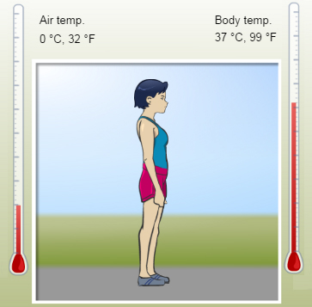
Gizmo Warm-up
To survive, an organism must be able to maintain stable internal conditions in a changing environment. This process is called homeostasis. The Human Homeostasis Gizmo allows you to explore how the human body stays at a nearly constant temperature in different conditions. Notice the Air temp. and Body temp. thermometers representing the air temperature and body temperature.

- What is the initial air temperature? _____________

- What is the initial body temperature? ___________

- Next to each factor listed below, write “increase,” “decrease,” or “same” based on how you expect that factor to affect body temperature.

Raising air temperature: ________________ Sweating: ________________

Lowering air temperature: ________________ Shivering: ________________

Adding clothing: ________________ Exercising: ________________

Activity A:  Body temperature | Get the Gizmo ready:  - If necessary, click Reset ().

Question: What factors increase or decrease body temperature?

- Observe: With the Air temp. at 0 °C (32 °F) and Body temp. at 37 °C (99 °F), click Play (). After one simulated hour (does not have to be exact), click Pause ().

What is the body temperature after one hour? ____________________________________

- Gather data: Fill in the first line of the data table below. Then, use the same procedure to test the effect of each of the following factors. Click Reset between each trial. Record the initial and final body temperatures in the table below. (Leave the last column blank.)
- Set the Exercise level to 70%. (All other settings in default position.)
- Click Reset. Set the Sweat level to 70%. (All other settings in default position.)
- Click Reset. Below Body position, click Shivering. (Other settings in default mode.)
- Click Reset. Next to Clothing, click Add four times to add a sweatshirt, hat, pants, and parka. (Other settings in default mode.)

Factor | Initial body temp. | Body temp. after one hour | Effect of factor on body temperature
Standing still
Exercising
Sweating
Shivering
Adding clothing

- Analyze: To determine the effect of a factor on body temperature, compare the final body temperature with that factor to the final body temperature while standing still. Based on this comparison, fill in the last column of the data table.

    - Which factor raised body temperature the most? ____________________________

    - Why do you think this process raises body temperature? ______________________

___________________________________________________________________

    - Which factor lowered body temperature the most? ___________________________

    - Why do you think this process lowers body temperature? ______________________

___________________________________________________________________

Activity B:  Thermoregulation | Get the Gizmo ready:  - Click Reset. | 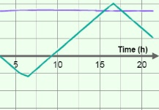

Introduction: Thermoregulation is the process in which a steady temperature is maintained inside the body. Some responses to temperature changes, such as sweating and shivering, are involuntary—they occur automatically. Other actions, such as exercising or putting on clothes, are called voluntary responses because they are things we have to think about doing.

Question: In the Human Homeostasis Gizmo, you can control both involuntary and voluntary responses to temperature changes. How good are you at thermoregulation?

- Play the Gizmo: Click Play. After one hour, the air temperature will start to fluctuate. Using what you have learned, try to maintain a steady body temperature by manipulating the Exercise level, Sweat level, Body position, and Clothing. (You may wish to click Pause occasionally to give yourself time to think.)
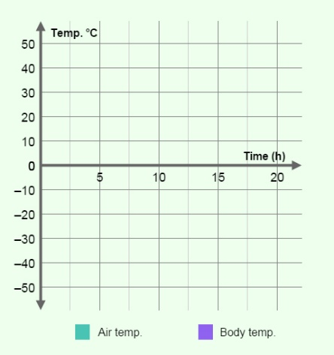
Click Pause after at least 10 hours have passed, if you can survive that long! Select the GRAPH tab. Sketch the resulting graph into the space at right.

What does this graph show? ____________________

____________________________________________

____________________________________________

____________________________________________

- Investigate: Click Reset. Click Play, and deliberately create a situation in which the body temperature gets so low that the simulation stops.

  - How did you do this? __________________________________________________

  - What is the name for this condition? ______________________________________

  - At what body temperature is immediate medical treatment required? _____________

- Investigate: Click Reset. Click Play, and create a situation in which the body temperature gets so high that the simulation stops.

  - How did you do this? __________________________________________________

  - What is the name for this condition? ______________________________________

  - At what body temperature is immediate medical treatment required? _____________

(Activity B continued on next page)
Activity B (continued from previous page)

- Challenge yourself: Click Reset. Click Play, and see if you can maintain a constant body temperature of 37 °C (99 °F) for 24 simulated hours or more. You will have to click Drink water or Eat food to avoid dehydration (lack of water) and low blood sugar. If the Fatigue level gets too high, you will have to rest.

If you succeed, click Pause. Select the GRAPH tab and click the camera () icon to take a snapshot of the graph. Right-click the image, and click Copy Image. Open a blank document and paste the snapshot into the document. You can print out the document and hand it in with this worksheet.

- Analyze: Select the TABLE tab. The air temperature and body temperature are recorded every hour. Scroll through the table to find the highest and lowest air temperatures.

  - What was the highest air temperature you had to deal with? ___________________

  - How did you respond to this temperature? _________________________________

___________________________________________________________________

  - What was the lowest air temperature in the simulation? _______________________

  - How did you maintain a constant body temperature at this time? ________________

___________________________________________________________________

- Think and discuss: Other than the options available in the Human Homeostasis Gizmo, what other methods are used to maintain body temperature? Try to think of both voluntary and involuntary responses.

_________________________________________________________________________

_________________________________________________________________________

_________________________________________________________________________

_________________________________________________________________________

_________________________________________________________________________

- Critique: On a separate page, describe the advantages and disadvantages of the model of human homeostasis used in the Gizmo. In what ways is the model realistic? What factors are not included in the model?

