Name: Date:

**Student Exploration: Hyperbolas**

**Vocabulary:** asymptote, conic section, foci of a hyperbola, hyperbola, Pythagorean Theorem, standard form of the equation of a hyperbola, transverse axis, vertices of a hyperbola

**Prior Knowledge Questions** (Do these BEFORE using the Gizmo.)

1. Light from a light bulb travels in all directions. But when the bulb is inside a lampshade, the light forms two cones, as shown to the right.

If the lamp is placed near a wall, what shape would the light make on the wall? Sketch this shape in the space to the right.

1. When one or two cones (like the two cones of light above) are intersected by a plane (like the wall), the resulting curve is called a **conic section**.

Compare the shapes above. What do you notice?

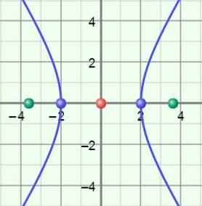

**Gizmo Warm-up**

The curve created when a plane intersects a double cone is called a **hyperbola**. In the *Hyperbolas* Gizmo, you can explore hyperbolas in the coordinate plane and their equations in standard form.

You can vary the values of ***a***, ***b***, ***h***, and ***k*** in the hyperbola equation by dragging the sliders. (To quickly set a slider to a value, type the value in the text box to the right of the slider, and hit **Enter**.)

1. Select **Horizontal**. Set ***a*** to 3, ***b*** to 4, ***h*** to 0, and ***k*** to 0 to graph  –  = 1.
2. Vary ***a***. How does the hyperbola change as *a* increases?

1. Vary ***b***. How does the hyperbola change as *b* increases?
2. Reset ***a*** to 3 and ***b*** to 4. Select **Vertical**.
   1. How is the equation different?
   2. How is the hyperbola different?

|  |  |  |
| --- | --- | --- |
| **Activity A:**  **Hyperbolas centered at the origin** | Get the Gizmo ready:   * Be sure the **CONTROLS** tab is selected. * Set ***a***to 1, ***b*** to 2, ***h***to 0, and ***k***to 0. | 140SE2 |

1. A hyperbola is a curve defined by two fixed points called the **foci of the hyperbola**, or focus points. In the Gizmo, the foci are the green points on the graph.
2. Select **Horizontal**. Click on **Explore geometric definition**. The values of *L*1 and *L*2 represent the distance from each of the foci to any (*x*, *y*) point on the hyperbola. Drag the purple point around each branch of the hyperbola.

Does the value of |*L*1 – *L*2| ever change for the hyperbola graphed?

1. Vary the value of ***a***, and drag the purple point again. Select **Vertical** and repeat. Is this always true about the value of |*L*1 – *L*2|?
2. Consider the graph of the hyperbola to the right. The center of this hyperbola is (0, 0). The points on the hyperbola that are closest to the center are **vertices**. The line segment through the center with endpoints at the vertices is the **transverse axis**.

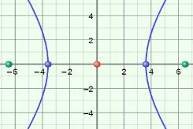

**(*c*, 0)**

**(–*c*, 0)**

**(–*a*, 0)**

**(*a*, 0)**

1. The vertices of the hyperbola shown to the right are (–*a*, 0) and (*a*, 0).

What distance does *a* represent?

1. The foci in the graph above are (–*c*, 0) and (*c*, 0). What distance does *c* represent?

1. What is the distance from each focus point to the vertex at (*a*, 0)?

Distance from (*c*, 0) to (*a*, 0) = Distance from (–*c*, 0) to (*a*, 0) =

1. What is the absolute value of the difference of those distances?
2. Based on what you found above, fill in the blanks to write the definition of a hyperbola.

Definition: A hyperbola is the set of all (*x*, *y*) points for which the absolute value of the difference of the distances from the foci to (*x*, *y*) is and equal to .

**(Activity A continued on next page)**

**Activity A (continued from previous page)**

1. The **standard form of the equation of a hyperbola**, with its center at the origin, is given by  –  = 1 if it opens horizontally, and  –  = 1 if it opens vertically.
2. Turn off **Explore geometric definition**. Select **Horizontal**, and graph  –  = 1. Turn on **Show asymptotes**. The red dashed lines are **asymptotes**, the lines the branches of the hyperbola approach as the branches move away from the center.

What are the slopes of the two asymptotes, as fractions? (To help answer this, notice that the point (5, 4) lies on one of the asymptotes, and (–5, 4) lies on the other.)

1. How are these slopes related to *a* and *b*?

Vary ***a*** and ***b*** to see if this is always true.

1. Select **Vertical**. Vary ***a*** and ***b*** to check the slopes of the asymptotes of hyperbolas that open vertically. How are the slopes related to *a* and *b* in this case?

1. Select **Horizontal**, and set ***a*** to 3 and ***b*** to 4. Turn on **Show Pythagorean relationship**.
2. How is the hypotenuse of the green right triangle related to the circle?
3. Use *a*, *b*, and the **Pythagorean Theorem** (*a*2 + *b*2 = *c*2) to find *c*, the distance from the center to each focus point. Show your work in the space to the right.
4. Use your answer from above to write the coordinates of the foci of this hyperbola.

and Check your answer in the Gizmo.

1. Look at the rectangle inscribed in the circle. What is the length of each side of the rectangle, in terms of *a* and *b*?
2. How are the asymptotes related to the rectangle?

1. With ***a*** still set to 3 and ***b*** to 4, select **Vertical** so that the hyperbola opens vertically.

Are all of the relationships the same?

|  |  |  |
| --- | --- | --- |
| **Activity B:**  **Translating a hyperbola** | Get the Gizmo ready:   * Be sure **Show asymptotes** is turned off. * Select **Horizontal**, and set ***a***to 2, ***b*** to 3, ***h***to 1, and ***k***to 4. | 140SE4 |

1. You should see the graph of  –  = 1 in the Gizmo.
   1. Mouseover the center of the hyperbola. What are its coordinates?
   2. How do these coordinates relate to *h* and *k*?

Vary ***h*** and ***k*** to confirm this is always true.

* 1. Where are *h* and *k* in the equation?
  2. Select **Vertical**, and vary ***h*** and ***k***. Is *h* still with *x* and *k* still with *y*?

1. Reset ***h*** to 1 and ***k*** to 4 to graph  –  = 1 again. This graph is shown below.
2. 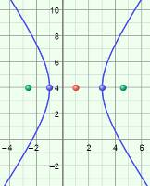How far is each vertex of the hyperbola from the center at (1, 4)?
3. Where is that value in the equation of the hyperbola?

1. Select **Show asymptotes**. One asymptote passes through (3, 7) and the other through (–1, 7). Use these points to help you sketch the asymptotes on the graph to the right.

What are the slopes of the asymptotes, written as fractions?

1. The equation of the same hyperbola centered at the origin is  –  = 1. Compare slopes of the asymptotes of this hyperbola to the slopes above.

What do you notice?

Vary ***a*** and ***b*** to see if this is always true.

1. Select **Vertical**. Check the asymptotes of hyperbolas that open vertically. Does the above relationship also apply to these hyperbolas?

**(Activity B continued on next page)**

**Activity B (continued from previous page)**

1. 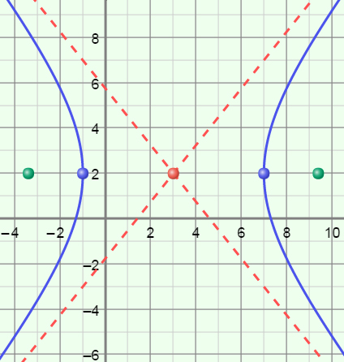Consider the hyperbola graphed to the right.
2. Sketch a rectangle with vertices on the asymptotes and vertical opposite sides that pass through the vertices of the hyperbola.

How long are the sides of the rectangle?

1. In the space to the right, write the equation of this hyperbola, in standard form.
2. Explain how you found the equation above.

Check your answers by graphing the equation in the Gizmo.

1. 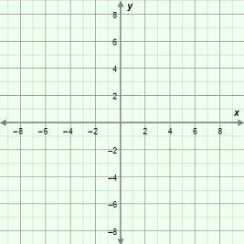Consider the equation  –  = 1.
2. On the grid to the right, plot the center and vertices. Label each point with its coordinates.
3. In the space below, use the Pythagorean relationship to determine the value of *c* to the nearest hundredth.
4. Find the coordinates of the foci. Plot and label the foci with their coordinates.
5. Add the asymptotes of the hyperbola to your graph. (Feel free to sketch a rectangle to help place the asymptotes.)
6. Sketch the graph of the hyperbola. Check your graph in the Gizmo.

|  |  |  |
| --- | --- | --- |
| **Activity C:**  **Practice with hyperbolas** | Get the Gizmo ready:   * Be sure the **CONTROLS** tab is selected. | 140SE7 |

1. 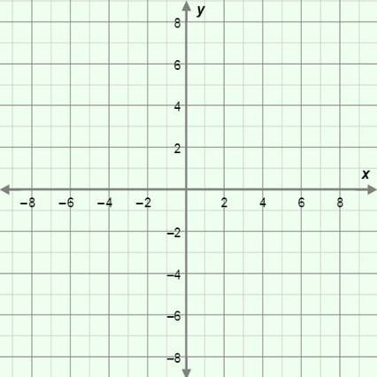Consider the hyperbola with the equation  –  = 1.
2. What are the center and vertices of the hyperbola?

Center: Vertices:

1. Find the coordinates of the foci of this hyperbola. Show your work to the right.
2. What are the slopes of the asymptotes?
3. Sketch the hyperbola on the grid above. Then graph it in the Gizmo to check.
4. Now consider the hyperbola given by  –  = 1. How is its graph the same as the graph above? How is it different? Be sure to state the center, vertices, and foci of this hyperbola in your answer. Use the Gizmo to check.

1. Write the equation of the hyperbola shown in each graph. Check your answer in the Gizmo. (Note that a point has been shown on each asymptote, to help show their slopes.)
2. 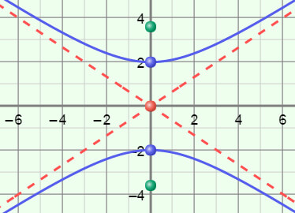

1. 