Name: ______________________________________ Date: ________________________

Student Exploration: Identifying Nutrients

Vocabulary: carbohydrate, disaccharide, lipid, monosaccharide, polysaccharide, protein, starch

Prior Knowledge Questions (Do these BEFORE using the Gizmo.)

- What are the major types of nutrients you can get from food? ________________________

_________________________________________________________________________

- How are these nutrients used by your body? _____________________________________

_________________________________________________________________________

_________________________________________________________________________

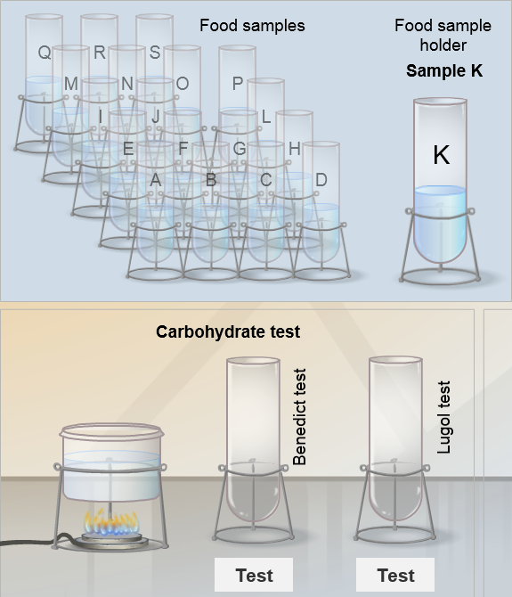

Gizmo Warm-up
Have you ever wondered what is in your food? Scientists use a variety of tests to determine the nutritional content of food. You will learn four of those tests with the Identifying Nutrients Gizmo.

- Below the Food samples label, drag tube A into the Food sample holder. Below the Benedict test, click the Test button. What is done in the Benedict test?

___________________________________________

___________________________________________

___________________________________________

- The Benedict solution is a test for monosaccharides; simple sugars like glucose or fructose (fruit sugar); and some disaccharides such as lactose and maltose. In contact with these sugars, the Benedict solution turns from blue to green to orange. For simplicity, we will consider the Benedict test a test for monosaccharides only.

Does Sample A contain these sugars? _________

Note: Sucrose (table sugar) is a disaccharide that is not detected by the Benedict test. Foods sweetened only with table sugar will show a negative Benedict test.
Activity A:  Identifying nutrients | Get the Gizmo ready:  - Click Reset.  - Drag Sample A into the Food sample holder. | 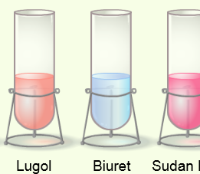

Introduction: Most food is composed of three types of molecules: carbohydrates, proteins, and lipids.
- Carbohydrates such as starches and sugars are major source of energy. Simple sugars are found in sweets and fruits. Starches are found in potatoes, cereal, pasta, flour, and other plant products.
- Proteins are used in body structures such as muscles, skin, and hair. Rich sources of proteins include meats, dairy products, and beans.
- Lipids (fats and oils) are used for energy, insulation, and as an essential building block of cells. Meats, dairy products, and oily plants such as olives are rich in lipids.

Question: How do you test for carbohydrates, proteins, and lipids?

- Test: Under the Benedict test, click Test. Is the Benedict test positive for sample A? _____

Recall that orange is a positive test for monosaccharides (and some disaccharides).

- Test: The Lugol test uses iodine to test for starch, a polysaccharide (complex carbohydrate). Iodine turns dark purple in the presence of starch.

Under Lugol test, click Test. Does sample A contain starch? _____

- Test: The Biuret test uses a solution of potassium hydroxide (KOH) and copper sulfate (CuSO₄) to test for protein. The Biuret solution turns purple when proteins are present.

Under Biuret test, click Test. Does sample A contain proteins? _____

- Test: The Sudan Red test uses a fat-soluble dye, Sudan Red, to indicate the presence of lipids. When lipids are present, the dye will be absorbed into the lipids, and will appear as concentrated spots of color in the test tube. (No spots indicates that lipids are not present.)

Under Sudan Red test, click Test. Does sample A contain lipids? _____

- Summarize: What nutrients does sample A contain? _______________________________

- Analyze: What kind of food is sample A most likely to be? (Circle your choice)

A. Apple juice B. Baked beans C. Oatmeal D. Scrambled eggs

Activity B:  Nutrients and food types | Get the Gizmo ready:  - Click Reset. | 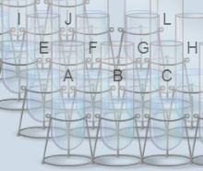

Question: What nutrients does each food sample contain?

- Collect data: Use the four available tests to find the nutritional content of samples E, G, and M. (Sample A has been done for you as an example.) Record results on the table below.

 | Carbohydrate Tests |  | Protein Test | Lipids Test | Test results – are these nutrients present?
Food sample | Benedict test | Lugol test | Biuret test | Sudan Red test | Mono-saccharides | Starches | Proteins | Lipids
A | + | – | – | – | Yes | No | No | No
E
G
M

- Analyze: Look at the results for samples A, E, G, and M.

  - Is sample E most likely to be steak, bread, or butter? Justify your answer.

___________________________________________________________________

  - Is sample G most likely to be table sugar, pasta, or olive oil? Justify your answer.

___________________________________________________________________

  - Is sample M most likely to be chicken, rice, a mango, or butter? Justify your answer.

___________________________________________________________________

- Draw conclusions: Why is it important to understand the nutritional content of food?

_________________________________________________________________________

_________________________________________________________________________

_________________________________________________________________________

(Activity B continued on next page)
Activity B (continued from previous page)

- Practice: Determine the nutritional content of the remaining food samples.

 | Carbohydrate Tests |  | Protein Test | Lipids Test | Test results – are these nutrients present?
Food sample | Benedict test | Lugol test | Biuret test | Sudan Red test | Mono-saccharides | Starches | Proteins | Lipids
B
C
D
F
H
I
J
K
L
N
O
P
Q
R
S

- Think and discuss: If possible, discuss these food samples with your classmates and teacher. Try to come up with a type of food that corresponds to each sample.

- Extend your thinking: In general, a balanced diet contains relatively even amounts of carbohydrates, proteins, and lipids. Too much sugar is unhealthy. Fruits and vegetables are important sources of vitamins and minerals.

Do you consider your diet balanced and healthy? Why or why not? ____________________

_________________________________________________________________________

_________________________________________________________________________

_________________________________________________________________________

