Name: Date:

**Student Exploration: Improper Fractions and Mixed Numbers**

**Vocabulary:** denominator, equivalent, fraction, improper fraction, mixed number, numerator

**Prior Knowledge Questions** (Do these BEFORE using the Gizmo.)

Suppose a pizza is cut into 8 pieces, and Mario eats 1 of the pieces.

1. A **fraction** is a number that shows the relationship between a part and a whole. What fraction of the pizza has Mario eaten?
2. Kim eats two more pieces. What fraction of the pizza has now been eaten?

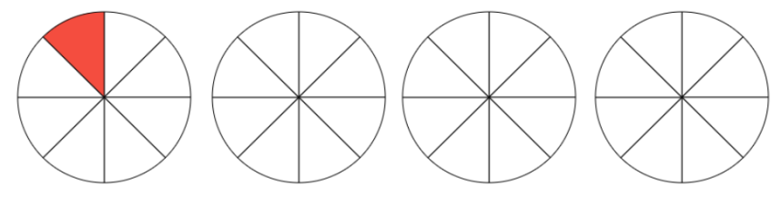**Gizmo Warm-up**

In the *Improper Fractions and Mixed Numbers* Gizmo, you can use area models shaped like pies to model fractions ranging in value from 0 to 4.

Each pie in the Gizmo can be cut into 2 to 10 slices. The number of slices per pie can be changed by dragging the slider. You can also click in and highlight the text field next to the slider, type the number of slices, and hit **Enter**. To shade a slice, simply click it.

1. Set **Number of slices** to 8 and shade 1 slice. Click on **Show calculation of total shaded pies**. What fraction is modeled by this one shaded slice?
2. Shade 2 more slices of the first pie in the Gizmo, for a total of 3 shaded slices.
3. A fraction has a **numerator** (top number) and a **denominator** (bottom number). What are the numerator and the denominator of the fraction modeled?

numerator: __________ denominator: __________

1. What does the numerator of the fraction tell you?

1. What does the denominator of the fraction tell you?

|  |  |  |
| --- | --- | --- |
| **Activity A:**  **Mixed numbers and improper fractions** | Get the Gizmo ready:   * Click **Clear**. * Set **Number of slices** to 6. * Select **Slices** under **Scale of measurement**. * Turn off **Show calculation of total shaded pies**. | 252SE2 |

An **improper fraction** is a fraction with a numerator that is greater than or equal to its denominator. A **mixed number** is a whole number combined with a fraction.

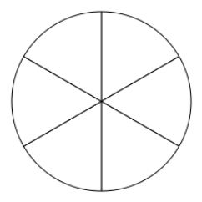

1. Shade 5 out of 6 slices in the Gizmo, and also in the pie at the right.
2. Fill in the blanks to name the fraction that is modeled. (Each piece is one sixth of the pie.) Check your answer by selecting **Pies** under **Scale of measurement** and looking at the number line.

__________ sixths =

1. Is the fraction improper? _______ How do you know?

1. Select **Slices** under **Scale of measurement**. Shade one additional slice in one of the pies.
2. How many pieces are shaded, total? _____________
3. What fraction is modeled now? Check your answer in the Gizmo.
4. Is the fraction improper? ______ How do you know?

1. How many whole pies are shaded? ______ What whole number is modeled? ______
2. Click **Clear**. Be sure **Slices** under **Scale of measurement** is selected. Cut each pie into fifths (5 pieces each). Shade 5 slices in each of the first 2 pies and 3 slices in the third pie.
3. How many pieces are shaded, total? _______
4. Use both words and numbers to name the improper fraction modeled.

words: ____________________________________ numbers:

**(Activity A continued on next page)**

**Activity A (continued from previous page)**

1. With each pie cut into fifths, be sure 13 slices are still shaded. The improper fraction modeled can be written as a mixed number.
2. How many whole pies are shaded? ________
3. How much of a partial pie is shaded?
4. What mixed number is modeled? Check your answer in the Gizmo.
5. Take the improper fraction you have modeled and divide its numerator by its denominator.
6. What part of the mixed number is the quotient?
7. What part of the mixed number is the remainder?
8. Multiply the denominator of the fraction in the mixed number from question 5 by the whole number. Then add the numerator to the result.
9. What is the answer? __________
10. What does this number tell you about the model?

1. Convert each improper fraction to an **equivalent** (equal) mixed number and each mixed number to an equivalent improper fraction. Then check your answers in the Gizmo. (Note: The last one cannot be modeled in the Gizmo.)
2.  =  =
3.  =  =
4.  =  =

|  |  |  |
| --- | --- | --- |
| **Activity B:**  **Adding fractions** | Get the Gizmo ready:   * Click **Clear**. * Set **Number of slices** to 7. * Select **Slices** under **Scale of measurement**. * Turn off **Show calculation of total shaded pies**. | 252SE4 |

1. 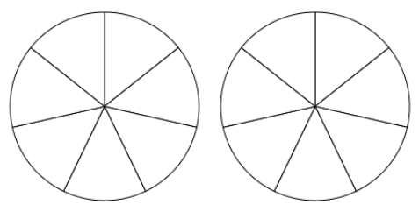Shade  of the two circles at the right. Then do the same thing in the Gizmo.
   1. How many slices did you shade to show 1? ______
   2. How many slices did you shade to show ? ______
   3. How many slices (sevenths) are shaded, total? _______
   4. Use your answers from above to help you fill in the blanks below.

_______ sevenths + _______ sevenths = _______ sevenths

* 1. Express the equation you wrote above as fractions.

+ =

* 1. Use the whole number equal to  to write a different addition sentence for  + .

+ =

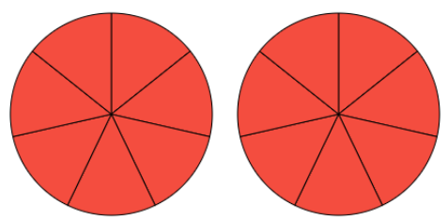

1. Be sure **Slices** under **Scale of measurement** is selected. Shade 5 more slices in the second circle. Two pies should now be fully shaded, as shown to the right.
2. Use a pencil to shade the slices you just added. What fraction is modeled by these 5 slices?
3. Fill in the blanks to show the sum modeled above.  + =

**(Activity B continued on next page)**

**Activity B (continued from previous page)**

1. Now find a mixed number and two fractions with a denominator of 7 whose sum is 2. Check your answer in the Gizmo.

7

7

7

+ + = 2

1. Click **Clear**. Be sure **Slices** under **Scale of measurement** is selected.
2. How many slices would you cut each pie into to model ? ______ Explain.

1. Find a whole number and mixed number can you add to get a sum of . Fill in your answer below. Then check your answer in the Gizmo.

+ = 

1. Find two fractions and/or mixed numbers whose sum is . Fill them in below.

_______ + _______ = 

Explain how you found your answer.

1. Find *two different* pairs of numbers (whole numbers, fractions, and/or mixed numbers) that add to each value given below. Then check your answers in the Gizmo. (Note: The last one cannot be modeled in the Gizmo.)
2. _______ + _______ =  _______ + _______ = 
3. _______ + _______ =  _______ + _______ = 
4. _______ + _______ =  _______ + _______ = 