Name: ______________________________________ Date: ________________________

Student Exploration: Inheritance

Vocabulary: acquired trait, asexual reproduction, clone, codominant traits, dominant trait, inherit, offspring, recessive trait, sexual reproduction, trait

Prior Knowledge Questions (Do these BEFORE using the Gizmo.)

- Johnny and Isabelle are a young couple expecting their first child. Both have blue eyes, tattoos, and green hair. Which features do you think their child is most likely to have?
  - Blue eyes
  - Tattoos
  - Green hair

- Features like eye color, skin tone, height, and hair color are called traits. What traits do you think children inherit, or receive, from their parents?

_________________________________________________________________________

_________________________________________________________________________

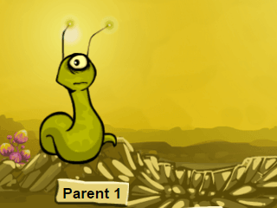
Gizmo Warm-up
In the Inheritance Gizmo you can create and breed aliens on an imaginary planet. Select Asexual reproduction. During asexual reproduction, a single parent produces offspring (children).

- Click Create alien and create your own alien. Describe its traits in the Parent row of the table:

Alien | Body type | Skin Color | Antenna shape | Tattoo
Parent
Offspring

- Drag the parent over to the Parent 1 space and press Reproduce. Fill in the Offspring traits on the table above. What traits appear to be inherited from the parent?

_________________________________________________________________________

Because this offspring inherits its traits from one parent, it is called a clone.

Activity A:  Inherited traits | Get the Gizmo ready:  - Select Sexual reproduction.  - Drop all remaining aliens (if any) in the Exit hole. | 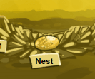

Question: Are all parental traits inherited by offspring?

- Observe: In sexual reproduction, two parents pass traits to the offspring. Create and breed a variety of aliens. Record your observations on a separate sheet of paper.

- Form a hypothesis: Which traits do you think are passed down from alien parents to their offspring, and which traits are not? Explain. ______________________________________
_________________________________________________________________________

- Experiment: Set the Food supply to 2 bushes. Create two identical parents with thick bodies, green skin, curly antennas, and triangle tattoos. Make two offspring and record their traits in the table below.

Offspring | Body type | Skin Color | Antenna shape | Tattoo
Offspring 1
Offspring 2

- Analyze: Compare the offspring traits to the parent traits.

    - Which traits were passed from parents to offspring? __________________________

    - Which traits were not passed down? ______________________________________

Traits that are not passed down (not inherited) are called acquired traits.

- Investigate further: Create offspring with a few different levels of Food supply. How does food supply affect the body type of offspring?

_________________________________________________________________________

- Think and discuss: Suppose a human child had a mother with dyed-pink hair and a father who was missing a finger (lost in an accident). Would the child inherit these traits? Explain.

_________________________________________________________________________

_________________________________________________________________________

Activity B:  Skin color | Get the Gizmo ready:  - Clear all parents and offspring from the Gizmo by dropping them into the Exit hole.  - Create a green alien and a pink alien. | 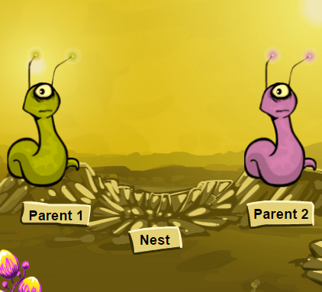

Question: How is alien skin color inherited?

- Predict: What do you think the offspring of a green alien and pink alien will look like? ______

_________________________________________________________________________

- Experiment: Test your prediction with the Gizmo. What did you find? __________________

_________________________________________________________________________

When offspring show a mixture of parent traits, the traits are called codominant traits.

- Predict: What do you think will happen when you breed two green-and-pink spotted aliens? _________________________________________________________________________

- Experiment: Follow the steps below. (You may have already done the first step or two.)
  - Place a green alien and a pink alien in the locations for Parent 1 and Parent 2.
  - Breed these parents twice. Drag both offspring to the spaces below the Nest.
  - Drag the two green-and-pink offspring up to become the new Parent 1 and Parent 2.
  - Breed these aliens 10 times. Record how many times each skin color occurred in their offspring. (For example, if there were 2 green offspring, write “2” below “green.”)

Skin color | Green | Green and pink | Pink
Number of offspring

- Analyze: Look at the results of your experiment.

    - What kind of skin did most of the offspring have? ____________________________

    - Did all of the offspring have green and pink skin? ____________________________

- Think and discuss: For a codominant trait, do the offspring of identical parents always look like the parents? Explain your answer.

_________________________________________________________________________

_________________________________________________________________________
Activity C:  Antenna shape | Get the Gizmo ready:  - Clear all aliens by dropping them into the Exit hole.  - Create two aliens – one with straight antenna and one with curly antenna. | 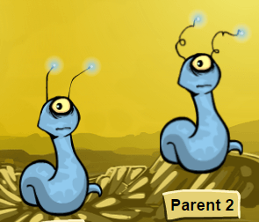

Question: How is alien antenna shape inherited?

- Predict: What do you think will happen when you breed an alien with straight antenna to an alien with curly antenna? _____________________________________________________

- Experiment: Test your prediction using the Gizmo. Create at least 5 offspring. What did you notice? ___________________________________________________________________

- Analyze: Sometimes when two traits are combined, one is a dominant trait and the other is a recessive trait. If both traits are present, only the dominant trait is seen in the offspring.

  - Which trait is dominant, straight antenna or curly? ___________________________

  - Which trait is recessive? ___________________________

- Investigate further: Take two of the straight-antenna offspring and breed them together to produce 10 new offspring. Record the antenna type of each offspring.

  - What happened? _____________________________________________________

  - Did the recessive trait disappear? ________________________________________

  - How can a trait skip a generation? _______________________________________

___________________________________________________________________

- Draw conclusions: For a dominant/recessive trait, do the offspring of identical parents always look like the parents? Explain. ___________________________________________
_________________________________________________________________________

- Compare: How do the offspring of two parents that reproduce sexually differ from the offspring of a single parent that reproduces asexually?

_________________________________________________________________________

_________________________________________________________________________

