Name: Date:

**Student Exploration:** **Introduction to Exponential Functions**

**Vocabulary:** asymptote, exponential function

**Prior Knowledge Questions** (Do these BEFORE using the Gizmo.)

A student sends a text to three friends. Then those three people each forward the text to three of their friends. (We’ll call that “round 2.”) Then the “round 2” recipients also each forward it to three friends. (That’s “round 3.”)

1. How many students receive the message in each “round” of texts?

Round 1: 3 people Round 2: Round 3:

1. Explain your reasoning.

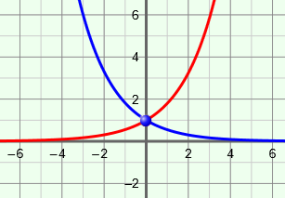**Gizmo Warm-up**

In an **exponential function**, an initial value (*a*) is multiplied repeatedly by the same positive factor (*b*, the base). In other words, *y* = *a* • *bx*. Note that this function has a variable in the exponent.

In the *Introduction to Exponential Functions* Gizmo, you can explore the effects of *a* and *b* in the function *y* = *a* • *bx*. To vary the values of *a* and *b*, drag the sliders. To enter a specific value, click on the number in the text field, type in the new value and hit **ENTER**.

1. Use the slider to vary the value of *b*, the base of the exponential function *y* = *a* • *bx*.
   1. Describe the graph when *b* is greater than 1.

* 1. Describe the graph when *b* is less than 1.

1. What point do all functions of the form *y* = *bx* have in common?

|  |  |  |
| --- | --- | --- |
| **Activity A:**  **Exponential basics** | Get the Gizmo ready:   * Select the **CONTROLS** tab. * Unselect all checkboxes. |  |

1. 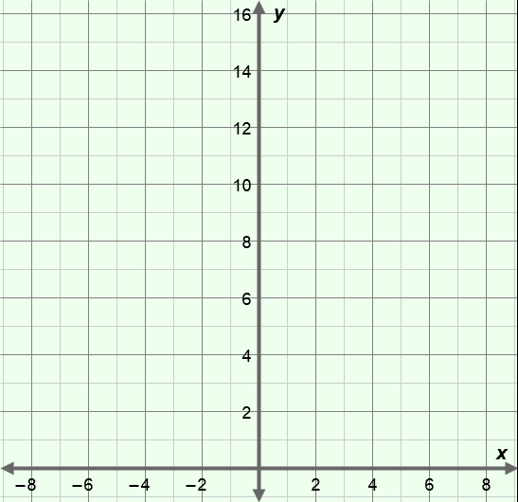Consider the function *y* = 2*x*. (Do not use the Gizmo yet.)
   1. First evaluate these expressions:

20 = 21 = 22 =

23 = 24 = 25 =

* 1. The values above give you six different points on the graph of *y* = 2*x*. What are they?

( 0 , ) ( 1 , ) ( , )

( , ) ( , ) ( , )

* 1. Graph these points on the axes to the right. Then graph *y* = 2*x* in the Gizmo. Check your graph and make any corrections needed.

1. Continue using *y* = 2*x*. Recall what negative exponents mean. (Example: 2–4 =  = .)
2. Evaluate each expression below. Then identify the corresponding point on the graph of *y* = 2*x*. (Express your answers as fractions.)

2–3 = 2–2 = 2–1 =

( , ) ( , ) ( , )

1. Graph these points on the same axes above. Then check your graph in the Gizmo. (Feel free to use a calculator to help convert fractions to decimals.)
2. With *y* = 2*x* graphed, select **Show probe**. Slowly drag the green probe to the left.
3. Describe the *y*-values as *x* approaches negative infinity (*x* 🡪 –∞).
4. What does the graph approach as *x* 🡪 –∞?

A line that a graph gets closer and closer to is called an **asymptote**.

**(Activity A continued on next page)**

**Activity A (continued from previous page)**

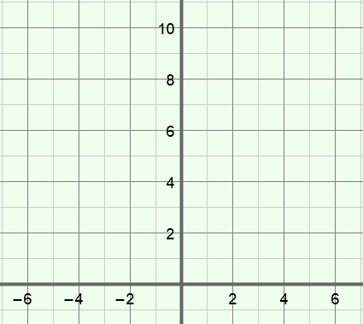

1. Consider the function *y* = 5*x*. (Do not use the Gizmo yet.)
2. Below, list six points that lie on the graph of *y* = 5*x*.

(–3, ) (–2, ) (–1, )

(0, ) (1, ) (2, )

1. Plot these points to the right. (Not all points will fit on the given axes.) Connect them with a smooth curve. Then check your graph in the Gizmo.
2. In general, what happens to the *y*-values of *y* = 5*x* as the *x*-value increases by 1?

By 2?

1. What happens to the *y*-values of *y* = 5*x* as the *x*-value *decreases* by 1?

By 2?

1. How do you think the *y*-values of *y* = 5*x* change as *x* increases from 6 to 9? Explain.

Check your answer in the Gizmo. (Hint: Adjust the **MAX** value on the **TABLE** tab.)

1. In the Gizmo, select **Show additional exponential function**. Graph the functions *y* = 5*x* and *y* = *x*. (Hint: In the Gizmo, you will need to use the decimal version of .)
2. How do the graphs differ?

1. How are the graphs similar?

|  |  |  |
| --- | --- | --- |
| **Activity B:**  **The effects of *a* on the graph** | Get the Gizmo ready:   * Be sure the **CONTROLS** tab is selected and that all boxes are unchecked. * Set *a* =1. |  |



1. Consider the function *y* = 4*x*. (Do not use the Gizmo yet.)
2. List four points that lie on the graph of *y* = 4*x*.

(–1, ) (0, ) (1, ) (2, )

1. What is the *y*-intercept of the function?
2. Plot these points on the grid to the right. Connect them with a smooth curve. Then, in the Gizmo, graph *y* = 4*x*. Correct your graph if you need to.
3. How would the graph change if all *y*-values of *y* = 4*x* were multiplied by 2?
4. What would the equation of this new function be?

Explain.

In the Gizmo, select **Show additional exponential function**. Graph both functions to check your answer. Make corrections if needed.

1. In the Gizmo, graph *y* =  • 4*x*. (The Gizmo uses decimals, so enter this as *y* = 0.5 • 4*x*.)
2. How do the *y*-values of *y* = 0.5 • 4*x* compare to those of *y* = 4*x*?

1. What is the *y*-intercept of *y* = 0.5 • 4*x*? Explain why.

1. Be sure **Show additional exponential function**is still selected. Graph both *y* = 2*x* and  
   *y* =  • 4*x* on the same axes. Is *y* =  • 4*x* equivalent to the function *y* = 2*x*?

Explain.

**(Activity B continued on next page)**

**Activity B (continued from previous page)**

1. For each function, identify four points that are on the graph. Graph the function by hand. (Not all of your points may fit on the axes below.) Then check your answer in the Gizmo.
2. *y* = 0.5 • 6*x*
3. *y* = 2 • 3*x*

( , ) ( , )

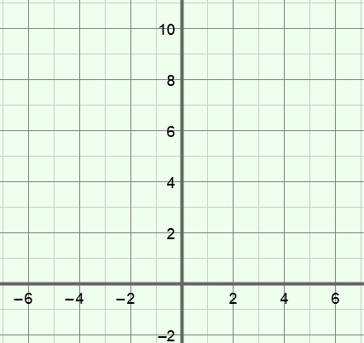( , ) ( , )

( , ) ( , )

( , ) ( , )

1. 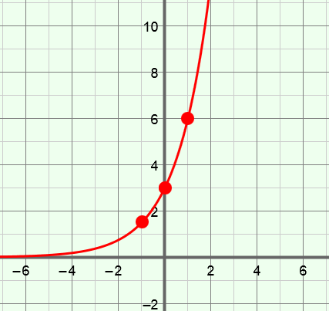Consider the graph to the right, containing the points   
   (–1, ), (0, 3), and (1, 6). Figure out what function is graphed here. Then check your answer in the Gizmo.
2. What function is this?

1. Explain.

1. 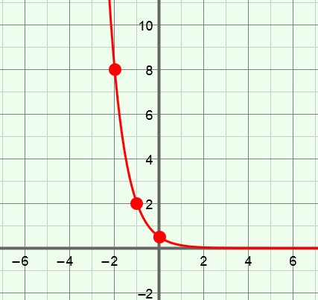Consider the graph to the right, which contains the points (–2, 8), (–1, 2) and (0, ). Figure out what function this is. Then check your answer in the Gizmo.
2. What function is this?
3. Explain.

|  |  |  |
| --- | --- | --- |
| **Activity C:**  **Graphing practice** | Get the Gizmo ready:   * Select the **CONTROLS** tab. * Unselect all checkboxes. | 135SE5 |

1. For each function below, identify two points that lie on its graph. Then sketch the graph. Use the Gizmo to check your answers. If necessary, make corrections.
2. *y* = 6*x*
3. *y* = *x*

points: (0, ) and (1, )

points: (0, ) and (1, )

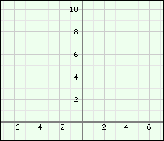

1. For each function below, identify two points that lie on its graph. Then sketch the graph. Use the Gizmo to check your answer. Make corrections as needed.
2. *y* = 3 • 2*x*
3. *y* =  • 4*x*

points: ( , ) and ( , )

points: ( , ) and ( , )

