Name: Date:

Student Exploration: Introduction to Functions

Vocabulary: domain, function, input, mapping diagram, ordered pair, output, range, relation

Prior Knowledge Questions (Do these BEFORE using the Gizmo.)
Matt wants a snack. He finds a vending machine with 25 different snacks. Each one is labeled with a letter (A to E), and then a number (1 to 5). He decides he wants the chips in slot A5.

- Matt puts in his money and pushes the A button.

  - Does the vending machine know what he wants yet?

  - Explain.

- Then Matt pushes the 5 button. What does that tell the machine to do?

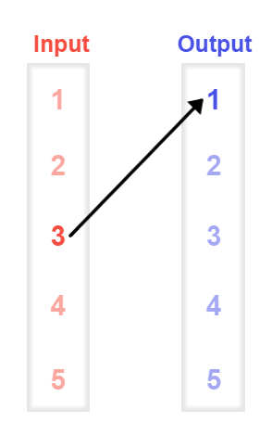
Gizmo Warm-up
In the Introduction to Functions Gizmo, you can create and analyze relations. A relation is a set of (input, output) or (x, y) ordered pairs. The Gizmo gives you three ways to link input values to output values, to form these pairs.

- In the Gizmo, turn on Show mapping diagram and Show ordered pairs. In the mapping diagram, click-and-drag an arrow from the red 3 to blue 1, as shown to the right. This means, “For an input of 3, the output is 1.”

  - How is this expressed as an ordered pair? ( , )

  - Turn on Show graph. How is this relationship shown on the graph?

- Drag another point onto the graph.

- What ordered pair did you graph? ( , )

- How is this ordered pair shown on the mapping diagram?

- Express this relationship as a sentence: For an input of , the output is .

Activity A:  Relations | Get the Gizmo ready:  - Click Clear all.  - Be sure Show mapping diagram, Show ordered pairs, and Show graph are selected. | 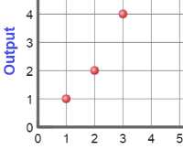

- Consider this relation: (1, 5), (4, 2), (3, 1), and (2, 4).

  - First, click inside the Show ordered pairs box, type (1, 5), and hit Enter. According to this ordered pair, what is the output of this relation when the input is 1?
  - In the Gizmo, type in the other three ordered pairs. The set of all input (x) values form the domain of a relation. The set of all output (y) values form the range. How can you determine the domain and range from the mapping diagram?

  - What are the domain and range of this relation, from smallest to largest?

Domain: { , , , } Range: { , , , }

Input | Output

- Click Clear all. Create a graph with 5 points whose domain is {2, 4, 5}.

- Record the coordinates of your points in the table to the right.

- What is the range of your relation?

- Look at the mapping diagram in the Gizmo. If a relation has more numbers in its range than in its domain, like this one does, what has to be true?

- Consider this relation: If the input is 3, the output is 5. If the input is 2, the output is 2. If the input is 1, the output is 4. If the input is 4, the output is 5. First, sketch the relation’s mapping diagram, ordered pairs, and graph below. Then create it in the Gizmo to check your answer.

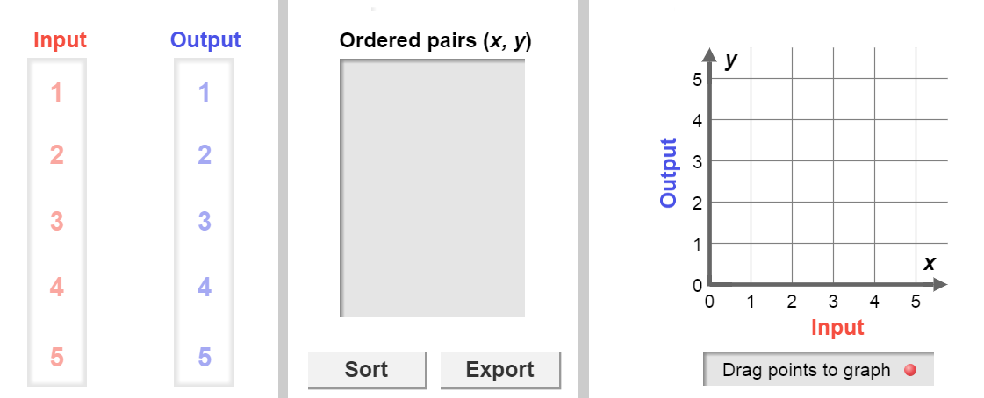

Activity B:  Functions | Get the Gizmo ready:  - Click Clear all.  - Turn on Show mapping diagram and Show ordered pairs. | 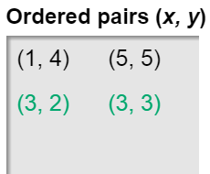

- In the Gizmo, create the mapping diagram for this relation: {(1, 4), (5, 5), (3, 2), (3, 3)}.

- Fill in the blanks with the output for each of the following inputs.

input 1, output input 5, output input 3, output

- Select Show function test under the mapping diagram. Why is this relation not a function?
- Which input is the “problem case” for this relation?

- How do you think you can spot a “problem case” on the graph?

Turn on Show graph to check.

- In the Gizmo, drag the point at (3, 3) to (4, 3). Look at Show function test under the mapping diagram. Why is this new relation a function?
- Select Show function test under the graph. Why does a “vertical line test” tell you if a relation is a function?

Input | Output

- Click Clear all. Create a graph with 4 points whose domain is {1, 2, 3}.

- Record the coordinates of your points in the table to the right.

- Is this relation a function? Explain.
- How can you turn this relation into a function?

Check your answer in the Gizmo.

- In general, what makes a relation a function?

