Vocabulary: Introduction to Functions

Vocabulary

- Domain – the set of all input (x) values of a relation.

- Function – a set of ordered pairs such that for each input (x) value, there is one and only one output (y) value.

- Input – a number that goes into a relation; an x-value.
  - An input value is the first element in an ordered pair. For example, in the ordered pair, (3, 4), the number 3 is the input.
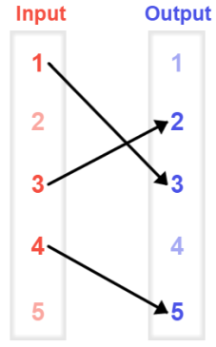
  - In the equation y = x + 1, if the input is 3, the output is 4.

- Mapping diagram – a diagram that contains two columns consisting of input and output values that can be paired to form a relation.
  - Pairs of values can be plotted as points in the x, y-coordinate plane.
  - This mapping diagram shows 1 mapped onto 3, 3 mapped onto 2, and 4 mapped onto 5. The mapping represents the ordered pairs (1, 3), (3, 2), and (4, 5).

- Ordered pair – the coordinates of a point in which the first coordinate represents its
x-value and the second coordinate represents its y-value.
  - For example, (3, 4) is an ordered pair where x = 3, and y = 4.
  - In the ordered pair (3, 4), 3 is the input, and 4 is the output.

- Output – a number that results from a relation; a y-value.
  - An output value is the second element in an ordered pair. For example, in the ordered pair, (3, 4), the number 4 is the output.
  - In the equation y = x + 1, if the input is 3, the output is 4.

- Range – the set of all output (y) values of a relation.

- Relation – a set of ordered pairs.

