Vocabulary: Investigating Angle Theorems

dictionary2

**Vocabulary**

* Complementary angles – two angles whose measures add to 90°.
* Complementary angles (also called *complements*) can be *adjacent* (sharing a common side and a common vertex) or *nonadjacent*.

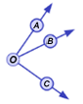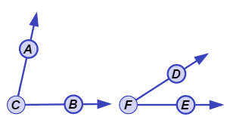

**Nonadjacent complementary angles**

**Adjacent complementary angles**

* 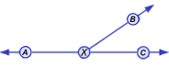Linear pair – two adjacent angles whose non-common sides form a straight line.
* In the figure shown to the right, rays  and  form a straight line, so ∠*AXB* and ∠*BXC* form a linear pair.
* Supplementary angles – two angles whose measures add to 180°.
* Supplementary­ angles (also called *supplements*) can be *adjacent* or *nonadjacent*.

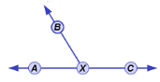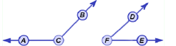

**Nonadjacent supplementary angles**

**Adjacent supplementary angles**

* Vertical angles – two nonadjacent angles formed by intersecting lines.
* 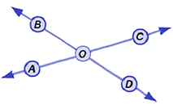A pair of intersecting lines forms two pairs of vertical angles.
* The vertical angles in the figure to the right are ∠*AOB* and ∠*DOC*, and ∠*AOD* and ∠*BOC*.